UNITED STATES
SECURITIES AND EXCHANGE COMMISSION
Washington, D.C. 20549
_____________________________
SCHEDULE 14A
_____________________________
Proxy Statement Pursuant to Section 14(a) of the Securities Exchange Act of 1934
(Amendment No. )
Filed by the Registrant ☒
Filed by a Party other than the Registrant ☐
Check the appropriate box:
☐ |  | Preliminary Proxy Statement
☐ |  | Confidential, for the use of the Commission only (as permitted by Rule 14a-6(e)(2))
☒ |  | Definitive Proxy Statement
☐ |  | Definitive Additional Materials
☐ |  | Soliciting Material Pursuant to §240.14a-12
OPTIMIZERX CORPORATION
(Name of Registrant as Specified In Its Charter)
Not Applicable
(Name of Person(s) Filing Proxy Statement, if other than the Registrant)
Payment of Filing Fee (Check all boxes that apply):
☒ |  | No fee required.
☐ |  | Fee paid previously with preliminary materials.
☐ |  | Fee computed on table in exhibit required by Item 25(b) per Exchange Act Rules 14a-6(i)(1) and 0-11.

Table of Contents

Notice of Annual Meeting of Stockholders
Date and Time  Wednesday, June 7, 2023, at 10:00 a.m. (EDT)  Meeting Access  Live Audio Webcast:  www.virtualshareholdermeeting.com/OPRX2023  Record Date  April 12, 2023  Items of Business  • Proposal 1: Election of six directors, as described in the accompanying proxy statement.  • Proposal 2: Advisory approval of the compensation of OptimizeRx’s named executive officers. |  | 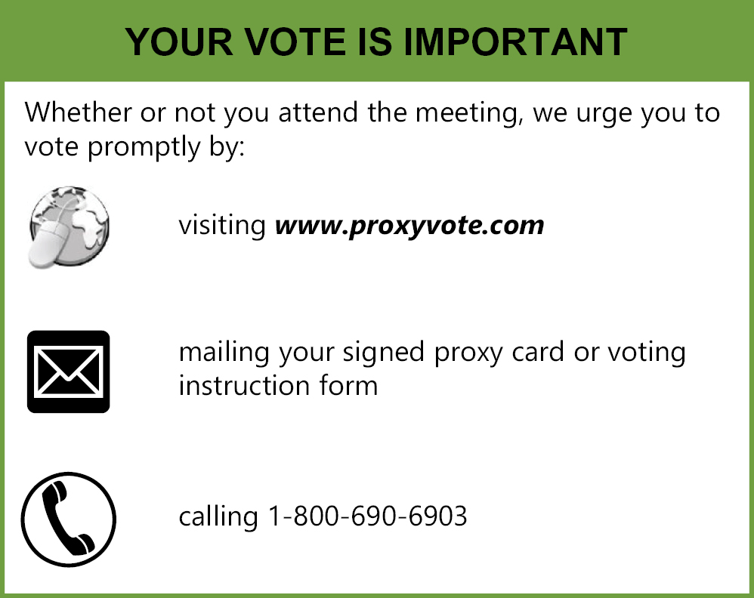
• Proposal 3: Ratification of UHY LLP as OptimizeRx’s independent registered public accounting firm for the 2023 fiscal year.
• Consideration of any other business properly brought before the annual meeting.
This year’s annual meeting will be a virtual meeting conducted via live webcast. The annual meeting format will be a live audio webcast where you can view presentation materials made available online. There will be no physical in-person meeting. Additional information regarding attending the annual meeting, voting your shares and submitting questions in advance of the annual meeting can be found in the proxy statement.
Eligibility to Vote
Only stockholders of record, as of the close of business on April 12, 2023, are entitled to notice of and to vote at the annual meeting and any postponements or adjournments thereof.
This Notice of Annual Meeting of Stockholders, the proxy statement, form of proxy and the Company’s Annual Report on Form 10-K for the year ended December 31, 2022 are being distributed and made available to our stockholders on or about April 25, 2023.
Your vote is important. Whether or not you attend the meeting, we urge you to vote promptly.
 |  | By Order of the Board of Directors
 |  | /s/ Gus D. Halas
 |  | Gus D. Halas
Rochester, MI |  | Chairperson
April 25, 2023
This Notice of Annual Meeting of Stockholders, the proxy statement and the Company’s Annual Report on Form 10-K for the year ended December 31, 2022 are available at www.proxyvote.com.

Table of Contents
TABLE OF CONTENTS
 |  | Page
PROXY STATEMENT SUMMARY |  | 1
QUESTIONS AND ANSWERS ABOUT THE ANNUAL MEETING |  | 2
PROPOSAL NO. 1 ELECTION OF DIRECTORS |  | 5
CORPORATE GOVERNANCE |  | 9
DIRECTOR NOMINATION PROCESS |  | 18
DIRECTOR COMPENSATION |  | 20
EXECUTIVE COMPENSATION |  | 22
PAY VERSUS PERFORMANCE |  | 31
CERTAIN RELATIONSHIPS AND RELATED TRANSACTIONS |  | 34
PROPOSAL NO. 2 ADVISORY VOTE ON EXECUTIVE COMPENSATION |  | 35
INFORMATION REGARDING SECURITY HOLDERS |  | 36
PROPOSAL NO. 3 RATIFICATION OF UHY LLP AS INDEPENDENT REGISTERED PUBLIC ACCOUNTING FIRM |  | 38
INDEPENDENT REGISTERED PUBLIC ACCOUNTANT FEE INFORMATION |  | 39
PRE-APPROVAL POLICIES AND PROCEDURES |  | 40
REPORT OF THE AUDIT COMMITTEE |  | 41
STOCKHOLDER PROPOSALS |  | 42
OTHER MATTERS |  | 43
HOUSEHOLDING |  | 43
i
Table of Contents
PROXY STATEMENT SUMMARY
This summary highlights information contained elsewhere in this proxy statement. It does not contain all of the information you should consider, and you should read the entire proxy statement carefully before voting. References in this proxy statement to the “Company,” “OptimizeRx,” “we,” “us,” and “our” refer to OptimizeRx Corporation, a Nevada company. This proxy statement, form of proxy and the Company’s Annual Report on Form 10-K for the year ended December 31, 2022 are being distributed and made available to our stockholders on or about April 25, 2023. Our principal executive offices are located at 400 Water Street, Suite 200 Rochester, MI 48307.
Annual Meeting Information
Date and Time: | June 7, 2023 at 10:00 a.m., Eastern Daylight Time
Meeting Access: | Live Audio Webcast: www.virtualshareholdermeeting.com/OPRX2023
Record Date: | April 12, 2023
Voting: | Stockholders have one vote per share on all matters presented at the annual meeting
This year’s annual meeting will be a virtual meeting. You will be able to attend the annual meeting and vote your shares electronically during the meeting by visiting www.virtualshareholdermeeting.com/OPRX2023. The annual meeting format will be a live audio webcast where you can view presentation materials made available online. There will be no physical in-person meeting. You may submit questions in advance of the meeting via the internet at www.proxyvote.com when you vote your shares. You can submit a question up to 11:59 p.m. EDT on June 6, 2023. Please see “Questions and Answers About the Annual Meeting” for more information regarding the annual meeting.
Even if you plan to attend the virtual annual meeting, please vote in advance so that your vote will be counted if you later decide not to attend the virtual annual meeting.
Voting Matters and the Board’s Recommendation
Agenda Item | Board Vote Recommendation | Page Reference
Election of six directors | FOR each Director Nominee | 5
Advisory approval of the compensation of OptimizeRx’s named executive officers | FOR | 35
Ratification of UHY LLP as OptimizeRx’s independent registered public accounting firm for the 2023 fiscal year | FOR | 38
In addition to these matters, stockholders may be asked to vote on such other business as may properly come before the annual meeting.
1
Table of Contents
QUESTIONS AND ANSWERS ABOUT THE ANNUAL MEETING
Why did I receive these proxy materials?
This proxy statement, form of proxy and the Company’s Annual Report on Form 10-K for the year ended December 31, 2022 are being distributed and made available to our stockholders starting on or about April 25, 2023. We are providing these proxy materials in connection with the solicitation by the Board of proxies to be voted at our 2023 Annual Meeting of Stockholders and at any adjournment or postponement of the meeting.
When and where will the annual meeting be held?
Date | Wednesday, June 7, 2023
Time | 10:00 a.m. (EDT)
Location | Live Audio Webcast at: www.virtualshareholdermeeting.com/OPRX2023
Who is entitled to vote at the annual meeting?
Holders of OptimizeRx common stock at the close of business on April 12, 2023, are entitled to receive the Notice of Annual Meeting and proxy statement and to vote their shares at the annual meeting. As of that date, there were 17,120,543 shares of the Company’s common stock outstanding and entitled to vote. Each share of common stock is entitled to one vote on each matter properly brought before the annual meeting.
What constitutes a quorum for the annual meeting?
The holders of at least a majority of the voting power of the Company’s capital stock, present in person or by proxy (regardless of whether the proxy has authority to vote on any matter), shall constitute a quorum. Abstentions and broker non-votes are counted for purposes determining whether there is a quorum.
How can I attend and participate in the annual meeting?
To attend and participate in the annual meeting, visit www.virtualshareholdermeeting.com/OPRX2023 and enter the 16-digit control number included on your proxy card. The virtual annual meeting will begin promptly at 10:00 a.m. (EDT) on Wednesday, June 7, 2023. You may log in beginning at 9:30 a.m. (EDT).
We encourage you to access the virtual annual meeting prior to the start time leaving ample time to confirm that your Internet or Wi-Fi connection is sufficient to access the features of the virtual annual meeting, and to allow sufficient time to check in. The virtual meeting platform is supported across browsers (Edge, Internet Explorer, Firefox, Chrome, and Safari) and devices (desktops, laptops, tablets, and mobile phones) that have the most updated version of applicable software and plugins installed. You should ensure that you have a strong Wi-Fi connection wherever you intend to participate in the annual meeting. While there is no fee to attend the virtual annual meeting, you may incur data or other fees imposed by your Internet or wireless carrier.
If you do not have a 16-digit control number, you may also visit www.virtualshareholdermeeting.com/OPRX2023 and log in as a guest. You will not be able to vote your shares during the virtual annual meeting if you participate as a guest.
The recording, reproduction or distribution of the virtual annual meeting, or any portion thereof, is strictly prohibited.
2
Table of Contents
What if I am having technical difficulties?
Technicians will be ready to assist you with any technical difficulties you may have in accessing the virtual annual meeting. Technical support will be available on the virtual annual meeting platform beginning at 9:30 a.m. (EDT) on the day of the annual meeting by calling the numbers posted on the log in page.
How do I submit a question for the annual meeting?
You may submit questions in advance of the meeting via the internet at www.proxyvote.com when you vote your shares. You can submit a question up to 11:59 p.m. EDT on June 6, 2023.
How do I vote if I am a stockholder of record?
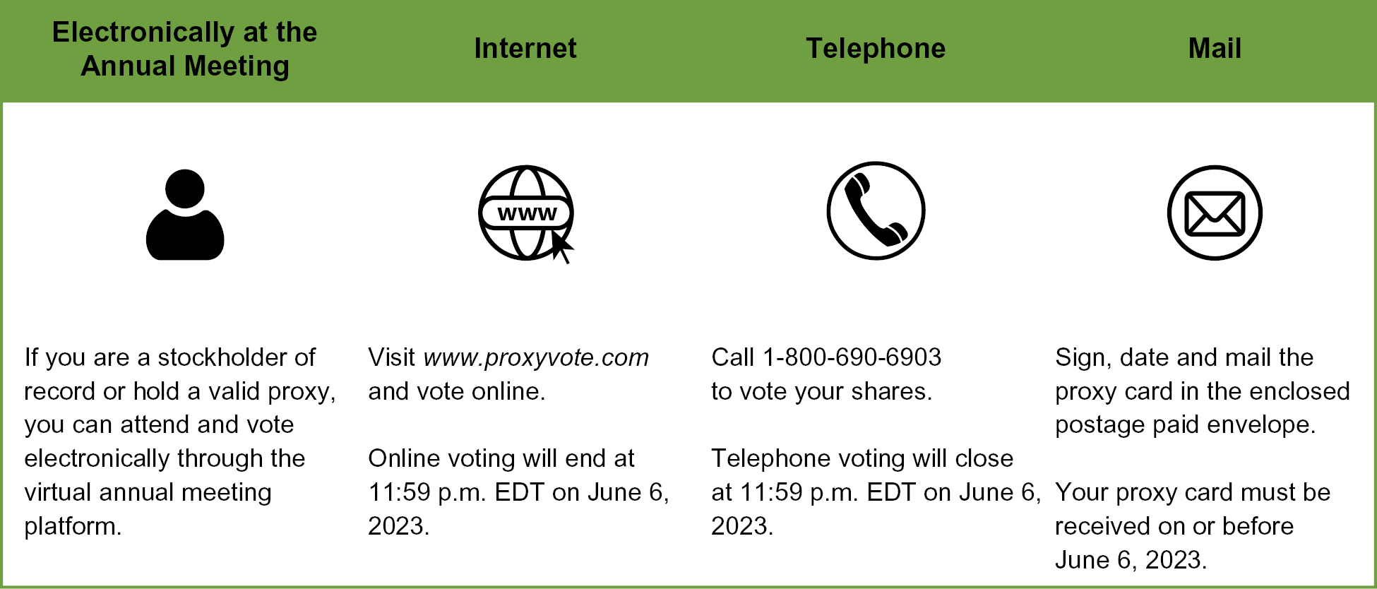
How do I vote if I am a beneficial owner of shares?
If you are a “beneficial owner,” also known as a “street name” holder (meaning that you hold your shares of our common stock through a broker, bank or other financial institution), your broker, bank or financial institution will ask you how you wish to have your shares voted. In addition, you will receive instructions as part of your proxy materials provided by your broker, bank or other financial institution on how to access the virtual annual meeting and participate and vote at the annual meeting (including, if your broker, bank or other financial institution elects to do so, instructions on how to vote via telephone or the Internet). You must follow those instructions in order to be able to access the virtual annual meeting and have your shares voted. You may also be able to obtain a proxy from your broker, bank or other financial institution by contacting them directly. Your broker is not permitted to vote on your behalf on the election of directors and other matters to be considered at the annual meeting (except on the ratification of the appointment of UHY as auditors for 2023) unless you provide specific instructions. Accordingly, your shares will only be voted if you give instructions to your broker, bank or financial institution.
Can I revoke my proxy or change my vote after I vote by proxy?
If you are a stockholder of record, you can revoke your proxy before it is exercised by:
• giving written notice to our Corporate Secretary;
• delivering a valid, later-dated proxy, or a later-dated vote by telephone or on the Internet, in a timely manner; or
• voting during the live webcast of the annual meeting.
If you are a beneficial owner of shares, you may submit new voting instructions by contacting your broker, bank or other holder of record and following their instructions for how to do so.
3
Table of Contents
What vote is needed to approve each proposal? How do abstentions or broker non-votes affect the voting results?
The following table summarizes the vote threshold required for approval of each proposal and the effect on the outcome of the vote of abstentions and uninstructed shares held by brokers (referred to as broker non-votes). When a beneficial owner does not provide voting instructions to the institution that holds the shares in street name, brokers may not vote those shares in matters deemed non-routine. Only Proposal 3 is a routine matter.
PROPOSAL | ITEM | VOTE REQUIRED FOR  APPROVAL | EFFECT OF  ABSTENTIONS  (or the  withholding  of authority) | EFFECT OF BROKER  NON-VOTES
1 | Election of six directors | Plurality—the six director nominees who receive the most “FOR” votes will be elected to serve on the Board | No effect | No effect
2 | Advisory approval of the compensation of OptimizeRx’s named executive officers | Number of votes cast in favor exceeds number of votes cast in opposition | No effect | No effect
3 | Ratification of the appointment of independent auditor | Number of votes cast in favor exceeds number of votes cast in opposition | No effect | No broker non-votes; shares are voted by brokers in their discretion
Your shares will be voted in accordance with your instructions. If you are a stockholder of record and sign, date and return a proxy card but do not indicate how you wish to vote your shares, the appointed proxies named on the proxy card will vote your shares “for” each of the nominees with respect to Proposal 1, “for” Proposals 2 and 3, and in the discretion of the appointed proxies named on the proxy card with respect to any other business properly brought before the annual meeting.
Who will pay for the cost of this proxy solicitation?
We will pay all expenses incurred in connection with the solicitation of proxies. In addition to solicitation by mail, our officers, directors and regular employees, who will receive no additional compensation for their services, may solicit proxies in person or by telephone, facsimile, email or the Internet. We have requested that brokers, banks and other nominees who hold stock in their names furnish this proxy material to their customers; we will reimburse these brokers, banks and nominees for their out-of-pocket and reasonable expenses. Although it is not anticipated, we reserve the right to retain a professional firm of proxy solicitors to assist in the solicitation of proxies. We estimate that we would be required to pay such firm fees ranging from $10,000 to $20,000 plus out-of-pocket expenses.
Could other matters be decided at the annual meeting?
We are not aware of any other matters that will be presented and voted upon at the annual meeting. If you return your signed and completed proxy card or vote by telephone or on the Internet and other matters are properly presented at the annual meeting for consideration, the persons named in the accompanying proxy card will have the discretion to vote for you on such matters and intend to vote the proxies in accordance with their best judgment.
4
Table of Contents
PROPOSAL NO. 1
ELECTION OF DIRECTORS
Our bylaws provide that our business shall be managed by or under the direction of a board of directors of not less than three nor more than seven directors, which number shall be fixed from time to time by such board of directors. The Board currently consists of six directors.
There are six nominees for election to the Board at the annual meeting. Each of the six nominees, if elected, will hold office for a term that expires at the next annual stockholders’ meeting. Each director shall hold office for the term for which the director was elected and until the director’s successor is elected and qualified or until the director’s earlier death, resignation, or removal. Proxies solicited by the Board will, unless otherwise directed, be voted to elect the six nominees named below to constitute the entire Board.
The Board has nominated each of the following individuals for election as a director at the annual meeting: William J. Febbo, Gus D. Halas, Lynn O’Connor Vos, James Lang, Patrick Spangler and Gregory D. Wasson. Each nomination for director was based upon the recommendation of our Nominating and Governance Committee and each nominee for director is a current member of the Board. All nominees have consented to be named and have indicated their intent to serve if elected. In the event any of the nominees shall be unable or unwilling to serve as a director, the persons named in the proxy intend to vote “FOR” the election of any person as may be nominated by the Board in substitution. The Company has no reason to believe that any of the nominees named below will be unable to serve as a director if elected.
The following table sets forth certain information, as of the date of this proxy statement, as to each nominee for the office of director:
Name | Age | Position | Director Since
William J. Febbo | 54 | Chief Executive Officer and Director | 2016
Gus D. Halas | 72 | Chairperson | 2014
Lynn O’Connor Vos | 67 | Director | 2015
James Lang | 58 | Director | 2017
Patrick Spangler | 67 | Director | 2018
Gregory D. Wasson | 64 | Director | 2020
The following information about our directors is based, in part, upon information supplied by them. Unless otherwise indicated, each individual has had the same principal occupation for more than five years.
William J. Febbo
Mr. Febbo joined the Company as Chief Executive Officer and as a director in February 2016. Mr. Febbo founded Plexuus, LLC, a payment processing business for medical professionals in September 2015 and remained its Chairman from September 2015 to December 2020. From April 2007 to September 2015, Mr. Febbo served as Chief Operating Officer of Merriman Holdings, Inc., an investment banking firm, where he assisted with capital raises in the tech, biotech, cleantech, consumer and resources industries. Mr. Febbo was a co-founder of, and from September 2013 to September 2015 served as Chief Executive Officer of, Digital Capital Network, Inc. a transaction platform for institutional and accredited investors. Mr. Febbo was a co-founder, and from January 1999 to September 2015 was Chief Executive Officer, of MedPanel, LLC, a provider of market intelligence and communications for the pharmaceutical, biomedical, and medical device industries. Since 2017, Mr. Febbo has been a faculty member of the Massachusetts Institute of Technology’s linQ program, which is a collaborative initiative focused on increasing the potential of innovative research to benefit society and the economy. Mr. Febbo currently serves as a director of Modular Medical (Nasdaq: MODD), a development stage medical device company focused on the design, development, and eventual commercialization of an innovative insulin pump, and as a director of Augmedix, Inc. (Nasdaq: AUGX), a provider of automated medical documentation
5
Table of Contents
and data services. In addition, since 2004, Mr. Febbo has been a board member of the United Nations Association of Greater Boston, a resource for the citizens of Greater Boston on the broad agenda of critical global issues addressed by the UN and its agencies.
On January 29, 2018, FINRA accepted a Letter of Acceptance, Waiver and Consent (the “Consent”) submitted by William Febbo. Without admitting or denying the findings, Mr. Febbo consented to the sanctions and to the entry of findings that he permitted Merriman Capital, Inc. to conduct a securities business while below its net capital requirement. From August 2012 to October 2015, Mr. Febbo was the Financial and Operations Principal (FinOp) for a registered broker-dealer, Merriman Capital, Inc. (“Merriman”). During certain months while Mr. Febbo was FinOp, FINRA found that certain of Merriman’s net capital filings with FINRA were inaccurate because of the method by which Merriman calculated net capital and that, when corrected, it was retroactively determined that Merriman had operated below its minimum net capital requirements. Mr. Febbo, as FinOp, signed certain of these reports and was thus held responsible. Based on the Consent, in settlement, Mr. Febbo, who was then no longer registered with any broker-dealer, accepted a fine of $5,000, a 10-business day suspension from acting as FinOp for any FINRA member and required to requalify by examination for the Series 27 license before again acting in a FinOp capacity.
Mr. Febbo is qualified to serve on our Board because he brings more than 20 years of experience in building and managing health services and financial businesses. In addition, as the only current management representative on the Board, Mr. Febbo’s leadership of OptimizerRx’s business provides the Board with invaluable insight into the Company’s operations and strategic direction.
Gus D. Halas
Mr. Halas, Chairperson, joined the Company as a director in August 2014. From April 2011 through May 2013, Mr. Halas was Chief Executive Officer and President of the Central Operating Companies at Central Garden & Pet Company (Nasdaq: CENT, CENTA), a market leader in the garden and pet industries. From 2009 to 2011, Mr. Halas served as an independent consultant and advisor to both private and public companies. From May 2003 to March 2009, Mr. Halas was President and Chief Executive Officer of T-3 Energy Services, Inc., then a public company listed on Nasdaq which designed, manufactured, repaired, and serviced products used in the drilling and completion of new oil and gas wells, the workover of existing wells, and the production and transportation of oil and gas. From August 2001 to April 2003, Mr. Halas served as President and Chief Executive Officer of Clore Automotive, LLC, a leader in the design, development, and manufacture of automotive service equipment. Mr. Halas served as a director of Ascension Energy Partners from 2020 until 2022, School Specialty, Inc. (listed on the OTCQB marketplace until May 2020) from 2015 until 2022, Triangle Petroleum Corp (listed on the NYSE MKT until January 2018) from 2015 until 2022, Madalena Energy, Inc. (TSXV & OTCQX: MVN) from 2015 until 2020 and Hooper Holmes, Inc., then a public company listed on NYSE MKT, from 2013 until 2017. Mr. Halas currently serves on the boards of the following privately held companies: AXON Energy Services and Kraus Hamdani Aerospace, Inc.
Mr. Halas has over 40 years of experience, currently serving on a number of boards and has served as chief executive officer of several companies. Mr. Halas is qualified to serve on our Board because of his experience and expertise as an executive and a director with companies implementing “turnaround” strategies.
Lynn O’Connor Vos
Ms. Vos initially joined the Company as a director in September 2015, representing Grey Healthcare Group, a healthcare advertising and communications company and wholly-owned operating company of WPP plc, when it acquired a minority interest in OptimizeRx as a strategic investor. Since 2017, Ms. Vos has served as an independent director of the Company. From August 2021 to March 2022, Ms. Vos served as the interim Chief Executive Officer of Modular Medical (Nasdaq: MODD), a development stage medical device company focused on the design, development, and eventual commercialization of an innovative insulin pump. Since November 2020, Ms. Vos has run VosHealth, LLC, a healthcare consulting
6
Table of Contents
firm focused on advising healthcare start-ups and marketing organizations. From October 2017 to November 2020, Ms. Vos served as the President and Chief Executive Officer of the Muscular Dystrophy Association. From October 1994 to September 2017, Ms. Vos served as the Chief Executive Officer of Grey Healthcare Group. Ms. Vos currently serves as the Chairperson of Medisafe, Inc., a medication adherence platform, and as a director of Aspira Women’s Health, Inc. (Nasdaq: AWH), a bio-analytical based company focused on the development of gynecologic disease diagnostic tools, and as a director of Modular Medical, and previously served on the boards of nTelos Wireless, a wireless telecommunications company and PCS provider; the Jed Foundation, a leading nonprofit dedicated to protecting the emotional health of college students; and was a founding board member of Multiple Myeloma Research Foundation (MMRF), a pioneering cancer research foundation.
Ms. Vos is qualified to serve on our Board because of her CEO experience and extensive executive skills in digital marketing, commercialization, and communications in the healthcare industry, as well as her knowledge and experience in corporate diversity, equity, inclusion and belonging (DEI&B) as well as in environmental, social and governance (ESG) matters.
James Lang
Mr. Lang joined the Company as a director in January 2017. Since May 2017, Mr. Lang has served as the Chief Executive Officer of EVERSANA, a leading provider of global commercialization services to the life science industry. Since December 2016, Mr. Lang has also served as an executive advisor to Water Street Healthcare Partners, a strategic private equity firm focused exclusively on building market-leading companies in healthcare. From 2012 to 2016, Mr. Lang served in leadership roles at Decision Resources Group (DRG), a multi-national corporation that provides high value global data solutions, analytics, and consulting services to pharmaceutical, biotech, medical device, healthcare provider and payer, and managed care companies, including as its Chief Executive Officer from 2014 to 2016. From 2006 to 2008, he served as President of IHS Cambridge Energy Research Associates, an international research and consulting firm, which delivered strategic knowledge and independent analysis on energy markets, geopolitics, industry trends, and strategy. From 1989 to 2006, he held various roles at Strategic Decisions Group (SDG), a global strategy consulting firm, including as President and Chief Operating Officer from 2000 to 2006. Mr. Lang is an active private investor in healthcare and has served on several private and public boards. Mr. Lang currently serves as a director of BioVie Inc. (Nasdaq: BIVI), a clinical-stage company pursuing several solutions, one targeting Alzheimer’s and Parkinson’s and another targeting complications from liver cirrhosis.
Mr. Lang brings more than 30 years of experience in healthcare data, analytic, and technology enabled business services and is qualified to serve on our Board because of his extensive executive skills and background in the healthcare industry.
Patrick Spangler
Mr. Spangler joined the Company as a director in March 2018. Since October 2020, Mr. Spangler has served as Chief Financial Officer of On Target Laboratories, a developer of fluorescent markers to target and illuminate cancer during surgery. From March 2020 to September 2020, Mr. Spangler served as Chief Financial Officer of MHC Software, LLC, a supplier of document automation software to a variety of industries. Prior to MHC, Mr. Spangler served as Chief Financial Officer of VigiLanz Corporation, a digital healthcare intelligence firm, from September 2014 to October 2019; Chief Financial Officer of Healthland Inc., an EHR company serving the critical access hospital market, from August 2012 to August 2014; Senior Vice President and Chief Financial Officer of Epocrates, Inc., then a public company listed on Nasdaq and a point-of-care medical applications provider, from October 2010 to August 2012; Operating Partner and CFO Advisor of Three Fields Capital, a private equity and venture capital investment firm, from April 2010 to October 2010; Chief Financial Officer of HighJump Software, a global provider of supply chain management software, from June 2009 to April 2010; Senior Vice President and Chief Financial Officer of ev3 Inc., then a public company listed on NASDAQ and a global endovascular company focused on identifying and treating peripheral vascular disease, from March 2005 to January 2009; and Executive Vice President and Chief Financial Officer for EMPI Inc., a medical device manufacturer, from July 1997 to March 2005. Prior to joining EMPI Inc., Mr. Spangler served for
7
Table of Contents
over eleven years in various senior finance leadership positions at Medtronic, Inc. (NYSE: MDT), a global medical device company, Mr. Spangler currently serves as a director of Lifespace Communities Inc, which owns and operates 15 CCRCs in eight states and houses more than 5100 residents, and previously served on the board of Urologix, Inc., then a public company and a leader in less invasive in office BPH treatments, from August 2010 to February 2016.
Mr. Spangler has over 35 years of experience in IPOs, mergers and acquisitions, operations and financial management experience in the medical device and health care IT industries. Mr. Spangler is qualified to serve on our Board because of his extensive executive skills and background in the healthcare industry and his finance experience.
Gregory D. Wasson
Mr. Wasson joined the Company as a director in July 2020. Since January 2016, Mr. Wasson has served as President and Co-founder of Wasson Enterprise, a family office that partners to build sustainable, high-growth businesses. In January 2015, Mr. Wasson served as President and Chief Executive Officer of Walgreens Boots Alliance, Inc., a global, pharmacy-led health and wellbeing enterprise. Prior to being appointed President and Chief Executive Officer of the combined companies, Walgreens Boots Alliance, Mr. Wasson rose through the ranks through a number of positions of increasing responsibility and executive leadership at Walgreens including, from 2009 to 2015 as its President and Chief Executive Officer, from 2007 to 2009 as its President and Chief Operating Officer, from 2001 to 2006 as the President and Executive Vice President of Walgreen Health Services, from 1999 to 2001 as its Vice President of Store Operations, from 1986 to 1999 as a District Manager, and from 1981 to 1986 as a Pharmacy Technician, Pharmacist and Store Manager. Mr. Wasson currently serves on the board of P3 Health Partners Inc. (Nasdaq: PIII), a patient-centered and physician-led population health management company, and served as the Chairperson of its predecessor Foresight Acquisition Corp. (Nasdaq: FORE) from 2020 to 2021. Mr. Wasson serves on the boards of the following privately held companies: Dom’s Kitchen and Market, Truvian, Reliefband, Golden Fleece Beverages, Inc., Innovation Associates dba iA, Performance Health Systems, Cooler Screens, Inc., and Innventure LLC. Mr. Wasson previously served on the boards of PNC Financial Services Group, Inc. (NYSE: PNC) from July 2015 to October 2018 and Verizon Communications Inc. (NYSE: VZ) from February 2013 to October 2018.
On September 28, 2018, the Securities and Exchange Commission (“SEC”) entered an Administrative Order consensually resolving an investigation into forward-looking financial goals and related disclosures by Mr. Wasson’s former employer, Walgreen Co. (“Walgreens”). The Order settled the SEC’s investigation into various allegedly misleading statements made by or on behalf of Walgreens, including statements made by Mr. Wasson and Walgreens’ former Chief Financial Officer (“CFO”), relating to its ability to achieve certain previously stated financial goals associated with its anticipated future merger with Alliance Boots GmbH. Without admitting or denying any of the SEC’s findings, Walgreens, Mr. Wasson and the company’s former CFO each consented to the entry of an SEC order finding that they violated the antifraud provision contained in Section 17(a)(2) of the Securities Act and each agreed to cease and desist from any future violations of Section 17(a)(2) of the Securities Act and to the payment of specified penalties. For his part, Mr. Wasson agreed to pay a civil monetary penalty of $160,000.
Mr. Wasson is qualified to serve on our Board because of his extensive experience as an executive in, and in-depth knowledge of, the healthcare industry.
THE BOARD RECOMMENDS A VOTE “FOR” EACH OF THE NOMINEES.
8
Table of Contents
CORPORATE GOVERNANCE
Our Board believes that sound corporate governance is essential to effective fulfillment of its oversight responsibilities. The Board has adopted Corporate Governance Guidelines to formalize the Company’s governance practices and which serve as a framework within which our Board and its committees operate. You can find a copy of our Corporate Governance Guidelines, along with the charters of our three standing Board committees, our articles of incorporation, bylaws, and our other governance polices, in the governance section of our website at www.optimizerx.com. Some highlights of our corporate governance policies and practices include:
ü 5 of our 6 directors are independent
ü De-classified board structure requiring annual nomination and election of directors
ü Independent Board chairperson
ü Independent directors regularly meet in executive session
ü Board committees composed entirely of independent directors
ü “Overboarding” limits
ü Stock ownership guidelines for directors and executive officers
ü Clawback policy for incentive compensation
ü Stockholder ability to call a special meeting
ü Annual stockholder ratification of independent auditors
ü Policies prohibiting short sales, hedging, margin accounts and pledging
ü Stockholder ability to remove directors
ü No stockholder rights plan
Information contained on, or that can be accessed through, our website does not constitute a part of this proxy statement and is not incorporated by reference herein.
Director Independence
The Board has determined that each director and director nominee, other than Mr. Febbo, is independent under the applicable listing standards of the Nasdaq Stock Market, Inc., or Nasdaq.
Under applicable SEC and Nasdaq rules, the existence of certain “related person” transactions in excess of certain thresholds between a director and the Company are required to be disclosed and may preclude a finding by the Board that the director is independent. A director is not considered “independent” unless the Board affirmatively determines that the director has no material relationship with us that, in the opinion of the Board, would interfere with the exercise of independent judgment in carrying out the responsibilities of a director. Based on its independence review, the Board determined that no transactions or relationships between the Company and the independent directors or any member of their immediate family (or any entity of which an independent director or an immediate family member is an executive officer, general partner or significant equity holder) were identified which would render such directors not independent.
Each member of the Audit, Compensation, and Nominating and Governance Committees is an independent director pursuant to all applicable listing standards of Nasdaq. In addition, each member of the Audit Committee also meets the additional independence standards for audit committee members established by the SEC, and each member of the Compensation Committee also qualifies as a “non-employee director” as defined in Rule 16b-3 of the Securities Exchange Act of 1934, as amended (“Exchange Act”).
9
Table of Contents
Board Leadership Structure and Risk Oversight
The Board appoints a Chairperson who may be an officer of the Company if the Board determines that is in the best interests of the Company and its stockholders. The Board does not have a policy that requires the separation of the roles of Chief Executive Officer and Chairperson. The Board annually reviews its leadership structure to assess what best serves the interests of the Company and its stockholders at a given time. The decision whether to combine or separate these positions depends on what our Board deems to be in the long-term interest of stockholders in light of prevailing circumstances. Our Board believes the Company is well-served by this flexible leadership structure and that the combination or separation of these positions should continue to be considered on an ongoing basis.
Currently, the positions of Chief Executive Officer and Chairperson are held by different persons. As our Chief Executive Officer, Mr. Febbo is responsible for our day-to-day operations and for executing our long-term strategies. The principal responsibilities of our Chairperson, Mr. Halas, are to manage the operations of the Board and its committees and provide counsel to the Chief Executive Officer on behalf of the Board. The Board believes that an appropriate leadership structure depends on the opportunities and challenges facing a company at a given time. The Board believes that the current leadership structure is appropriate for us at this time.
Each independent director has direct access to our Chairperson and our Chief Executive Officer, as well as other members of the senior management team. The independent directors meet in executive session without management present at least quarterly.
The Board as a whole is responsible for consideration and oversight of risks facing the Company and is responsible for ensuring that material risks are identified and managed appropriately. Certain risks are overseen by committees of the Board and these committees make reports to the full Board. Financial risks are overseen by the Audit Committee which meets with management to review the Company’s major financial risk exposures and the steps management has taken to monitor and control such exposures. Compensation risks are overseen by the Compensation Committee. Members of the Company’s senior management team periodically report to the full Board about their areas of responsibility and a component of these reports is risk within their area of responsibility and the steps management has taken to monitor and control such exposures. Additional review or reporting on risks is conducted as needed or as requested by the Board or committee.
Diversity
We are dedicated to maintaining an environment where everyone feels valued, and we celebrate both the differences and similarities among our people. We also believe that diversity in all areas, including cultural background, experience and thought, is essential in making our Company stronger.
Our Nominating and Governance Committee and Board seek to achieve a mix of directors that represents a diversity of attributes, background, experiences (including experience with businesses and other organizations of a comparable complexity), perspectives and skills, including with respect to differences in customs, culture, international background, thought, generational views, race, gender, ethnicity and specialized professional experience. At least annually and when Board vacancies arise, our Nominating and Governance Committee and Board will review the qualifications, judgment, attributes, background, experiences, perspectives and skills of each director and any director candidate and the interplay of such director’s and director candidate’s qualifications, judgment, attributes, background, experiences, perspectives and skills with the Board as a whole.
In 2021, we committed to the Parity Pledge—pledging to interview and consider at least one qualified female and one underrepresented minority for every open role, Vice President or higher. In April 2022, the Nominating and Governance Committee agreed to extend the Parity Pledge to the Board nomination process.
10
Table of Contents
The matrix below summarizes certain of the key experiences, qualifications, skills, and attributes that our director members bring to the Board. This matrix is intended to provide a summary of our directors’ qualifications and is not a complete list of each director nominee’s strengths or contributions to the Board. Additional details on each director’s experience, qualifications, skills and attributes are set forth in their biographies.
Board Qualifications, Experience and Diversity Matrix (As of April 25, 2023)
Total Number of Directors: 6
 | Halas  (Chair) | Vos | Lang | Spangler | Wasson | Febbo
Skills and Experience
Current/Former Public Company CEO | ü | ü |  |  | ü | ü
Strategic Planning | ü | ü | ü | ü | ü | ü
Mergers & Acquisitions/Joint Ventures | ü | ü | ü | ü | ü | ü
Business Operations | ü | ü | ü | ü | ü | ü
Risk Management | ü | ü | ü | ü | ü | ü
Other Public Company Board Experience | ü | ü | ü | ü | ü | ü
Digital Healthcare Technology | ü | ü | ü | ü | ü | ü
Healthcare Industry | ü | ü | ü | ü | ü | ü
Technology/Information Security/Cybersecurity | ü |  | ü | ü |  | ü
Corporate Governance | ü | ü | ü | ü | ü | ü
Sales and Marketing | ü | ü | ü |  |  | ü
Financial Accounting or Expertise | ü | ü | ü | ü |  | ü
Executive Compensation | ü | ü | ü | ü | ü | ü
Government & Regulatory | ü |  | ü | ü
Diversity, Equity, Inclusion & Belonging | ü | ü | ü |  | ü | ü
Environmental/Sustainability/Climate Change |  | ü | ü |  |  | ü
Human Capital Management | ü | ü | ü | ü | ü | ü
Tenure and Independence
Years | 9 | 8 | 6 | 5 | 3 | 7
Independence | ü | ü | ü | ü | ü
Demographic Information
Age | 72 | 67 | 58 | 67 | 64 | 54
Gender
Male | ü |  | ü | ü | ü | ü
Female |  | ü
Non-Binary
Background
African American or Black
Alaskan Native or Native American
Asian
Hispanic or Latinx
Native Hawaiian or Other Pacific Islander
White | ü | ü | ü | ü | ü | ü
Two or More Races or Ethnicities
LGBTQ+
11
Table of Contents
Committees of the Board
The Board has established three standing committees: the Audit Committee; the Compensation Committee; and the Nominating and Governance Committee. Each of the standing committees has a charter that is reviewed annually by that committee. Proposed changes to the charter of any standing committee are approved by the Board. The charters of each of our Board committees are available on our website at http://www.optimizerx.com under “Investor Relations—Governance.”
Information regarding current membership in the standing committees, the principal responsibilities of the standing committees, and other relevant information are described in the tables that follow.
AUDIT COMMITTEE  Committee Members:  Patrick Spangler (Chair)  Gus D. Halas  Lynn O’Connor Vos |  | Responsibilities  • Be directly responsible for the appointment, compensation, retention and oversight of the work of the Company’s independent auditors  • Pre-approve all audit and permitted non-audit services to be provided by the independent auditors  • Discuss with management and the independent auditors significant financial reporting issues and judgments made in connection with the preparation of the Company’s financial statements  • Review with the independent auditors the matters required to be discussed by the applicable auditing standards adopted by the PCAOB and approved by the SEC from time to time  • Review and discuss the Company’s annual and quarterly financial statements with management and the independent auditors  • Review and discuss with management the Company’s earnings press releases  • Discuss Company policies and practices with respect to risk assessment and risk management  • Establish procedures for (i) the receipt, retention and treatment of complaints received by the Company regarding accounting, internal accounting controls or auditing matters, and (ii) the confidential, anonymous submission by Company employees of concerns regarding questionable accounting or auditing matters  • Review related party transactions  The responsibilities of the Audit Committee are further described in the Audit Committee Charter, which was adopted by the Board and a copy of which is available on the Company’s website.  The Board has determined that Patrick Spangler qualifies as an “audit committee financial expert” under applicable SEC rules.  Report  The Report of Audit Committee is on page 41 of this proxy statement.
12
Table of Contents
COMPENSATION COMMITTEE  Committee Members:  James Lang (Chair)  Gus D. Halas  Patrick Spangler  Gregory D. Wasson |  | Responsibilities  • Annually determine and approve the CEO’s compensation, based upon an evaluation of the CEO’s performance in light of approved corporate goals and objectives  • Annually review and approve the compensation of the Company’s other executive officers  • Review and approve and, when appropriate, recommend to the Board for approval, incentive compensation plans and equity-based plans of the Company  • Review and approve and, when appropriate, recommend to the Board for approval any employment agreements and any severance arrangements or plans, including any benefits to be provided in connection with a change in control, for the CEO and other executive officers  • Review, approve and, when appropriate, recommend to the Board for approval, stock ownership guidelines and monitor compliance therewith  • Review, approve and, when appropriate, recommend to the Board for approval, the creation or revision of any clawback policy and oversee the application thereof  • Annually review the potential risk to the Company from its compensation policies and practices  • Oversee submissions to stockholders on executive compensation matters and discuss the results of any stockholder advisory votes on executive compensation  • Periodically review the compensation paid to non-employee directors for their service and make recommendations to the Board for any adjustments  • Develop and recommend to the Board for approval an executive officer succession plan  The responsibilities of the Compensation Committee are further described in the Compensation Committee Charter, which was adopted by the Board and a copy of which is available on the Company’s website.
13
Table of Contents
NOMINATING AND Governance COMMITTEE  Committee Members:  Lynn O’Connor Vos (Chair)  James Lang  Gus D. Halas |  | Responsibilities  • Periodically make recommendations to the Board regarding the size and composition of the Board  • Develop and recommend to the Board criteria for the selection of individuals to be considered as candidates for election to the Board  • Identify and screen individuals qualified to become members of the Board  • Review and make recommendations to the full Board whether members of the Board should stand for re-election  • Recommend to the Board director nominees to fill vacancies  • Recommend to the Board director nominees for stockholder approval at each annual or any special meeting of stockholders at which one or more directors are to be elected  • Make recommendations to the Board regarding Board committee memberships  • Develop and recommend to the Board a set of corporate governance guidelines and oversee the Company’s corporate governance practices  • Review the Company’s strategies, activities, and policies regarding ESG matters and make recommendations to the Board  • Oversee an annual evaluation of the Board and its committees  The responsibilities of the Nominating and Governance Committee are further described in the Nominating and Governance Committee Charter, which was adopted by the Board and a copy of which is available on the Company’s website.
Meetings of the Board of Directors and Committees
During fiscal 2022, the Board held 7 meetings, the Compensation Committee held 10 meetings, the Nominating and Governance Committee held 2 meetings and the Audit Committee held 5 meetings. During fiscal 2022, each incumbent director attended at least 75% of the aggregate of (1) the total number of meetings of the directors which were held during the period for which the director was a director, and (2) the total number of meetings held by all committees of which the director was a member during the period that the director served.
Attendance at Annual Meeting of Stockholders
It is the policy of the Board that, absent sufficient cause, each of our directors is expected to attend our annual meeting of stockholders, either in person or by remote communication. A director who is unable to attend the Company’s annual meeting of stockholders is expected to notify the Chairperson. All of our directors attended last year’s annual meeting of stockholders.
Communication with the Board of Directors
Stockholders desiring to communicate with the Board, or any individual director, may directly contact such director or directors by sending a letter addressed to the Board or the individual director c/o Corporate Secretary, OptimizeRx Corporation at our principal executive offices: 400 Water Street, Suite 200, Rochester, MI 48307. In the letter, the stockholder must identify himself, herself, or themselves as a stockholder of the Company. The Corporate Secretary may require reasonable evidence that the communication is being made by or on behalf of a stockholder before the communication is transmitted to the individual director or to the Board.
14
Table of Contents
Director Service on other Public Company Boards
The Board recognizes that service on other public company boards provides valuable governance and leadership experience that benefits OptimizeRx. The Board also believes, however, that it is critical that directors dedicate sufficient time to their service on the Company’s Board. Directors are expected to advise the chairperson of the Nominating and Governance Committee and the General Counsel before accepting membership on other boards of directors or other significant commitments involving affiliation with other businesses, non-profit entities or governmental units in order to allow the Company to conduct a review for potential conflicts and other issues. Directors are expected to refrain from accepting any such seat if the Board determines such position to be inadvisable and not in the Company’s bests interests.
Our Corporate Governance Guidelines provide that, absent prior approval of the Board:
• A director who also serves as a CEO, or in an equivalent position, at a public company may not serve on more than two other public company boards; and
• Other directors may not serve on more than four other public company boards.
All of our directors are in compliance with this policy.
Director Resignation in the Event of a Change in Occupation
Our corporate governance guidelines provide that if a Board member changes the board member’s principal employment, position, or professional role or affiliation following election or re-election to the Board, such director must notify the Nominating and Governance Committee and offer the director’s resignation from the Board. The Nominating and Governance Committee will evaluate the facts and circumstances and make a recommendation to the Board whether to accept an offer of resignation or request that the director continue to serve on the Board.
Code of Business Conduct and Ethics
We have a Code of Business Conduct and Ethics (the “Code”) that applies to our directors, officers, and employees. Only the Board may grant a waiver of any provision for a director, executive officer, or any other principal financial officer, and any such waiver, or any amendment to the Code, will be promptly disclosed as required at www.optimizerx.com. The Code can be found on the Company’s website at www.optimizerx.com under “Investor Relations—Governance.”
Stock Ownership Requirements
To further align our executive officers’ and directors’ long-term interests with those of stockholders, OptimizeRx adopted stock ownership requirements. Stock ownership requirements for executive officers are based on a multiple of annual base salary, and for non-employee directors are based on a multiple of the annual cash retainer that the Company pays such director for regular service on the Board (not including any cash compensation paid for services as Chairperson, chair of a Board committee, or member of a Board committee) in each case as set forth below.
Position | Multiple of Base Salary or Annual Cash Retainer
CEO | 3x
Each of the Other Executive Officers | 2x
Non-employee Directors | 3x
The stock ownership requirements must be satisfied within five years of the later of (a) the date of hire or promotion as an executive officer or election as a director, and (b) June 22, 2021. Once achieved, the guideline amount must be maintained at the level that pertains to an executive officer’s then-current title for as long as the executive officer is subject to the ownership requirements. Non-employee directors are subject to the ownership requirements for as long as they continue to serve on the Board.
15
Table of Contents
Until an executive officer or director has achieved the applicable guideline amount of share ownership, such individual is required to retain an amount equal to 50% of the net shares received as a result of any exercise, vesting or payment of any equity awards granted by the Company to such individual. Net shares are those shares that remain after shares are sold or withheld, as the case may be, to pay any applicable exercise price for the award and satisfy any tax obligations arising in connection with the exercise, vesting or payment of the award.
Shares that are counted for purposes of satisfying the ownership requirements include:
• Shares owned directly by the individual or the individual’s immediate family members residing in the same household;
• Shares held in a trust for the benefit of the individual or the individual’s immediate family members residing in the same household;
• Shares owned through savings plans or acquired through a Company sponsored employee stock purchase plan;
• Unvested time-based restricted stock held by the individual;
• Shares underlying unvested time-based restricted stock units held by the individual; and
• Shares, restricted stock and restricted stock units held by the individual in any Company sponsored deferred compensation plan.
For purposes of the stock ownership guidelines, shares underlying stock options, unvested performance-based restricted stock and shares underlying unvested performance-based restricted stock units will not be considered when determining an individual’s stock ownership.
To determine compliance with the stock ownership guideline amounts, a calculation will be made in January of each year based on the current salary or annual retainer and the value of the stock using the average closing price of the Company’s common stock for the prior calendar year.
If an individual who has achieved compliance in any year falls below the applicable guideline amount in any subsequent year due solely to a decline in the value of the Company’s common stock, he or she shall not be found to be noncompliant; however, such individual will be required to retain all shares then held (except for shares sold or withheld to pay any applicable exercise price or satisfy any tax obligations arising in connection with the exercise, vesting or payment of an equity award) until such time as the individual regains compliance with the applicable guideline amount.
As of the date of this proxy statement, all of our directors and named executive officers comply or have additional time in which to comply with these guidelines.
Prohibition against Short Sales, Hedging, Margin Accounts and Pledging
Pursuant to our Insider Trading Policy, we prohibit our directors, officers, and employees from purchasing any financial instrument or engaging in any other transaction, such as a prepaid variable forward, equity swap, collar or exchange fund, that is designed to hedge or offset any decrease in the market value of OptimizeRx securities. Our Insider Trading Policy also prohibits our directors, officers, and employees from: (i) participating in short sales of OptimizeRx securities; (ii) participating in a transaction involving publicly traded options, such as puts, calls or other derivative securities, related to OptimizeRx securities; and (iii) holding Company securities in margin accounts or pledging Company securities as collateral for a loan.
Environmental, Social and Governance Framework
We continue to recognize the importance of making a broad commitment to long-term, sustainable value creation that embraces the larger demands of people and planet. Transparency of our ESG priorities is critical to ensure that we align our corporate goals with the long-term goals of society and to allow our stakeholders to hold us accountable for our progress.
16
Table of Contents
In March 2023, we publicly shared our updated ESG report to highlight our efforts to deliver on the promise of stakeholder capitalism across 21 core metrics and help our stakeholders understand our perspective on relevant ESG issues, and to manage ESG risks and opportunities that are integral to our core business strategy. Some of our notable ESG highlights reflected in the updated ESG report include providing more details on the composition of our Board of Directors, reaching out to stakeholders to better understand the material issues that impact them and updating this data, reporting on Scope 1 and Scope 2 greenhouse gas emissions to improve our energy efficiency, and promoting a diverse, equitable and inclusive workplace.
More information regarding the Company’s ESG program can be found on our website located at www.optimizerx.com under “Investor Relations—Governance.”
17
Table of Contents
DIRECTOR NOMINATION PROCESS
Nominating and Governance Committee
The Nominating and Governance Committee is responsible for, among other matters, annually presenting to the Board a list of individuals recommended for nomination for election as directors at the annual meeting. The Nominating and Governance Committee identifies and screens candidates for the Board and has the authority as it deems appropriate to retain a professional search firm to identify and evaluate director candidates.
Before recommending a director candidate, the Nominating and Governance Committee will review the candidate’s qualifications to determine whether the director candidate meets the qualifications described below. In the case of an incumbent director, the Nominating and Governance Committee will also review the director’s service to the Company during the past term, including the number of Board and committee meetings attended, the quality of participation, tenure and whether the candidate continues to meet the qualifications for director as described below. After completing this evaluation, the Nominating and Governance Committee will make a formal recommendation to the full Board as to election or re-election of the candidate.
Candidates may come to the attention of the committee through current and former Board members, management, professional search firms (to whom we would pay a fee), stockholders or other persons. The Nominating and Governance Committee evaluates candidates for the Board on the basis of the needs of the Board and the standards and qualifications set forth below, regardless of the source of the candidate referral.
Director Qualifications & Board Diversity
The Nominating and Governance Committee and the Board seek to achieve a mix of directors that represents a diversity of attributes, background, experiences (including experience with businesses and other organizations of a comparable complexity), perspectives and skills, including with respect to differences in customs, culture, international background, thought, generational views, race, gender, ethnicity, and specialized professional experience.
To be nominated for director, a director candidate must be a natural person at least twenty-one (21) years of age. Characteristics expected of all directors include integrity, high personal and professional ethics, sound business judgment, and the ability and willingness to commit sufficient time to the Board. In evaluating the suitability of individual Board members, the Board considers many factors including capability, experience, diversity (including diversity with respect to race, gender, national origin and ethnicity), skills, expertise, dedication, conflicts of interest, independence from the Company’s management and such other relevant factors that may be appropriate in the context of the needs of the Board.
The Board evaluates each individual, whether an incumbent director or a director candidate, based on their qualifications, judgment, attributes, background, experiences, perspectives and skills in the context of the Board as a whole, with the objective of recommending a group that can best perpetuate the success of the Company’s business and represent stockholder interests through the exercise of sound judgment, using its diversity of experience. Accordingly, the Nominating and Governance Committee believes that the Board, as a whole, should include members who collectively bring the following strengths and backgrounds to the Board:
• experience as a chief executive officer, president or a principal officer of another company;
• senior-level experience in the healthcare industry or with companies that have similar business models;
• experience with health information technology; and
• strengths in the functional areas of finance, corporate governance, financial statement analysis, business operations, strategic planning and mergers and acquisitions.
18
Table of Contents
In April 2022, the Nominating and Governance Committee agreed to extend the Parity Pledge to the Board nomination process—to interview and consider at least one qualified person who self-identifies as female and one who self-identifies as an underrepresented minority—when considering candidates for all open Board seats.
Additional criteria apply to directors being considered to serve on particular committees of the Board. For example, members of the Audit Committee must meet additional standards of independence and have the ability to read and understand our financial statements.
Stockholder Recommendations for Director Nominees
Any stockholder wishing to recommend a candidate for director should submit the recommendation in writing to our principal executive offices: OptimizeRx Corporation, 400 Water Street, Suite 200, Rochester, MI 48307, Attn: Corporate Secretary. The recommendation must include the same information that would be required for a candidate to be nominated by a stockholder at a meeting of stockholders as described under “Stockholder Proposals” on page 42. Candidates who are recommended by stockholders, as opposed to nominated, will receive the same consideration as other proposed candidates.
Director Candidates Nominated by Stockholders
Stockholders who wish to propose a director nominee at an annual meeting must follow the advance notice procedures contained in our bylaws, which include notifying the secretary of the Company not earlier than the close of business on the 120th day and not later than the close of business on the 90th day prior to the first anniversary of the preceding year’s annual meeting; provided, however, that in the event that the date of the annual meeting is more than 30 days before or more than 60 days after such anniversary date, notice by the stockholder must be so delivered not earlier than the close of business on the 120th day prior to the date of such annual meeting and not later than the close of business on the later of the 90th day prior to the date of such annual meeting or, if the first public announcement of the date of such annual meeting is less than 100 days prior to the date of such annual meeting, the 10th day following the day on which public announcement of the date of such meeting is first made by the Company. The notice must contain all of the information required in our bylaws (which, if applicable, includes information required by Rule 14a-19). Based on this year’s annual meeting date of June 7, 2023, a notice will be considered timely for the 2024 Annual Meeting of Stockholders if the secretary of our Company receives it not earlier than the close of business on February 8, 2024 and not later than the close of business on March 9, 2024. See “Stockholder Proposals” on page 42 for additional information.
19
Table of Contents
DIRECTOR COMPENSATION
The following table sets forth certain information regarding the compensation earned by or awarded to each of our non-employee directors who served on our Board during the fiscal year ended December 31, 2022. Mr. Febbo, our Chief Executive Officer, received no compensation for his service as a director, and is not included in the table below.
Name |  | Fees Earned or  Paid in Cash ($) |  | Stock  Awards  ($)(1) |  | Total  ($)
Gus D. Halas |  | 99,000 |  | 150,026 |  | 249,026
James Lang |  | 54,000 |  | 150,026 |  | 204,026
Patrick Spangler |  | 65,000 |  | 150,026 |  | 215,026
Lynn O’Connor Vos |  | 58,000 |  | 150,026 |  | 208,026
Gregory D. Wasson |  | 45,000 |  | 150,026 |  | 195,026
____________
(1) For each of our non-employee directors, represents the grant date fair value computed in accordance with FASB ASC Topic 718 for stock awards granted during fiscal 2022. We calculated the estimated fair value of the stock awards issued to our non-employee directors using the closing price per share of our common stock on the grant date. See also Notes 2 and 11 of the audited financial statements included in our Annual Report on Form 10-K for the fiscal year ended December 31, 2022. As of December 31, 2022, the aggregate number of unvested restricted stock units held by each of our non-employee directors was as follows: Gus D. Halas–5,294; James Lang–5,294; Patrick Spangler–5,294; Lynn O’Connor Vos–5,294; and Gregory D. Wasson–5,294.
Narrative Disclosure to the Director Compensation Table
2022 Director Compensation Program. Our director compensation program is designed to provide competitive compensation to attract and retain high-quality non-employee directors. Directors that are also employees of our Company do not receive additional compensation for serving on the Board. Our Compensation Committee periodically reviews and makes recommendations to the Board regarding director compensation. As part of this review, the Compensation Committee may solicit the input of outside compensation consultants.
Our non-employee director compensation program in fiscal 2022 was structured by the Compensation Committee following a review with Pearl Meyer & Partners, LLC, an independent compensation consultant (“Pearl Meyer”). For 2022, our non-employee director compensation program consisted of the following components:
• an annual cash retainer of $40,000;
• annual equity grants with a grant date value of approximately $150,000;
• an additional annual cash retainer of $40,000 for the Chairman of the Board;
• an additional annual cash retainer of $20,000 for the Audit Committee Chair;
• an additional annual cash retainer of $10,000 for each Audit Committee Member;
• an additional annual cash retainer of $10,000 for the Compensation Committee Chair;
• an additional annual cash retainer of $5,000 for each Compensation Committee Member;
• an additional annual cash retainer of $8,000 for the Nominating & Governance Committee Chair; and
• an additional annual cash retainer of $4,000 for each Nominating & Governance Committee Member.
20
Table of Contents
During 2022, each non-employee director received two grants of restricted stock units with an aggregate grant date value of approximately $150,000. Beginning in 2023, the Compensation Committee intends to issue a single grant of restricted stock units annually with a grant date value of approximately $150,000 to each non-employee director.
Our non-employee director compensation program is subject to an annual aggregate limit on compensation, which provides that the cash fees paid during any calendar year and the value of equity awards as determined on the date of grant for each non-employee director may not exceed $750,000, with a $1,000,000 limit as to any new non-employee director for the calendar year in which the non-employee director is first elected or appointed to the Board.
21
Table of Contents
EXECUTIVE COMPENSATION
Background
The Compensation Committee of our Board of Directors administers our compensation program for executive officers. The Company’s compensation philosophy is to provide compensation that will attract, motivate, retain and reward high-performing executive talent and foster a pay-for-performance philosophy by tying a significant portion of pay to the Company’s performance. The Compensation Committee believes that the compensation of its executive officers should align the executive officers’ interests with those of the stockholders and focus executive officer behavior to achieve both near-term corporate goals and long-term business objectives and strategies.
Our executive officers named in the Summary Compensation Table below are referred to herein as the “named executive officers.” These named executive officers are:
• William J. Febbo, Chief Executive Officer
• Edward Stelmakh, Chief Financial Officer & Chief Operations Officer
• Stephen L. Silvestro, Chief Commercial Officer
Elements of Executive Compensation
Individual compensation packages include both fixed and variable components and vary depending on the executive’s level, nature of responsibilities, growth potential, performance, tenure, and internal pay equity. The main elements of our 2022 executive compensation program are outlined in the table below.
Compensation Element |  | Purpose
Base Salary |  | • Provides a fixed level of compensation that is competitive with the external market and reflects each executive’s contributions, experience, responsibilities and potential to contribute to our future success
Annual Incentives |  | • Aligns officers’ efforts with the near-term corporate goals of the Company through competitive annual incentive opportunities  • Rewards achievement of qualitative or quantitative performance measures  • The amount earned will vary relative to the targeted level based on our actual results and/or the individual’s performance
Discretionary Cash Bonuses |  | • To reward an executive for significant contributions to the Company or when the executive has performed at a level above what was expected, or other similar circumstances  • A discretionary bonus may also be used to attract a new hire
Long-Term Equity Incentive Compensation |  | • Aligns executives’ interests with the long-term interests of our stockholders  • Motivates and rewards the achievement for stock price growth  • Promotes executive retention and stock ownership, and focuses executives on enhancing stockholder value
Benefits |  | • Promotes health and wellness  • Provides financial protection in the event of disability or death  • Provides tax-beneficial ways for executives to save towards their retirement, and encourages savings through matches to executives’ retirement savings
We believe these compensation elements are consistent with relevant competitive market practices.
Executive Compensation Processes
Role of Committee and Management. In reviewing each executive officer’s compensation terms, the Compensation Committee considers relevant factors including the nature and scope of the executive officer’s role and responsibilities, leadership and management experience, individual contributions, Company performance, market compensation levels, retention considerations, the terms of the executive officer’s employment agreement, tenure, prior compensation and internal pay equity.
22
Table of Contents
Executives do not participate in the Compensation Committee’s deliberations or decisions regarding their own compensation. The Compensation Committee’s independent compensation consultant assists the Compensation Committee in determining named executive officer compensation by providing data, analyses and recommendations. In addition, the Company’s Chief Executive Officer presents individual pay recommendations to the Compensation Committee for the other executive officers. Following such review, the Compensation Committee approves the compensation terms for all executive officers.
Role of Compensation Consultants. The Compensation Committee has the authority under its charter to retain compensation consultants to assist in carrying out its responsibilities. The Compensation Committee has from time to time retained consultants to provide independent advice on executive officer and director compensation and to perform specific tasks as requested by the Compensation Committee. Any such consultant reports directly to the Compensation Committee.
The Compensation Committee engaged Pearl Meyer as its independent compensation consultant in 2022 to provide market and peer group data, as well as advice on the components of executive officer compensation. The Compensation Committee assessed the independence of Pearl Meyer pursuant to SEC rules and in accordance with Nasdaq listing standards, noting that Pearl Meyer (i) did not have any relationships with the Company, our executive officers or our Committee members that would impair its independence, and (ii) does not provide any services to the Company other than advice to the Compensation Committee regarding executive officer and director compensation, and concluded that Pearl Meyer is free from conflicts of interest and is independent.
Competitive Market Pay Information
Our Compensation Committee reviews competitive market data to ensure that our executive compensation program offers competitive compensation opportunities. The primary frame of reference for market-based analysis is a peer group of comparable public companies collectively reviewed by the Compensation Committee and Pearl Meyer, and ultimately selected by the Compensation Committee, using a balanced approach that focuses on companies of similar size (revenue, market capitalization and/or valuation) and in the same or adjacent sectors (health care technology/software). As needed, the Compensation Committee may reference published market survey data as an additional reference point. The peer group for evaluating 2022 compensation decisions consisted of the following companies:
CareCloud, Inc. | iCAD, Inc. | ShotSpotter, Inc.
Castlight Health, Inc. | Ideanomics, Inc. | Simulations Plus, Inc.
Computer Programs and Systems, Inc. | Intelligent Systems Corporation | Smith Micro Software, Inc.
Evolent Health, Inc. | NantHealth, Inc. | Tabula Rasa HealthCare, Inc.
Health Catalyst, Inc. | Phreesia, Inc. | Vocera Communications, Inc.
HealthStream, Inc.
The Compensation Committee believes that the compensation data related to companies in our peer group and compensation survey data constituted appropriate guidelines for it to compare proposed pay levels for our named executive officers with those of other companies. The purpose of using this data was to assist the Compensation Committee in assessing whether our proposed executive compensation was competitive. The Compensation Committee considered these data only as a guidepost to their evaluation of proposed compensation amounts, and there was no mandate that any actual compensation paid must fall within any set range. Our Compensation Committee and the Board believe that using the market comparative data in this manner was useful in establishing an appropriate and competitive compensation structure.
Annual Cash Compensation
Base Salary. Base salaries are an important element of compensation and provide our executive officers with a base level of income. Generally, base salaries of our executive officers are set upon hire or promotion and are annually set at levels that we determine adequately reward and retain capable executives. In determining base pay, our Compensation Committee considers the responsibilities associated with each executive officer’s respective position, experience, individual performance,
23
Table of Contents
base salary competitiveness (externally and internally), and, for executive officers other than the Chief Executive Officer, the recommendation of the Chief Executive Officer. The 2022 approved annual salaries for our named executive officers were as follows:
Name |  | Base Salary ($)
William J. Febbo |  | 450,000
Edward Stelmakh |  | 425,000
Stephen L. Silvestro |  | 350,000
Annual Incentive Awards. All of our named executive officers were participants in the OptimizeRx Corporation 2022 Cash Bonus Plan, or the “2022 Cash Plan” during 2022. The 2022 Cash Plan was adopted in February 2022 by the Compensation Committee. The purpose of the 2022 Cash Plan is to align officers’ and other employees’ efforts with the strategic goals of the Company through competitive annual incentive opportunities. The 2022 Cash Plan is administered by the Compensation Committee. The Compensation Committee has the power to grant awards under the 2022 Cash Plan, to determine the amount of cash to be paid pursuant to each award and the terms and conditions of each award. Awards may provide for payment in installments, or upon the satisfaction of qualitative performance standards or quantitative performance standards, on an individual, divisional or Company-wide basis, as determined by the Compensation Committee.
Each participant in the 2022 Cash Plan is entitled to receive payment of the award only after certification by the Compensation Committee that the targets associated with the award have been satisfied. Final payments with respect to awards vary based on the level of achievement measured against the pre-determined performance measures. The Compensation Committee has the discretion to reduce or eliminate the amount otherwise payable to a participant if it determines that such a reduction or elimination is in the best interests of the Company.
Each named executive officer’s target annual incentive opportunity is based on a number of factors, including the individual’s role and responsibilities within the Company, the individual’s experience and expertise, pay levels in the marketplace for similar positions, and performance of the individual and the Company as a whole. For 2022, the Compensation Committee set the target performance-based cash awards, as a percentage of base salary, for each of our named executive officers as follows:
Name |  | Target  (% of Base Salary)
William J. Febbo |  | 100 | %
Edward Stelmakh |  | 50 | %
Stephen L. Silvestro |  | 60 | %
The annual cash bonus for 2022 under the 2022 Cash Plan for all of our named executive officers was based on (i) a revenue goal, and (ii) an adjusted EBITDA goal. Each performance goal was assigned a weighting – 75% for revenue, and 25% for adjusted EBITDA. Revenue was measured against our 2022 audited financial results and adjusted EBITDA was a non-GAAP measure. For purposes of the 2022 bonus awards, we defined EBITDA as net income (loss), as determined under GAAP, before interest, taxes, depreciation and amortization and Adjusted EBITDA as EBITDA further adjusted to exclude stock-based compensation. In addition, the Compensation Committee, at its discretion, may eliminate (i) extraordinary, unusual, and/or nonrecurring items of gain or loss; (ii) gains or losses on the disposition of a business; (iii) dividends declared on the Company’s stock; (iv) changes in tax or accounting principles, regulations or laws; (v) expenses incurred in connection with a merger, acquisition or similar transaction; or (vi) such other effects that the Committee may approve to be eliminated. In 2022, the Compensation Committee eliminated an additional $19,739 of acquisition expenses.
For 2022, our Compensation Committee set threshold, target, and maximum performance-based cash bonus award levels based on our annual operating budget. There would be no annual performance-based cash bonus payout under the 2022 Cash Plan with respect to any Company performance metric for which actual Company performance did not meet the threshold level. Payout at threshold would be at 50% of target. Achievement between specified Company performance levels would result in a payout based on
24
Table of Contents
linear interpolation. In addition, the annual performance-based cash bonus award had a cap of 200% of the target annual incentive opportunity for such performance measure as a maximum award level for each of our named executive officers. The Company performance metrics operate independently.
Revenue and Adjusted EBITDA actual results were below threshold and no payout was made to any of the named executive officers for 2022 performance under the 2022 Cash Plan.
Discretionary Cash Bonuses. In addition to the performance-based bonuses described above, the Compensation Committee has the authority to award discretionary cash bonuses. This type of bonus may be used to reward executive officers for exemplary performance during the year and to attract and recruit qualified candidates. The Compensation Committee considers the following factors in determining the amount of discretionary bonus payable to an executive officer, if any: the Company’s overall performance in light of economic conditions experienced during the fiscal year, the executive’s contribution to the Company’s annual and long-term strategic objectives, the quality of the executive’s work, as well as the officer’s contribution to specific strategic initiatives as may be measured in ways different from the performance criteria identified above. The Compensation Committee believes that it is important to have the flexibility to grant discretionary awards if the Company does not achieve one or more specific financial metrics in the event that the Compensation Committee determines that management’s overall performance during the year otherwise merits recognition. Discretionary bonus amounts, if any, are paid in the first quarter of the year following the year in which the bonus was earned. In February 2023, the Compensation Committee approved discretionary bonuses for each of the named executive officers in recognition of the officer’s individual performance and contributions towards the Company’s annual and long-term strategic objectives not reflected in the Company’s 2022 Cash Plan as follows: Mr. Febbo ($225,000), Mr. Stelmakh ($106,250) and Mr. Silvestro ($105,000).
Equity Awards
We view long-term incentive compensation in the form of equity awards as a critical element of our executive compensation program. The realized value of these equity awards bears a direct relationship to our stock price, and, therefore, these awards are an incentive for our executive officers to create value for our stockholders. Equity awards also help us retain qualified executive officers in an increasingly competitive market.
Long-term incentive awards are granted to our executive officers under the OptimizeRx Corporation 2021 Equity Incentive Plan, or the “2021 Equity Plan.” As with other elements of compensation, the Compensation Committee generally determines the target value for each long-term incentive award for each named executive officer as part of its annual compensation review and after taking into consideration individual performance and experience of each executive, internal pay equity, expected future contributions of each executive, historical compensation levels and peer comparisons.
In March 2022, the Compensation Committee granted Mr. Silvestro an equal mix of stock options and restricted stock unit (“RSU”) awards, based on the grant date fair value of these awards. Stock options are a key aspect of our pay-for-performance culture, by providing a return to our executive officers only if the market price of our common stock appreciates over the stock option term. RSU awards deliver fewer shares than the stock options therefore helping to manage dilution, while reinforcing the importance of stockholder value creation. RSU awards provide a return based on the market price of our common stock; if our share price declines, RSU awards correspondingly decline in value but still maintain value, and therefore, a mix of RSU awards and stock options aligns executive officers’ interests with those of stockholders by minimizing incentive for short-term risk-taking at the expense of realizing long-term value. The time-based element of such equity awards also serves as an incentive for continued employment.
The Compensation Committee did not issue equity awards to Mr. Febbo in 2022 as he received a performance-based restricted stock unit award in October 2021 with an aggregate grant date value equal to $12.5 million, which units may be earned over a five-year period in three tranches with each one-third portion earned when the stock price exceeds pre-established stock price milestones (the “2021 Febbo Grant”). The 2021 Febbo Grant was expected to be Mr. Febbo’s equity award from the Company for the next five years (in lieu of any additional annual grants); however, the Compensation Committee
25
Table of Contents
may in its sole discretion reconsider additional grants. Mr. Stelmakh did not receive an equity award in February 2022, as he was awarded an equity award in October 2021 in connection with his hire and appointment as Chief Financial Officer and Chief Operations Officer.
In October 2022, the Compensation Committee granted Messrs. Stelmakh and Silvestro an equal mix of stock options and RSU awards, based on the grant date fair value of these awards. The purpose of these awards was to recognize and reward high performance and to promote retention. The October 2022 grants were in lieu of any awards being issued in 2023.
All stock option and RSU awards granted in 2022 vest in three equal annual installments beginning on the first anniversary of the date of grant.
The table below shows the target equity award value approved for our named executive officers and the resulting number of RSUs and stock options actually awarded to them on their respective grant dates.
Name |  | Grant Date |  | Target Total  LTI ($) |  |  | Number of  RSUs  Granted |  | Number of  Options  Granted
Edward Stelmakh |  | October 3, 2022 |  | $ | 1,500,000 |  | 49,867 |  | 97,637
Stephen L. Silvestro |  | March 1, 2022 |  | $ | 500,000 |  | 5,782 |  | 11,726
 |  | October 3, 2022 |  | $ | 600,000 |  | 19,947 |  | 39,055
Employment Agreements in Effect During 2022
William J. Febbo. Mr. Febbo joined the Company as Chief Executive Officer on February 22, 2016. On February 25, 2019, we entered into an amended employment agreement with Mr. Febbo, which was further amended as of March 2020, September 2020 and September 2021. Mr. Febbo’s employment agreement, as amended, is referred to as the “Febbo Agreement” and the material terms of this agreement are summarized below. The Febbo Agreement provides for at-will employment and does not have a specific term. Pursuant to the Febbo Agreement, Mr. Febbo’s annual base salary was set at $450,000. Mr. Febbo’s total compensation, including his base salary, will be reviewed by the Compensation Committee annually and adjusted at its discretion. The Febbo Agreement also provides that Mr. Febbo is eligible to participate in (i) the Company’s executive bonus plan, with a target bonus of 100% of his annual salary, and (ii) the Company’s health and welfare benefit programs and other benefit programs for which other Company employees are generally eligible. The Febbo Agreement also calls for (x) Mr. Febbo to be reimbursed $4,000 per year for a separate term life insurance policy, and (y) the issuance of the 2021 Febbo Grant.
Additionally, the Febbo Agreement contains provisions that provide for the following payments upon termination of employment as a result of death, disability, without “cause,” or for “good reason”: (i) a lump sum payment in an amount equal to twelve months of his then applicable base pay, (ii) an amount equal to his annual target bonus based on his then applicable base pay, and (iii) twelve months of Company provided benefits, including health, dental, vision, life, and disability, as well as Company retirement plan contributions. In the event of a “change in control” of the Company, Mr. Febbo will receive (i) eighteen months of his then applicable base pay, (ii) an amount equal to his target bonus associated with such final base pay, calculated as 1.5 times the annual target amount, (iii) eighteen months of Company provided benefits including health, dental, vision, life, and disability insurance, as well as Company retirement plan contributions, and (iv) if the Company’s equity awards are assumed in the change in control, accelerated vesting of his unvested stock options. Mr. Febbo’s employment agreement further provides that in the event that there is an excise tax imposed with respect to any payment described above or pursuant to any other plan, arrangement or agreement as a result of or in connection with a change of control or termination, Mr. Febbo will be paid an additional tax gross-up payment to offset the effect of the excise tax. The Febbo Agreement also includes standard confidentiality, invention assignment and non-compete provisions typically included in agreements of this type.
A fourth addendum to the Febbo Agreement was entered into in March 2023, see “—Post-2022 Compensation Actions—Amendment to Will Febbo’s Employment Agreement.”
26
Table of Contents
Edward Stelmakh. Mr. Stelmakh joined the Company as Chief Financial Officer & Chief Operations Officer on October 11, 2021. In connection with Mr. Stelmakh’s appointment as Chief Financial Officer & Chief Operations Officer, the Company entered into an offer letter with Mr. Stelmakh. The offer letter provides that Mr. Stelmakh’s employment will be on an at-will basis and provides Mr. Stelmakh an annual base salary of $425,000. Mr. Stelmakh’s annual compensation will be reviewed by the Compensation Committee annually and adjusted at its discretion. In addition, the offer letter provides that Mr. Stelmakh will: (i) be eligible to participate in the Company’s executive bonus plan, with a target annual bonus equal to 50% of his base salary; (ii) receive a one-time equity grant valued at $3.0 million on the grant date; (iii) be eligible to participate in the Company’s annual equity grant program; and (iv) be entitled to participate in various Company benefit programs offered to employees and be eligible to participate in the Company’s flexible paid time off policy. Mr. Stelmakh’s offer letter also provides that if his employment is terminated without cause, Mr. Stelmakh will receive, as severance pay, twelve months of his then applicable base salary. In addition, assuming Mr. Stelmakh makes a timely election to continue his medical and dental insurance benefits pursuant to COBRA, medical, dental and vision insurance will be available to Mr. Stelmakh for the twelve month period following termination (until he obtains alternative health insurance) to the same extent that such insurance is provided to persons who are employed by the Company, including the Company’s payment of the employer portion of premiums, and Mr. Stelmakh’s contribution to premiums, the latter of which will be deducted from the severance pay. The Company’s obligation to pay or to provide the above benefits are conditioned on Mr. Stelmakh executing a waiver and release in favor of the Company. The agreement also includes standard confidentiality, invention assignment and non-compete provisions typically included in agreements of this type.
Stephen Silvestro. Mr. Silvestro joined the Company as Chief Commercial Officer on April 29, 2019. On March 18, 2019, we entered into an employment agreement with Mr. Silvestro, which was further amended in March 2020, January 2021, and February 2022. Mr. Silvestro’s employment agreement, as amended, is referred to as the “Silvestro Agreement” and the material terms of this agreement are summarized below. The Silvestro Agreement provides for at-will employment and does not have a specific term. Pursuant to the Silvestro Agreement, Mr. Silvestro’s annual base salary was set at $350,000, with such base salary subject to increase but not decrease from time to time by the Compensation Committee. In addition, the Silvestro Agreement provides that Mr. Silvestro (i) shall be eligible to receive annual cash bonuses under the Company’s 2022 Cash Plan/or any other cash incentive plan maintained by the Company, as determined by the Compensation Committee in its sole discretion, and (ii) may receive grants of awards under the Company’s 2021 Equity Incentive Plan and/or any other equity-related incentive plan maintained by the Company, as determined by the Compensation Committee in its sole discretion. The Silvestro Agreement also provides that Mr. Silvestro is eligible to participate in various Company benefit programs generally offered to employees, such as a 401(k) plan, group medical and dental insurance, and short and long-term disability benefits. Additionally, the Silvestro Agreement contains provisions providing for twelve months of severance if he is terminated without cause. Such severance will be paid out on normal payroll dates for the twelve months following termination. The Silvestro Agreement further provides that in the event that there is an excise tax imposed with respect to any payment described above or pursuant to any other plan, arrangement or agreement as a result of or in connection with a change of control or termination, Mr. Silvestro will be paid an additional tax gross-up payment to offset the effect of the excise tax. The Silvestro Agreement also includes standard confidentiality, invention assignment and non-compete provisions typically included in agreements of this type.
401(k) Retirement Plan
The OptimizeRx Corporation 401(k) Profit Sharing Plan (the “401(k) Plan”) is available to all eligible employees, including our named executive officers. We offer the 401(k) Plan to enhance our ability to attract and retain talented executives and other employees and to encourage them to systematically save for retirement. Individual accounts are maintained for the cash contributions made on behalf of each eligible employee, and each eligible employee has a choice of investment options from among a variety of mutual funds and professionally managed accounts as to the contributions to the account.
There are two types of contributions to the 401(k) Plan: (1) voluntary employee contributions, which we deduct from each participating employee’s compensation (subject to certain limits established by law); and (2) the Company discretionary matching contribution to each eligible employee.
27
Table of Contents
Under the 401(k) Plan, the Company matches dollar per dollar of the first 3%, and fifty cents per dollar of the next 2% of pay contributed by the employee up to the Internal Revenue Code limits. After completing two years of service, 20% of the matching contributions to the 401(k) Plan vest and, for each year thereafter, an additional 20% of the matching contributions vest until 100% of the matching contributions are vested after completing six years of service. There are no vesting requirements for employee voluntary contributions.
Benefits under the 401(k) Retirement Plan are payable at age 65 (normal retirement), total disability, death, or, if earlier, upon employment termination if so elected by the participant.
Clawback Policy
The Board has adopted a clawback policy which allows the Company to recover performance-based compensation, whether cash or equity, from a current or former executive officer in the event the Board determines that such executive officer engaged in fraud, willful misconduct or gross negligence that directly caused or otherwise materially contributed to the need for a restatement of the Company’s financial results due to material noncompliance with any financial reporting requirement under the federal securities laws.
Under such policy, the Company may recoup annual incentives and long-term incentives received by such executive officer during the completed fiscal year immediately preceding the date on which the Company is required to prepare such restatement if the Board determines, in its reasonable discretion, that any such performance-based compensation would not have been paid, awarded, or vested or would have been at a lower amount had it been based on the restated financial results.
The Board has the sole discretion to determine the form and timing of the recovery, which may include repayment, forfeiture and/or an adjustment to future performance-based compensation payouts or awards. The remedies under the clawback policy are in addition to, and not in lieu of, any legal and equitable claims available to the Company.
Post-2022 Compensation Actions
Executive Severance Plan. On March 8, 2023, the Compensation Committee adopted the OptimizeRx Corporation Executive Severance Plan (the “Severance Plan”) to provide severance benefits to certain eligible employees of the Company. Each of the Company’s named executive officers, other than Mr. Febbo, was designated a participant in the Severance Plan.
The Severance Plan provides that if either Mr. Stelmakh or Mr. Silvestro is terminated without Cause or resigns for Good Reason, such officer will be paid (i) an amount equal to 1.0 times his base salary, paid in installments over 12 months, (ii) an amount equal to his target annual bonus in effect at the time of termination, paid in a lump sum, and (iii) payment by the Company of COBRA premiums for such officer and his spouse and eligible dependents for up to 12 months following termination (the payments in (i), (ii) and (iii) collectively referred to as “Severance Benefits”). In addition, if either Mr. Stelmakh or Mr. Silvestro is terminated without Cause or resigns for Good Reason three months prior to or 24 months following a Change in Control, in addition to the Severance Benefits, such officer will be paid a lump sum payment equal to 2.0 times his then current base salary. The Severance Plan also provides that if either Mr. Stelmakh or Mr. Silvestro is terminated due to death or Disability, such officer (or the officer’s estate) will be paid an amount equal to his target annual bonus in effect at the time of termination, paid in a lump sum. Terms not otherwise defined herein have the meanings assigned to them in the Severance Plan.
Unless otherwise stated in a participant’s individual employment agreement, if any payments or benefits under the Severance Plan would be considered “parachute payments” under Section 280G of the Code, and would be subject to the excise tax imposed by Section 4999 of the Code, then such payments will either be (i) reduced so than no portion of the payments is subject to the excise tax, or (ii) delivered in full, whichever of the foregoing results in the participant receiving a greater amount on a net after-tax basis, taking into account all federal, state and local taxes and the excise tax imposed by Section 4999 of the Code.
28
Table of Contents
The Severance Plan provides that in no event will any participant receive the severance benefits provided for in the Severance Plan in addition to severance benefits provided for under any other severance arrangement. Rather, if a participant is covered by any other severance arrangement, such participant will receive as severance the greater of (x) the payments and benefits set forth in the Severance Plan and (y) the payments and benefits set forth in, and subject to the terms, conditions and restrictions of, the other severance arrangement.
Amendment to Will Febbo’s Employment Agreement. On March 8, 2023, the Company entered into a fourth addendum to the Febbo Agreement (the “Fourth Addendum”) to provide that if three months prior to, or 24 months following, a Change in Control, Mr. Febbo is terminated without Cause or resigns for Good Reason, in addition to other amounts payable to Mr. Febbo pursuant to the Febbo Agreement, Mr. Febbo will be paid a lump sum payment equal to 4.0 times his then current base salary. Terms not otherwise defined herein have the meanings assigned to them in the Fourth Addendum.
Forfeiture of Will Febbo’s 2021 Equity Grant. On April 18, 2023, Mr. Febbo forfeited the 2021 Febbo Grant. In light of Mr. Febbo’s forfeiture of the 2021 Febbo Grant, the Compensation Committee determined to again include Mr. Febbo in the Company’s annual equity grants under the 2021 Equity Incentive Plan.
Summary Compensation Table for Fiscal 2022
The table below summarizes all compensation awarded to, earned by, or paid to our named executive officers for all services rendered in all capacities to us and our subsidiaries during the fiscal years noted below:
Name and Principal Position |  | Year |  | Salary  ($) |  | Bonus  ($) |  | Stock  Awards  ($)(2) |  | Option  Awards  ($)(3) |  | Non-Equity  Incentive Plan  Compensation  ($)(4) |  | All Other  Compensation  ($)(5) |  | Total  ($)
William J. Febbo |  | 2022 |  | 450,000 |  | 225,000 |  | — |  | — |  | — |  | 19,400 |  | 694,400
Chief Executive Officer |  | 2021 |  | 410,417 |  | — |  | 13,583,077 |  | — |  | 610,482 |  | 15,600 |  | 14,619,576
Edward Stelmakh(1) |  | 2022 |  | 425,000 |  | 106,250 |  | 750,000 |  | 750,000 |  | — |  | 15,800 |  | 2,047,050
Chief Financial Officer & Chief Operations Officer |  | 2021 |  | 96,715 |  | — |  | 2,000,004 |  | 1,000,020 |  | 72,071 |  | — |  | 3,168,810
Stephen L. Silvestro |  | 2022 |  | 350,000 |  | 105,000 |  | 550,017 |  | 550,020 |  | — |  | 3,600 |  | 1,558,637
Chief Commercial Officer |  | 2021 |  | 330,000 |  | — |  | — |  | 690,059 |  | 223,843 |  | — |  | 1,243,902
____________
(1) Mr. Stelmakh’s employment began on October 11, 2021.
(2) Represents the grant date fair value of awards determined in accordance with FASB ASC Topic 718. Stock awards granted in 2022 consisted of time-based restricted stock units. We calculated the estimated fair value of the time-based restricted stock unit awards using the closing price per share of our common stock on the grant date. See also Notes 2 and 11 of the audited financial statements included in our Annual Report on Form 10-K for the fiscal year ended December 31, 2022. The stock awards granted in 2022 are subject to vesting conditions described under “– Equity Awards.”
(3) Represents the grant date fair value of option awards determined in accordance with FASB ASC Topic 718. We calculated the grant date fair value of option awards using the Black-Scholes option pricing model using assumptions set forth in Note 2 of the audited financial statements included in our Annual Report on Form 10-K for the fiscal year ended December 31, 2022. The option awards granted in 2022 are subject to vesting conditions described under “– Equity Awards.”
(4) Represents annual performance-based cash bonuses paid after the fiscal year with respect to that fiscal year’s performance to our named executive officers.
(5) The “All Other Compensation” column for the fiscal year ended December 31, 2022 includes the following compensation items.
Named Executive Officer | Contribution  to 401(k) Plan  ($) | Technology  Reimbursement | Total  ($)
William J. Febbo | 12,200 | 7,200 | 19,400
Edward Stelmakh | 12,200 | 3,600 | 15,800
Stephen L. Silvestro | — | 3,600 | 3,600
29
Table of Contents
Narrative Disclosure to the Summary Compensation Table
Employment Agreements. For a description of the employment agreements for each of Messrs. Febbo, Stelmakh and Silvestro, please see “–Employment Agreements in Effect During 2022.”
2021 Equity Incentive Plan. The purpose of the 2021 Equity Incentive Plan, referred to as the “2021 Equity Plan,” is to provide directors, officers, employees and consultants of the Company or an affiliate of the Company an equity-based incentive to maintain and enhance the performance and profitability of the Company. The 2021 Equity Plan is administered by the Compensation Committee. Subject to adjustment as provided in the 2021 Equity Plan, 2,500,000 shares of our common stock may be issued pursuant to the 2021 Equity Plan upon exercise of awards. If an award is forfeited, terminates, expires or lapses instead of being exercised, or any award is settled for cash, the shares underlying such forfeited, terminated, expired or lapsed award will return to the pool of shares available for issuance under the 2021 Equity Plan.
Awards will be evidenced by award agreements in such forms as the Compensation Committee may from time to time approve. All awards must be granted on or before the tenth anniversary of the effective date of the 2021 Equity Plan. All awards under the 2021 Equity Plan will be subject to any clawback policy that may be adopted by the Company from time to time or any recoupment requirement imposed under applicable laws, rules, regulations, or stock exchange listing standards.
Outstanding Equity Awards at Fiscal Year-End
The following table sets forth for each of our named executive officer’s information regarding unexercised options and unvested stock awards outstanding at December 31, 2022.
 |  |  |  | Option Awards |  |  |  |  |  |  |  | Stock Awards
Name |  | Grant  Date |  | Number of  Securities  Underlying  Unexercised  Options (#)  Exercisable |  | Number of  Securities  Underlying  Unexercised  Options (#)  Unexercisable(1) |  | Option  Exercise  Price  ($) |  | Option  Expiration  Date |  | Number of  Shares or  Units of  Sock  That  Have Not  Vested  (#)(2) |  | Market  Value of  Shares or  Units of  Stock  that  Have Not  Vested  ($)(3) |  | Equity  Incentive  Plan  Awards:  Number of  Unearned  Shares,  Units or  Other  Rights  That  Have Not  Vested  (#)(4) |  | Equity  Incentive  Plan  Awards:  Market or  Payout  Value of  Unearned  Shares,  Units or  Other  Rights  That  Have Not  Vested  ($)(3)(4)
William J. Febbo |  | 01/07/2021 |  | — |  | — |  | — |  | — |  | 19,256 |  | 323,501 |  | — |  | —
 |  | 10/15/2021 |  | — |  | — |  | — |  | — |  | — |  | — |  | 60,191 |  | 1,011,209
Edward Stelmakh |  | 10/11/2021 |  | 8,397 |  | 16,794 |  | 81.09 |  | 10/11/2026 |  | — |  | — |  | — |  | —
 |  | 10/11/2021 |  | — |  | — |  | — |  | — |  | 16,443 |  | 276,242 |  | — |  | —
 |  | 10/03/2022 |  | — |  | 97,637 |  | 15.04 |  | 10/02/2027 |  | — |  | — |  | — |  | —
 |  | 10/03/2022 |  | — |  | — |  | — |  | — |  | 49,867 |  | 837,766 |  | — |  | —
Stephen L. Silvestro |  | 05/02/2019 |  | — |  | — |  | — |  | — |  | 90,000 |  | 1,512,000
 |  | 01/07/2021 |  | 12,837 |  | 25,674 |  | 37.50 |  | 01/07/2026 |  | — |  | — |  | — |  | —
 |  | 03/01/2022 |  | — |  | 11,726 |  | 43.24 |  | 03/01/2027 |  | — |  | — |  | — |  | —
 |  | 03/01/2022 |  | — |  | — |  | — |  | — |  | 5,782 |  | 97,138 |  | — |  | —
 |  | 10/03/2022 |  | — |  | 39,055 |  | 15.04 |  | 10/02/2027 |  | — |  |  |  | — |  | —
 |  | 10/03/2022 |  | — |  | — |  | — |  | — |  | 19,947 |  | 335,110 |  | — |  | —
____________
(1) All options set forth in this column vest in three equal annual installments beginning on the first anniversary of the date of grant.
(2) All restricted stock units in this column, other than the 05/02/2019 restricted stock unit award to Mr. Silvestro, vest in three equal annual installments beginning on the first anniversary of the date of grant. The 05/02/2019 restricted stock unit award to Mr. Silvestro cliff vests on the fifth anniversary of the date of grant.
(3) Calculated by multiplying the closing price per share of the Company’s common stock on December 30, 2022, $16.80, by the number of shares.
(4) Shares of performance-based restricted stock unit awards granted in 2021 which may be earned if and when predetermined stock price thresholds are met over a five-year performance period. For more information, see “– Equity Awards” Consistent with SEC rules, the number of shares is presented assuming threshold performance. The actual number of shares earned pursuant to performance-based restricted stock units may vary substantially from the amounts set forth above based on actual performance through the end of the applicable performance period.
30
Table of Contents
Pay versus Performance
The following table shows (i) the total compensation for our principal executive officer (PEO), and on an average basis, our other named executive officers (NEOs) as set forth in the summary compensation table of this proxy statement and the Company’s proxy statement for 2021(“SCT”); (ii) the “compensation actually paid” to our PEO and, on an average basis, our other named executive officers (in each case, as determined under applicable SEC rules); (iii) our total shareholder return, and (iv) our net income. Compensation actually paid, as determined under SEC requirements, does not reflect the actual amount of compensation earned by or paid to our named executive officers during a covered year. No dividends were paid or accrued on stock awards for the years presented.
Year |  | SCT Total  Compensation  for PEO(1)  ($) |  | Compensation  Actually Paid  to PEO(1)(3)  ($) |  |  | Average SCT  Total  Compensation  for Other  NEOs(2)(3)  ($) |  | Average  Compensation  Actually Paid  to Other  NEOs(2)(3)  ($) |  |  | Value of Initial  Fixed  $100  Investment Based  On  Total  Shareholder  Return(4)  ($) |  | Net  Income  (Loss)(5)  ($)
2022 |  | 694,400 |  | (7,300,454 | ) |  | 1,802,844 |  | (1,536,360 | ) |  | 53.92 |  | (11,438,440 | )
2021 |  | 14,619,576 |  | 10,775,969 |  |  | 2,823,520 |  | 2,270,492 |  |  | 199.33 |  | 378,079
____________
(1) Mr. Febbo, our PEO, served as chief executive officer for each of the two years presented in the table.
(2) The other NEOs included for purposes of calculating the average amounts in each applicable year are as follows: for 2022, Stephen L. Silvestro and Edward Stelmakh; and (ii) for 2021, Marion K. Odence-Ford and Edward Stelmakh.
(3) SEC rules require certain adjustments be made to the SCT total compensation to determine “compensation actually paid” for purposes of the Pay versus Performance Table, which are detailed in the table below. Neither our PEO nor our other NEOs participated in a defined benefit plan; therefore, no adjustment for pension benefits is included in the table below.
Year |  |  |  | Reported SCT  Total  Compensation |  |  | [Less]  Reported Grant  Date Value of  Equity Awards  (a) |  |  |  | [Plus/Minus]  Equity Award  adjustments  (b) |  |  |  | [Equals]  Compensation  Actually  Paid
2022 |  | PEO |  | $ | 694,400 |  | $ | 0 |  |  | $ | (7,994,854 | ) |  | $ | (7,300,454 | )
 |  | Other NEOs Average |  | $ | 1,802,844 |  | $ | (1,300,019 | ) |  | $ | (2,039,185 | ) |  | $ | (1,536,360 | )
2021 |  | PEO |  | $ | 14,619,576 |  | $ | (13,583,077 | ) |  | $ | 9,739,470 |  |  | $ | 10,775,969
 |  | Other NEOs Average |  | $ | 2,823,520 |  | $ | (2,539,652 | ) |  | $ | 1,986,624 |  |  | $ | 2,270,492
_________
(a) Represents the grant date fair value of equity awards reported in the “Stock Awards” and “Option Awards” columns of the SCT for the applicable year.
(b) The equity award adjustments for each applicable year include the addition (or subtraction, as applicable) of the following: (i) the year-end fair value of any equity awards granted in the applicable year that are outstanding and unvested as of the end of the year; (ii) the amount of change as of the end of the applicable year (from the end of the prior fiscal year) in fair value of any awards granted in prior years that are outstanding and unvested as of the end of the applicable year; (iii) for awards that are granted and vest in same applicable year, the fair value as of the vesting date; (iv) for awards granted in prior years that vest in the applicable year, the amount equal to the change as of the vesting date (from the end of the prior fiscal year) in fair value; and (v) for awards granted in prior years that are determined to fail to
31
Table of Contents
meet the applicable vesting conditions during the applicable year, a deduction for the amount equal to the fair value at the end of the prior fiscal year. The valuation methodologies and assumptions used to calculate fair values did not materially differ from those disclosed at the time of grant. The amounts deducted or added in calculating the equity award adjustments are as follows:
Year |  | Position |  | [Plus]  Fair Value at  Fiscal Year-End  of Outstanding  and Unvested  Option Awards  and Stock  Awards Granted  in Fiscal Year |  |  | [Plus]  Change in  Fair Value of  Outstanding  and Unvested  Option  Awards and  Stock Awards  Granted  in Prior  Fiscal Years |  |  |  | [Plus] Fair  Value at Vesting  of Option  Awards and  Stock Awards  Granted in  Fiscal Year that  Vested During  Fiscal Year |  |  | [Plus] Change  in Fair Value  as of Vesting  Date of Option  Awards and  Stock Awards  Granted in Prior  Fiscal Years  for Which  Applicable  Vesting  Conditions Were  Satisfied During  Fiscal Year |  |  |  | [Less] Fair  Value as of Prior  Fiscal Year-End  of Option  Awards and  Stock Awards  Granted in Prior  Fiscal Years  that Failed to  Meet Applicable  Vesting  Conditions  During Fiscal  Year |  |  | Total Equity  Award  Adjustments
2022 |  | PEO |  | $ | 0 |  | $ | (7,909,841 | ) |  | $ | 0 |  | $ | (85,012 | ) |  | $ | 0 |  | $ | (7,994,854 | )
 |  | Other NEOs |  | $ | 1,293,145 |  | $ | (3,022,704 | ) |  | $ | 0 |  | $ | (309,626 | ) |  | $ | 0 |  | $ | (2,039,185 | )
2021 |  | PEO |  | $ | 9,739,470 |  | $ | 0 |  |  | $ | 0 |  | $ | 0 |  |  | $ | 0 |  | $ | 9,739,470
 |  | Other NEOs |  | $ | 1,986,624 |  | $ | 0 |  |  | $ | 0 |  | $ | 0 |  |  | $ | 0 |  | $ | 1,986,624
(4) TSR is determined based on the value of an initial fixed investment of $100 in the Company’s common stock at December 31, 2020.
(5) The dollar amounts reported represent the amount of net income (loss) reflected in the Company’s audited financial statements for the applicable year.
32
Table of Contents
Comparisons
The charts below show, for the past two years, the following: the relationship of “compensation actually paid“ to our PEO and, on average, to our other NEOs as a group and each of (a) the Company’s TSR, and (b) the Company’s net income.
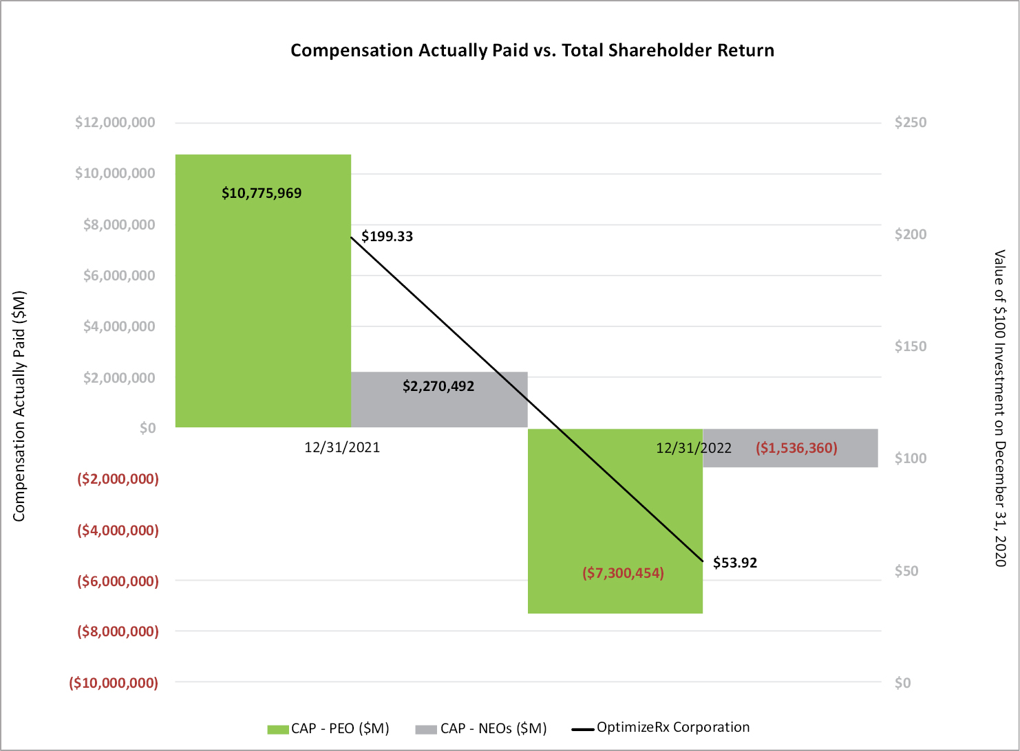
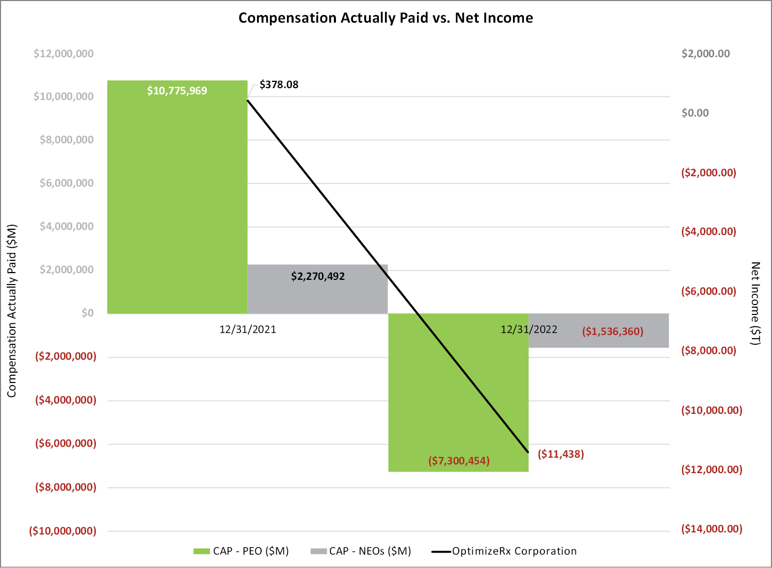
33
Table of Contents
CERTAIN RELATIONSHIPS AND RELATED TRANSACTIONS
Our Policy on Related Party Transactions
In June 2021, the Company adopted a written Related Person Transaction Policy to govern the procedures for review and consideration of all related party transactions.
The Related Person Transaction Policy applies to any transaction in which OptimizeRx is a participant, the amount involved exceeds $120,000 and a related party has or will have a direct or indirect material interest. A related party means any director or executive officer, any nominee for director, any stockholder known to OptimizeRx to be the beneficial owner of more than 5% of any class of the Company’s voting securities, any immediate family member of any such persons, any entity in which any of such persons is employed or occupies a similar position, and any entity in which any of such persons has a direct or indirect ownership interest in such entity that, when aggregated with the ownership interests of all the persons identified above, amounts to a 10% or greater ownership interest.
It is the responsibility of the Audit Committee to review related party transactions and approve, ratify, revise or reject such transactions. It is our policy to enter into or ratify related party transactions only when it is determined that the related party transaction in question is in, or is not inconsistent with, the best interests of OptimizeRx and its stockholders. In determining whether to approve or ratify a related party transaction, the Audit Committee may consider, among other factors it deems appropriate, whether the proposed transaction would occur in the ordinary course of business; the purpose and benefits of the proposed transaction to OptimizeRx; the terms and conditions of the proposed transaction; and the terms and conditions available to unrelated third parties in arms-length negotiations in respect of similar transactions. No director may participate in the deliberations or vote regarding a transaction in which the director, or a member of the director’s immediate family, has a direct or indirect interest.
Under our Related Person Transaction Policy, certain types of transactions are deemed to be pre-approved, including compensation of executive officers and directors approved by the Compensation Committee and transactions involving competitive bids or at rates fixed by governmental authority.
Related Party Transactions
James Lang, one of our Board Members, is the Chief Executive Officer of EVERSANA, a leading provider of global commercialization services to the life science industry. OptimizeRx has entered into a Reseller Agreement with EVERSANA whereby EVERSANA may offer OptimizeRx solutions to its life sciences customers from which we generate revenue. During the years ended December 31, 2022 and December 31, 2021, respectively, we recognized $401,972 and $218,333 in revenue from OptimizeRx solutions sold by EVERSANA to its life sciences customers. Each opportunity sourced by EVERSANA was reviewed and approved by the Audit Committee. In the opinion of the Audit Committee, the contracts are at market rates, were generated in the normal course of business and are no less favorable than those which could have been obtained from an unaffiliated party.
34
Table of Contents
PROPOSAL NO. 2
ADVISORY VOTE ON EXECUTIVE COMPENSATION
As required by Section 14A of the Exchange Act, we are asking our stockholders to vote to approve, on an advisory (non-binding) basis, the compensation of our named executive officers as disclosed in this proxy statement. This proposal, commonly known as a ”say on pay” proposal, gives our stockholders the opportunity to express their views on the compensation of our named executive officers. This vote is not intended to address any specific item of compensation, but rather the overall compensation of our named executive officers described in this proxy statement. Accordingly, the following resolution is submitted for stockholder vote at the annual meeting:
“RESOLVED, that the compensation paid to the Company’s named executive officers, as disclosed in this Proxy Statement pursuant to applicable SEC rules, including the compensation tables and any related narrative discussion, is hereby APPROVED.”
The ”say on pay” vote is advisory, and therefore not binding on the Company, the Compensation Committee or our Board. Our Board and our Compensation Committee value the opinion of our stockholders and to the extent there is any significant vote against the compensation of our named executive officers as disclosed in this proxy statement, we will consider our stockholders’ concerns and the Compensation Committee will evaluate whether any actions are necessary to address those concerns.
In keeping with the preference expressed by our stockholders at our 2021 Annual Meeting of Stockholders, our Board has adopted a policy of holding say-on-pay votes every year until the Company is required to hold another advisory vote on the frequency of say-on-pay votes, which will occur no later than our 2027 Annual Meeting of Stockholders. The next say-on-pay vote will occur at our 2024 Annual Meeting of Stockholders.
THE BOARD RECOMMENDS A VOTE “FOR” THE APPROVAL, ON AN ADVISORY
BASIS, OF THE COMPENSATION OF OUR NAMED EXECUTIVE OFFICERS,
AS DESCRIBED IN THIS PROXY STATEMENT PURSUANT TO SEC RULES.
35
Table of Contents
INFORMATION REGARDING SECURITY HOLDERS
Security Ownership of Management
Set forth below is certain information with respect to the beneficial ownership of our common stock as of the record date by each director, each named executive officer, and by all of our directors and executive officers as a group. As of the record date, 17,120,543 shares of our common stock were outstanding. Unless otherwise indicated, each person or member of the group listed has sole voting and investment power with respect to the shares of common stock listed. The address of each person named in this table is c/o OptimizeRx Corp., 400 Water Street, Suite 200, Rochester, MI 48307.
Name of Beneficial Owner |  | Amount and Nature of  Beneficial  Ownership(1)(2)(3) |  | Percent(1)
William J. Febbo |  | 471,396 |  | 2.8 | %
Edward Stelmakh |  | 13,079 |  | *
Stephen L. Silvestro |  | 34,041 |  | *
Gus D. Halas |  | 70,865 |  | *
James Lang |  | 44,697 |  | *
Patrick Spangler |  | 22,120 |  | *
Lynn O’Connor Vos |  | 39,427 |  | *
Gregory D. Wasson |  | 23,968 |  | *
All current directors and executive officers as a group (11 persons) |  | 757,565 |  | 4.4 | %
____________
* Denotes less than 1%.
(1) The securities “beneficially owned” by a person are determined in accordance with the definition of “beneficial ownership” set forth in the regulations of the SEC and, accordingly, may include securities owned by or for, among others, the spouse, children or certain other relatives of such person as well as other securities as to which the person has or shares voting or investment power. The same shares may be beneficially owned by more than one person. Shares of common stock currently issuable or issuable within 60 days of the record date upon the exercise of options or vesting of restricted stock units are deemed to be outstanding in computing the beneficial ownership and percentage of beneficial ownership of the person holding such securities, but they are not deemed to be outstanding in computing the percentage of beneficial ownership of any other person. Beneficial ownership does not include stock options and restricted stock units which have not vested as of, and will not vest within 60 days of, the record date. Beneficial ownership may be disclaimed as to certain of the securities.
(2) Includes shares that could be acquired upon the exercise of stock options that are currently exercisable or exercisable within 60 days of the record date, as follows: 8,397 shares for Mr. Stelmakh; 29,582 shares for Mr. Silvestro; and 64,757 shares for all current directors and executive officers as a group.
(3) Includes shares that could be acquired upon the vesting of restricted stock units that will vest within 60 days of the record date, as follows 4,637 shares for Mr. Halas; 4,637 shares for Mr. Lang; 4,637 shares for Mr. Spangler; 4,637 shares for Ms. Vos; 4,637 shares for Mr. Wasson; and 23,185 shares for all current directors and executive officers as a group.
36
Table of Contents
Principal Security Holders
The following table sets forth information regarding persons or entities that, to the best of our knowledge, are beneficial owners of more than 5% of our outstanding common stock.
Name and Address of Beneficial Owner |  | Amount and  nature of  beneficial  ownership |  |  | Percentage  of Class(1)
BlackRock, Inc.  50 Hudson Yards  New York, NY 10001 |  | 1,041,738 | ​(2) |  | 6.1 | %
The Vanguard Group, Inc.  100 Vanguard Blvd.  Malvern, PA 19355 |  | 1,111,411 | ​(3) |  | 6.5 | %
____________
(1) Based on 17,120,543 shares of common stock outstanding as of the record date.
(2) The number of shares reported above is based solely on a Schedule 13G/A filed with the SEC on April 6, 2023 by BlackRock, Inc., referred to as “BlackRock,” on behalf of BlackRock and its subsidiaries. BlackRock reported that, as of March 31, 2023, it had sole voting power with respect to 1,034,726 shares of our common stock, sole dispositive power with respect to 1,041,738 shares of our common stock, and shared voting and dispositive power with respect to 0 shares of our common stock.
(3) The number of shares reported above is based solely on a Schedule 13G/A filed with the SEC on February 9, 2023 by The Vanguard Group, Inc., referred to as “Vanguard.” Vanguard reported that, as of December 31, 2022, it had sole voting power with respect to 0 shares of our common stock, sole dispositive power with respect to 1,067,308 shares of our common stock, shared voting power with respect to 30,162 shares of our common stock and shared dispositive power with respect to 44,103 shares of our common stock.
Delinquent Section 16(a) Reports
Section 16(a) of the Exchange Act and the regulations promulgated thereunder require our executive officers, directors and persons who beneficially own more than 10% of our common stock to file forms with the SEC to report their ownership of the Company’s shares and any changes in ownership. We have reviewed all forms filed electronically with the SEC during, and with respect to, fiscal 2022. Based on that review and written information given to us by all of our directors and executive officers, we believe that all of our directors, executive officers and holders of more than 10% of our stock filed on a timely basis all reports that they were required to file under Section 16(a) during fiscal 2022, except for a late Form 4 filed on March 30, 2023 for Edward Stelmakh to report the vesting of a restricted stock unit award and the concurrent disposition to the Company of shares to satisfy Mr. Stelmakh’s tax withholding obligation on October 11, 2022.
37
Table of Contents
PROPOSAL NO. 3
RATIFICATION OF UHY LLP AS INDEPENDENT
REGISTERED PUBLIC ACCOUNTING FIRM
Our independent registered public accounting firm for the fiscal year ended December 31, 2022 was the firm of UHY LLP (“UHY”). The Audit Committee has appointed UHY as our independent registered public accounting firm for the fiscal year ending December 31, 2023. A representative of UHY is expected to attend the annual meeting and to have the opportunity to make a statement, if he or she desires to do so, and is expected to be available to respond to appropriate questions submitted by stockholders in advance of the annual meeting.
The Audit Committee, with the endorsement of the Board, recommends that you ratify that appointment. Although ratification is not required by our bylaws or otherwise, we are submitting the selection of UHY to you for ratification as a matter of good corporate practice. If the selection is not ratified by a majority of the votes cast on this proposal at the annual meeting, our Audit Committee will consider whether it is appropriate to select another registered public accounting firm. Even if the selection is ratified, our Audit Committee in its discretion may select a different registered public accounting firm at any time during the year if it determines that such a change would be in the best interests of the Company and our stockholders.
The Board recommends a vote “FOR” the
ratification of the appointment of UHY AS the Company’s
independent registered public accounting firm for FISCAL 2023.
38
Table of Contents
Independent Registered Public Accountant Fee Information
Aggregate fees for professional services rendered by UHY to us as of and for the fiscal years ended December 31, 2022 and December 31, 2021 were:
Fiscal Year Ended December 31 |  | Audit Fees(a) |  |  | Audit-Related  Fees(a) |  |  | Tax Fees(a) |  | Other Fees(a)
2022 |  | $ | 353,000 |  | $ | 10,400 |  | — |  | —
2021 |  | $ | 389,500 |  | $ | 32,500 |  | — |  | —
____________
(a) The aggregate fees included in Audit Fees are fees billed for the fiscal years. The aggregate fees included in each of the other categories are fees billed in the fiscal years.
Audit Fees Audit fees were for professional services rendered for the audits of our annual financial statements and review of our quarterly financial statements.
Audit-Related Fees Audit-Related fees were for services relating to consent and review of registration statements and proxy statements filed by the Company with the SEC.
Tax Fees. UHY did not provide any tax services during the period.
All Other Fees. UHY did not provide any “other services” during the period.
The Audit Committee has considered and determined that the services provided by UHY are compatible with UHY maintaining its independence.
39
Table of Contents
Pre-Approval Policies and Procedures
The Audit Committee Charter provides that one of the Audit Committee’s responsibilities is the pre-approval of all audit and permitted non-audit services performed by the independent registered public accounting firm. Unless the specific service has been previously pre-approved with respect to that year, the Audit Committee must approve the permitted service before the independent registered public accounting firm is engaged to perform it. The Audit Committee Charter also authorizes the Audit Committee to delegate to one or more of its members the authority to pre-approve all audit and permitted non-audit services. The Audit Committee and/or its delegate pre-approved all of the audit and audit-related services provided by our independent registered public accounting firm to us during the fiscal years ended December 31, 2022 and December 31, 2021.
40
Table of Contents
REPORT OF THE AUDIT COMMITTEE
The Audit Committee reviews the Company’s financial reporting processes on behalf of the Board. Management is responsible for the financial statements and the reporting processes, including the internal control over financial reporting. The Company’s independent registered public accounting firm, UHY, is responsible for expressing an opinion on the conformity of the audited financial statements with U.S. generally accepted accounting principles. The Audit Committee monitors these processes. The Audit Committee has reviewed and discussed the audited financial statements with management.
As required by the standards of the Public Company Accounting Oversight Board (“PCAOB”), the Audit Committee has discussed with UHY (i) the matters required to be discussed by the applicable requirements of the PCAOB and the SEC, and (ii) the independence of UHY from the Company and management. UHY has provided the Audit Committee the written disclosures and letters required by applicable requirements of the PCAOB regarding the independent accountant communicating with the Audit Committee concerning independence.
Based upon the review and discussions referred to above, the Audit Committee recommended to the Board, and the Board approved, the inclusion of the audited financial statements in the Company’s Annual Report on Form 10-K for the fiscal year ended December 31, 2022 for filing with the SEC.
The Audit Committee:
Patrick Spangler, Chair
Gus D. Halas
Lynn O’Connor Vos
41
Table of Contents
STOCKHOLDER PROPOSALS
The table below summarizes the requirements for stockholders who wish to submit proposals or director nominations for our 2024 Annual Meeting of Stockholders. Stockholders are encouraged to consult Rule 14a-8 of the Exchange Act and our bylaws, as appropriate, to see all applicable requirements.
 |  | Proposals for inclusion in  2024 Proxy Statement |  | Other proposals/nominees  to be presented at the  2024 Annual Meeting*
Type of proposal |  | SEC rules permit stockholders to submit proposals for inclusion in our 2024 proxy statement by satisfying the requirements set forth in Rule 14a-8 of the Exchange Act |  | Stockholders may present proposals or director nominations directly at the 2024 Annual Meeting (and not for inclusion in our proxy materials) by satisfying the requirements set forth in Article II, Section 2.13 of our bylaws**
When proposal must be received by OptimizeRx |  | No later than December 27, 2023 |  | Not earlier than the close of business on February 8, 2024 and not later than the close of business on March 9, 2024
Where to send |  | OptimizeRx Corporation, 400 Water Street, Suite 200, Rochester, MI 48307
What to include |  | The information required by Rule 14a-8 |  | The information required by our bylaws (which, if applicable, includes information required by Rule 14a-19)**
____________
* SEC rules permit management to vote proxies in its discretion in certain cases if the stockholder does not comply with this deadline, and in certain other cases notwithstanding the stockholder’s compliance with this deadline.
** Our bylaws are available on our website located at www.optimizerx.com under “Investor Relations—Governance.”
42
Table of Contents
OTHER MATTERS
As of the date of this proxy statement, no other matter is known which will be brought before the annual meeting. If any matter not described in this proxy statement is properly presented for a vote at the meeting, the persons named in the accompanying proxy card will vote in accordance with their best judgment and discretion.
HOUSEHOLDING
In accordance with notices previously sent to many stockholders who hold their shares through a broker, bank or other holder of record (“street-name stockholders”) and share a single address, only one annual report and proxy statement is being delivered to that address unless contrary instructions from any stockholder at that address were received. This practice, known as “householding,” is intended to reduce our printing and postage costs. However, any such street-name stockholder residing at the same address who wishes to receive a separate copy of this proxy statement or the accompanying annual report on Form 10-K may request a copy by contacting the broker, bank or other holder of record. Alternatively, we will promptly deliver a separate copy of either of such documents if a street-name stockholder contacts us either by calling (248) 651-6568 or by writing to OptimizeRx Corporation, 400 Water Street, Suite 200, Rochester, MI 48307 Attn: Corporate Secretary.
Street-name stockholders who are currently receiving householded materials may revoke their consent, and street-name stockholders who are not currently receiving householded materials may request householding of our future materials, by contacting Broadridge Financial Services, Inc., either by calling toll free at (866) 540-7095 or by writing to Broadridge, Householding Department, 51 Mercedes Way, Edgewood, New York 11717. If you revoke your consent, you will be removed from the “householding” program within 30 days of Broadridge’s receipt of your revocation, and each stockholder at your address will receive individual copies of our future materials.
43
Table of Contents
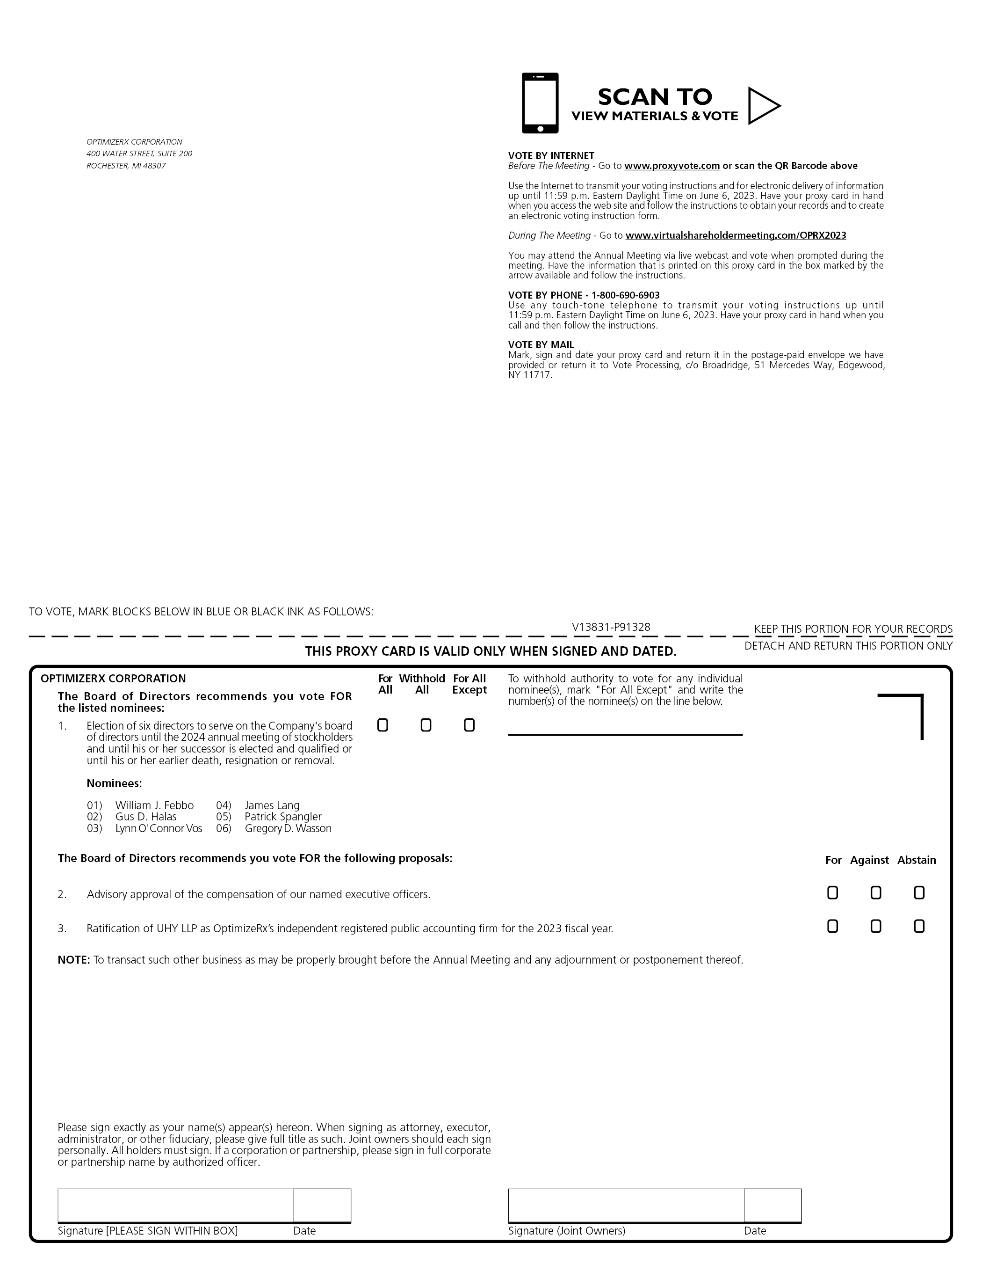
SCAN TO VIEW MATERIALS & VOTE OPTIMIZERX CORPORATION 400 WATER STREET, SUITE 200 VOTE BY INTERNET ROCHESTER, MI 48307 Before The Meeting - Go to www.proxyvote.com or scan the QR Barcode above Use the Internet to transmit your voting instructions and for electronic delivery of information up until 11:59 p.m. Eastern Daylight Time on June 6, 2023. Have your proxy card in hand when you access the web site and follow the instructions to obtain your records and to create an electronic voting instruction form. During The Meeting - Go to www.virtualshareholdermeeting.com/OPRX2023 You may attend the Annual Meeting via live webcast and vote when prompted during the meeting. Have the information that is printed on this proxy card in the box marked by the arrow available and follow the instructions. VOTE BY PHONE - 1-800-690-6903 Use any touch-tone telephone to transmit your voting instructions up until 11:59 p.m. Eastern Daylight Time on June 6, 2023. Have your proxy card in hand when you call and then follow the instructions. VOTE BY MAIL Mark, sign and date your proxy card and return it in the postage-paid envelope we have provided or return it to Vote Processing, c/o Broadridge, 51 Mercedes Way, Edgewood,NY 11717. V13831-P91328 OPTIMIZERX CORPORATION For With hold For All To withhold authority to vote for any individual All All Except nominee(s), mark “For All Except” and write the The Board of Directors recommends you vote FOR number(s) of the nominee(s) on the line below. the listed nominees: 1.Election of six directors to serve on the Company’s board of directors until the 2024 annual meeting of stockholdersand until his or her successor is elected and qualified or until his or her earlier death, resignation or removal. Nominees: 01)William J. Febbo04)James Lang 02)Gus D. Halas05)Patrick Spangler 03)Lynn O’Connor Vos06)Gregory D. Wasson The Board of Directors recommends you vote FOR the following proposals: For Against Abstain 2.Advisory approval of the compensation of our named executive officers. 3.Ratification of UHY LLP as OptimizeRx’s independent registered public accounting firm for the 2023 fiscal year.!!! NOTE: To transact such other business as may be properly brought before the Annual Meeting and any adjournment or postponement thereof. Please sign exactly as your name(s) appear(s) hereon. When signing as attorney, executor, administrator, or other fiduciary, please give full title as such. Joint owners should each sign personally. All holders must sign. If a corporation or partnership, please sign in full corporate or partnership name by authorized officer. Signature [PLEASE SIGN WITHIN BOX] Date Signature (Joint Owners) Date

Table of Contents
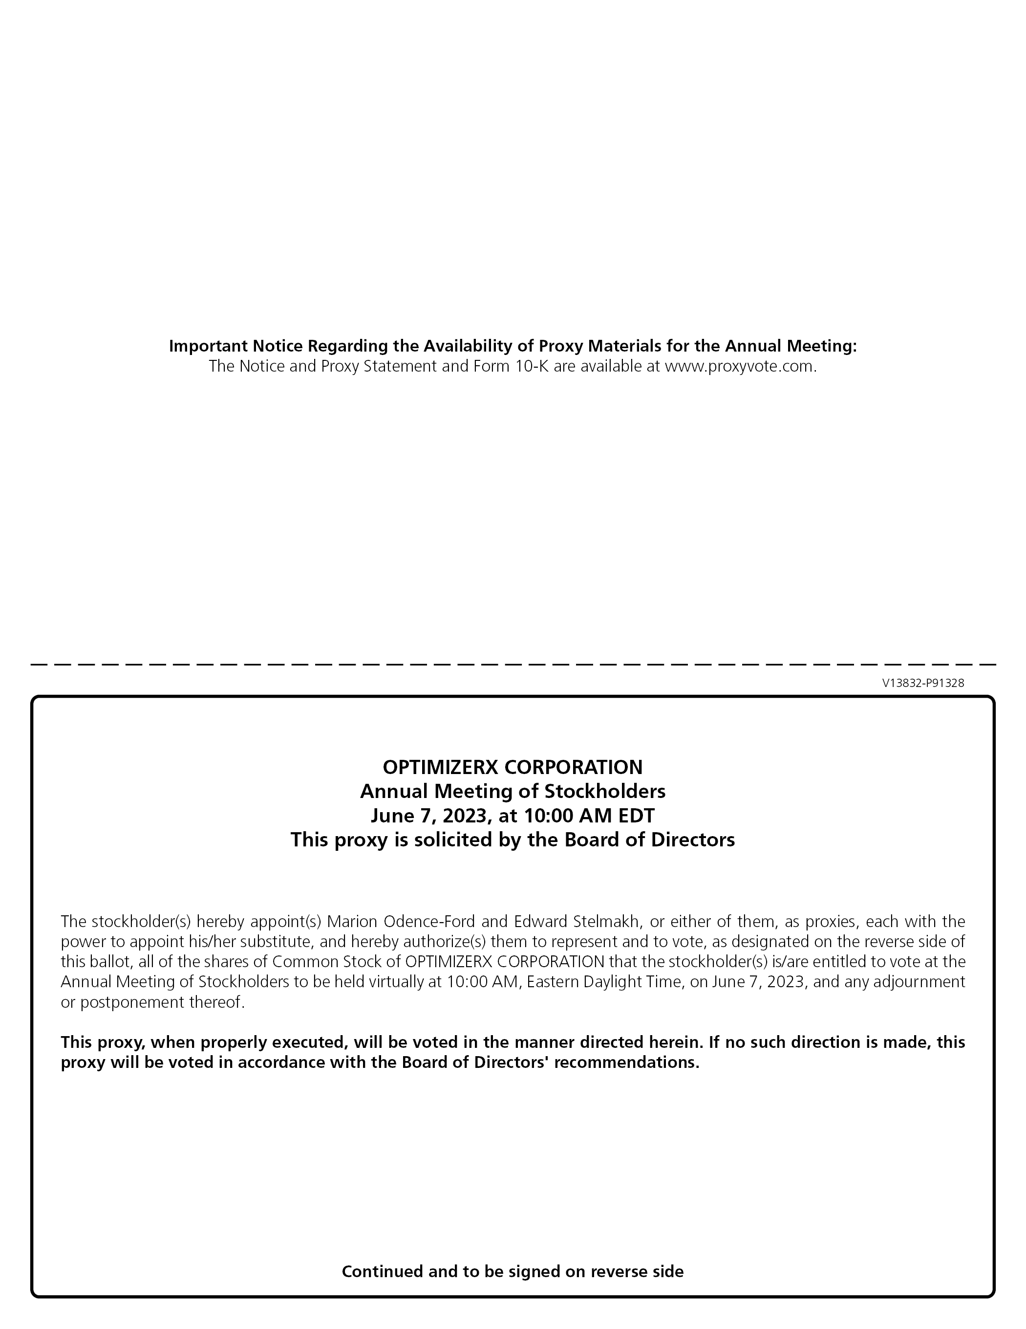
Important Notice Regarding the Availability of Proxy Materials for the Annual Meeting: The Notice and Proxy Statement and Form 10-K are available at www.proxyvote.com. V13832-P91328 OPTIMIZERX CORPORATION Annual Meeting of Stockholders June 7, 2023, at 10:00 AM EDT This proxy is solicited by the Board of Directors The stockholder(s) hereby appoint(s) Marion Odence-Ford and Edward Stelmakh, or either of them, as proxies, each with the power to appoint his/her substitute, and hereby authorize(s) them to represent and to vote, as designated on the reverse side of this ballot, all of the shares of Common Stock of OPTIMIZERX CORPORATION that the stockholder(s) is/are entitled to vote at the Annual Meeting of Stockholders to be held virtually at 10:00 AM, Eastern Daylight Time, on June 7, 2023, and any adjournment or postponement thereof. This proxy, when properly executed, will be voted in the manner directed herein. If no such direction is made, this proxy will be voted in accordance with the Board of Directors’ recommendations. Continued and to be signed on reverse side

