SEC Form 3
FORM 3 | UNITED STATES SECURITIES AND EXCHANGE COMMISSION
 | Washington, D.C. 20549
 | Washington, D.C. 20549 |  | OMB APPROVAL
 | INITIAL STATEMENT OF BENEFICIAL OWNERSHIP OF SECURITIES
 | INITIAL STATEMENT OF BENEFICIAL OWNERSHIP OF SECURITIES |  | OMB Number: | 3235-0104
 |  |  | Estimated average burden
 | Filed pursuant to Section 16(a) of the Securities Exchange Act of 1934 |  | hours per response: | 0.5
or Section 30(h) of the Investment Company Act of 1940
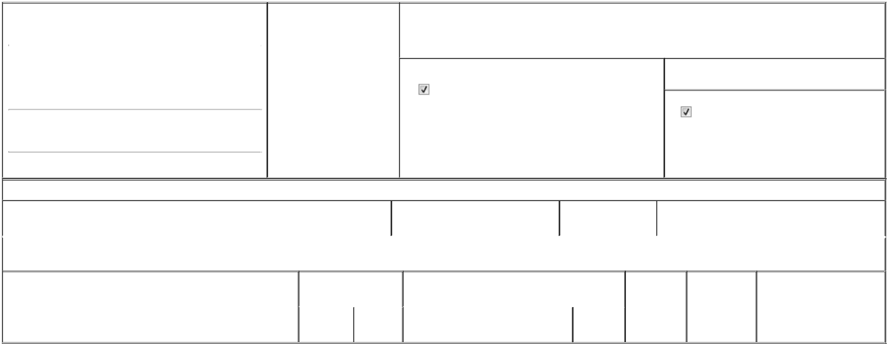

1. Name and Address of Reporting Person* |  |  |  |  |  | 2. Date of Event Requiring
 |  | Presti Mariyamma Varghese |  |  |  | Statement (Month/Day/Year)
 |  |  |  |  | 04/03/2026
 |  | (Last) | (First) |  | (Middle)

3. Issuer Name and Ticker or Trading Symbol

OptimizeRx Corp [ OPRX ]

C/O OPTIMIZERX CORPORATION
260 CHARLES STREET, SUITE 302
(Street)
WALTHAM | MA | 02453

- Relationship of Reporting Person(s) to Issuer (Check all applicable)

Director | 10% Owner
Officer (give title | Other (specify below)
below) | Other (specify below)

- If Amendment, Date of Original Filed (Month/Day/Year)

- Individual or Joint/Group Filing (Check Applicable Line)

Form filed by One Reporting Person

Form filed by More than One Reporting Person

(City) (State) (Zip)

Table I - Non-Derivative Securities Beneficially Owned

 | 1. Title of Security (Instr. 4) | 2. Amount of Securities Beneficially | 3. Ownership Form: | 4. Nature of Indirect Beneficial Ownership (Instr. 5)
 |  | Owned (Instr. 4) | Direct (D) or Indirect
 |  |  | (I) (Instr. 5)

Table II - Derivative Securities Beneficially Owned

(e.g., puts, calls, warrants, options, convertible securities)

1. Title of Derivative Security (Instr. 4) | 2. Date Exercisable and |  | 3. Title and Amount of Securities Underlying |  | 4. | 5. Ownership | 6. Nature of Indirect Beneficial
 | Expiration Date |  | Derivative Security (Instr. 4) |  | Conversion | Form: Direct | Ownership (Instr. 5)
 | (Month/Day/Year) |  |  |  | or Exercise | (D) or Indirect
 |  |  |  |  | Price of | (I) (Instr. 5)
 |  |  |  | Amount or | Price of | (I) (Instr. 5)
 |  |  |  | Amount or | Derivative
 | Date | Expiration | Title | Number of | Security
 | Exercisable | Date | Title | Shares

Explanation of Responses:

Remarks:

The filing of this Statement shall not be construed as an admission (a) that the person filing this Statement is, for the purposes of Section 16 of the Securities Exchange Act of 1934, as amended, the beneficial owner of any equity securities covered by this Statement, or (b) that this Statement is legally required to be filed by such person.

No securities are beneficially owned.

/s/ Marion Odence-Ford, by Power of

Attorney

** Signature of Reporting Person

Reminder: Report on a separate line for each class of securities beneficially owned directly or indirectly.

* If the form is filed by more than one reporting person, see Instruction 5 (b)(v).

- Intentional misstatements or omissions of facts constitute Federal Criminal Violations See 18 U.S.C. 1001 and 15 U.S.C. 78ff(a). Note: File three copies of this Form, one of which must be manually signed. If space is insufficient, see Instruction 6 for procedure.
Persons who respond to the collection of information contained in this form are not required to respond unless the form displays a currently valid OMB Number.

04/22/2026

Date



