SECURITIES AND EXCHANGE COMMISSION

WASHINGTON, D.C. 20549

 |  |  |  | FORM 8-K
 |  |  |  | CURRENT REPORT
 |  |  | PURSUANT TO SECTION 13 OR 15(d) OF
 |  | THE SECURITIES EXCHANGE ACT OF 1934
 | Date of Report (Date of earliest event reported): March 15, 2016
 |  |  |  | OptimizeRx Corporation
 |  | (Exact name of registrant as specified in its charter)
Nevada | 000-53605 |  |  |  |  |  |  |  |  | 26-1265381
(State or other jurisdiction |  |  | (Commission File Number) |  |  |  |  |  |  | (I.R.S. Employer
of incorporation) |  |  |  |  |  |  |  |  |  | Identification No.)
400 Water Street, Suite 200, Rochester, MI |  |  |  |  |  |  |  |  |  | 48307
(Address of principal executive offices) |  |  |  |  |  |  |  |  |  | (Zip Code)

Registrant’s telephone number, including area code: 248-651-6568

(Former name or former address, if changed since last report)

Check the appropriate box below if the Form 8-K filing is intended to simultaneously satisfy the filing obligation of the registrant under any of the following provisions:

- Written communications pursuant to Rule 425 under the Securities Act (17 CFR 230.425)

- Soliciting material pursuant to Rule 14a-12 under the Exchange Act (17 CFR 240.14a-12)

- Pre-commencement communications pursuant to Rule 14d-2(b) under the Exchange Act (17 CFR 240.14d-2(b))

- Pre-commencement communications pursuant to Rule 13e-4(c) under the Exchange Act (17 CFR 240.13e-4(c))

SECTION 7 – Regulation FD Disclosure

Item 7.01 Regulation FD Disclosure

On March 15, 2016, the Company made an investor presentation that included the slides furnished as Exhibit 99.1 to this Current Report on Form 8-K. The slides contained in Exhibit 99.1 are also posted on the Company’s website at www.optimizeRx.com.

The Company has prepared certain projections and assumptions with respect to the future operations of the Company in connection with the investor presentation furnished with this Current Report on Form 8-K. The Company undertakes no duty or obligation to update these projections and assumptions, or provide new projections and assumptions, with respect to its operations in the future.

The projections and assumptions contain forward-looking statements within the meaning of Section 27A of the Securities Act, and Section 21E of the Securities Exchange Act of 1934, as amended. These forward-looking statements are subject to risks and uncertainties that could cause actual results to differ materially from those projected. Further information on factors that could affect the Company’s financial and other results is set forth in the projections and assumptions and included in the Company’s Forms 10-Q and 10-K, filed with the Securities and Exchange Commission.

The information in Item 7.01 of this Current Report on Form 8-K (including Exhibit 99.1) shall not be deemed “filed” for purposes of Section 18 of the Securities Exchange Act of 1934 (the “Exchange Act”) or otherwise subject to the liabilities of that section, nor shall it be deemed incorporated by reference in any filing under the Securities Act of 1933 or the Exchange Act, except as expressly set forth by specific reference in such a filing.

Section 8 – Other Events

Item 8.01 Other Events

On March 15, 2016, the Company held a conference call to discuss the Company’s 2015 year-end earnings and other matters of business, a transcript of which is furnished herewith as Exhibit 99.2 and is incorporated herein by reference.

The information in Item 8.01 of this Current Report on Form 8-K (including Exhibit 99.2) shall not be deemed “filed” for purposes of Section 18 of the Securities Exchange Act of 1934 (the “Exchange Act”) or otherwise subject to the liabilities of that section, nor shall it be deemed incorporated by reference in any filing under the Securities Act of 1933 or the Exchange Act, except as expressly set forth by specific reference in such a filing.

Section 9 – Financial Statements and Exhibits

Item 9.01 Financial Statements and Exhibits

99.1 | Investor presentation
99.2 | Conference call transcript dated March 15, 2016

2

SIGNATURES

Pursuant to the requirements of the Securities Exchange Act of 1934, the registrant has duly caused this report to be signed on its behalf by the undersigned hereunto duly authorized.

OptimizeRx Corporation

/s/ Doug Baker

Doug Baker

Chief Financial Officer

Date: March 17, 2016

3

Exhibit 99.1


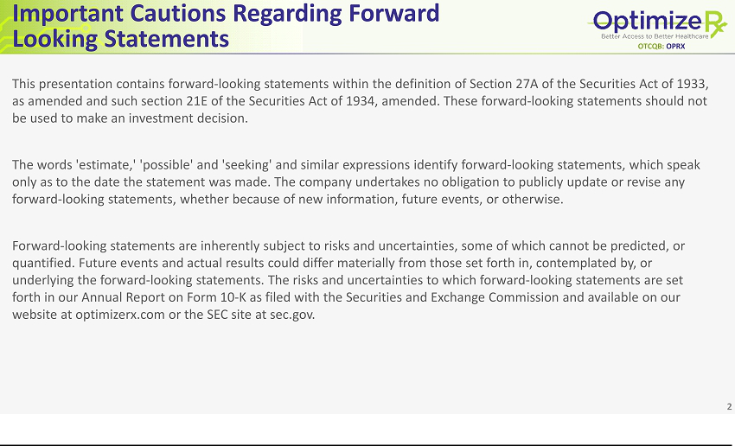

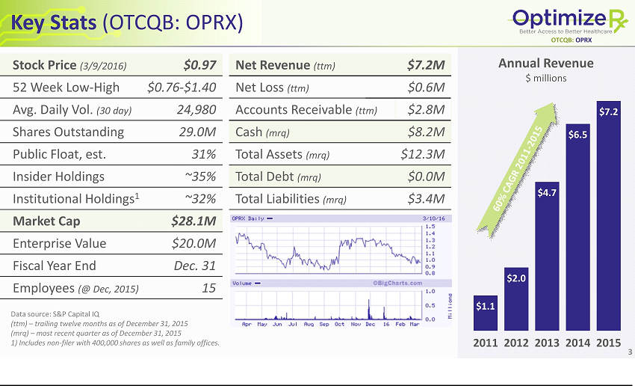

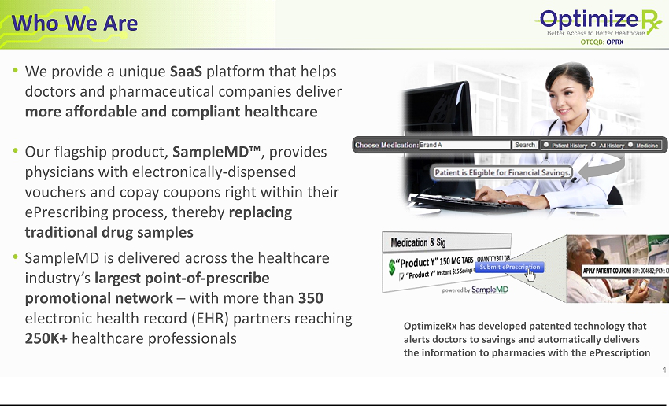

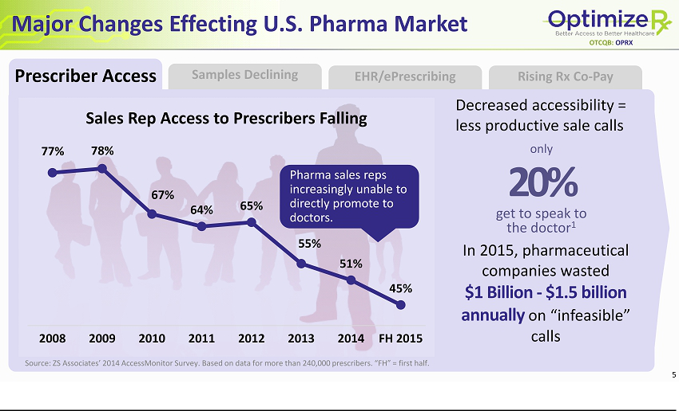

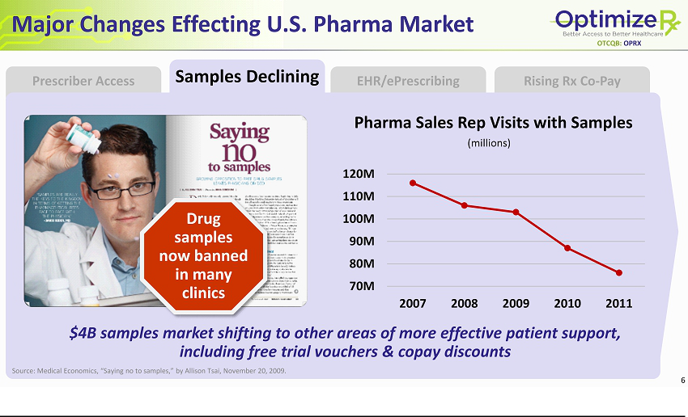

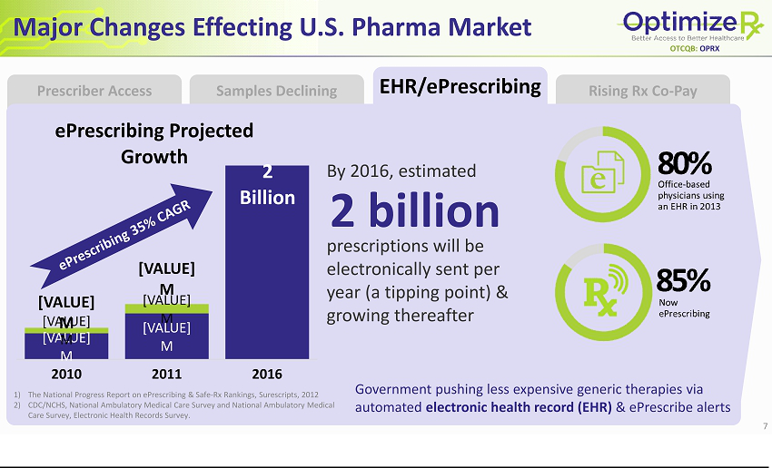

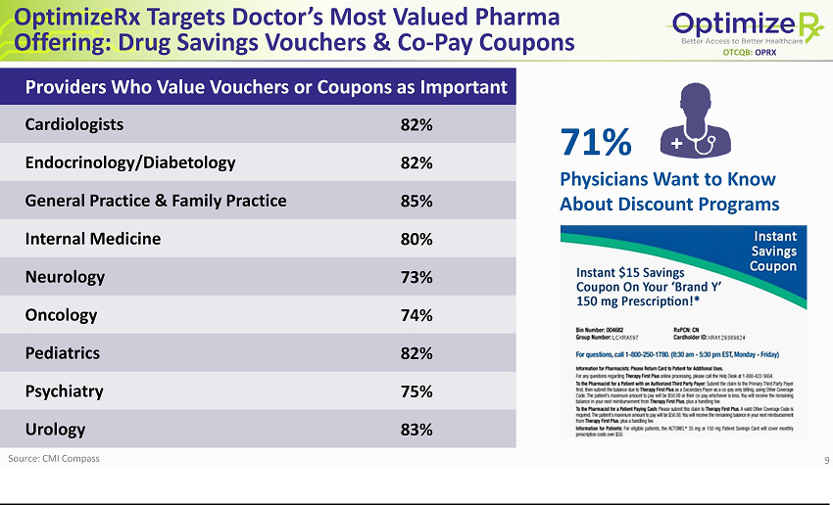

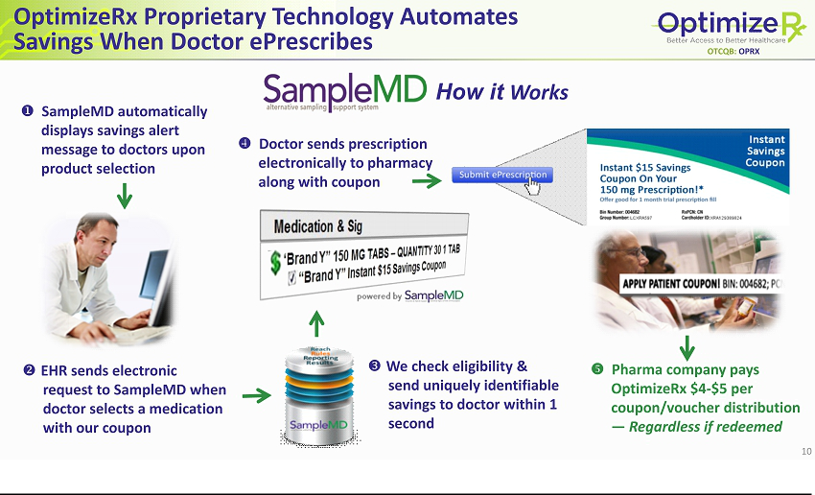

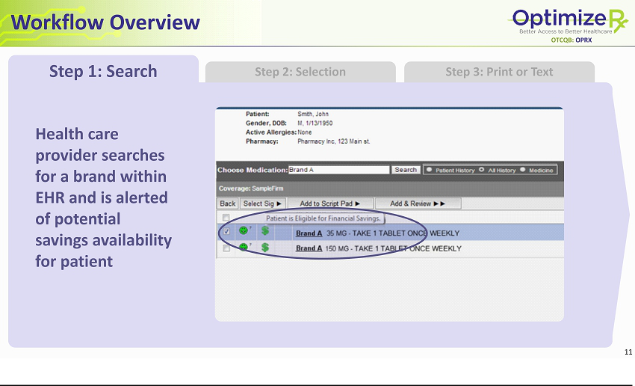

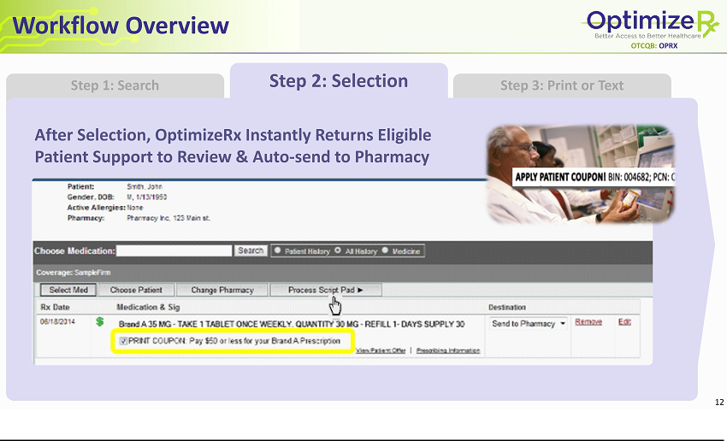

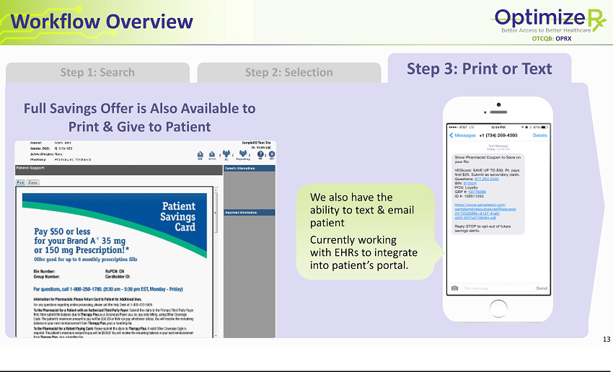

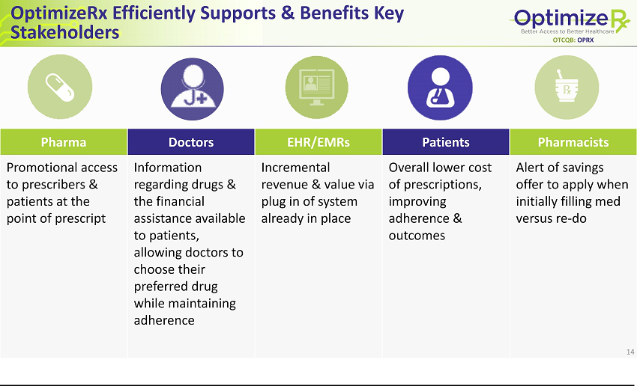

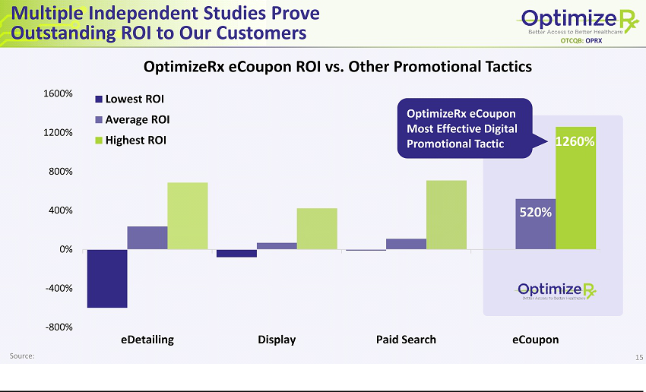

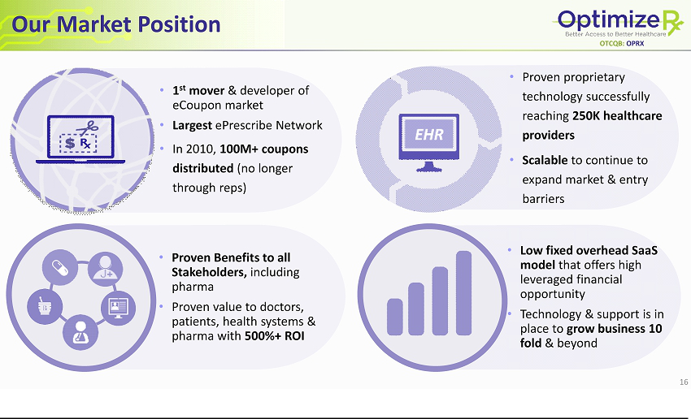

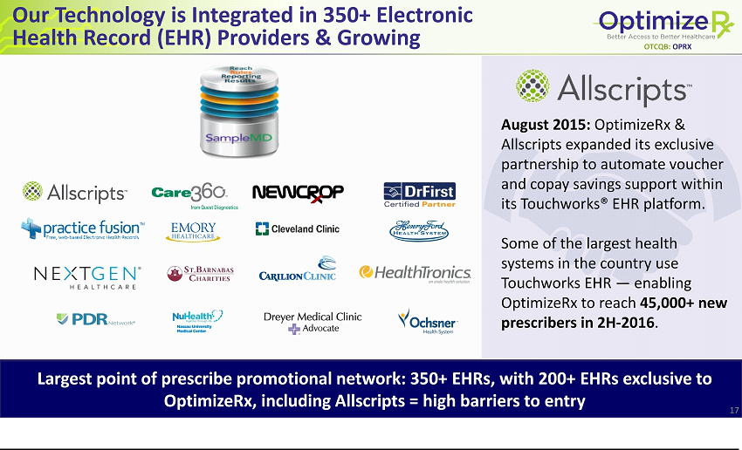

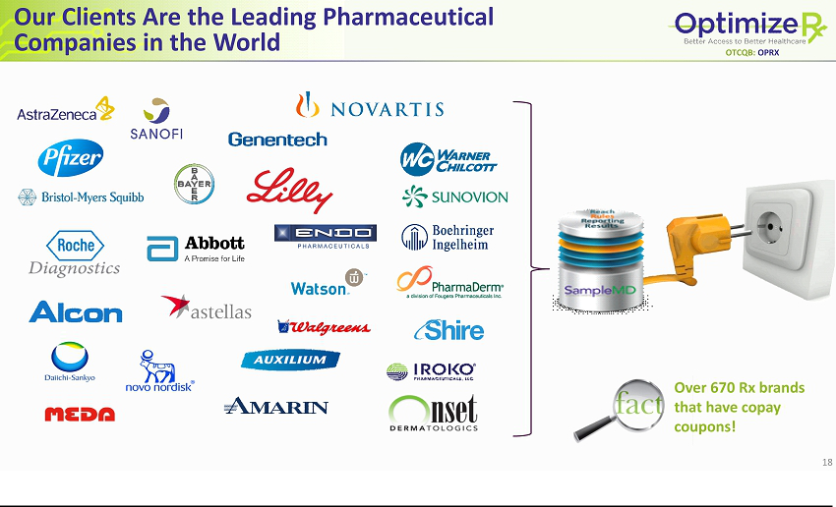

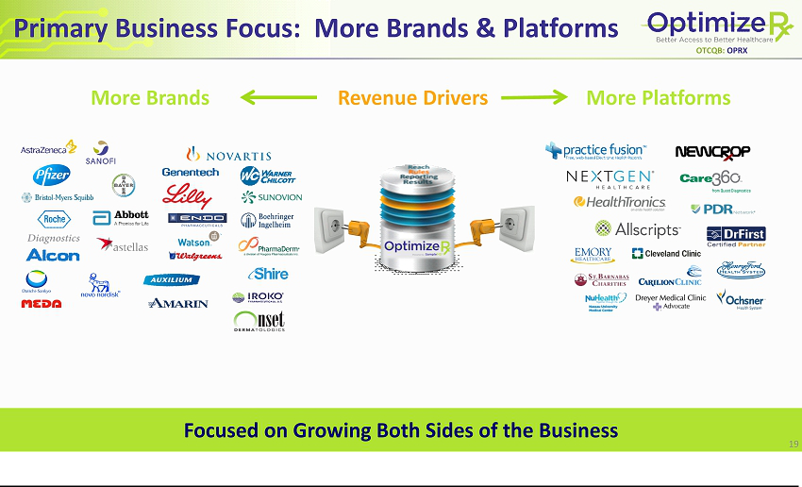

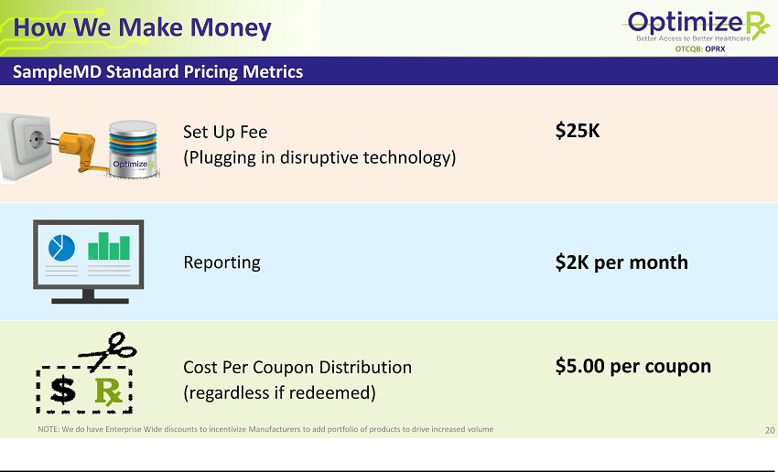

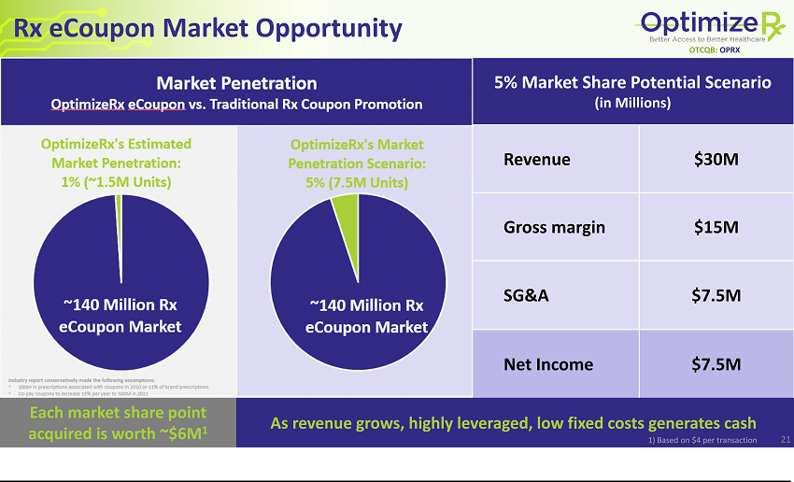

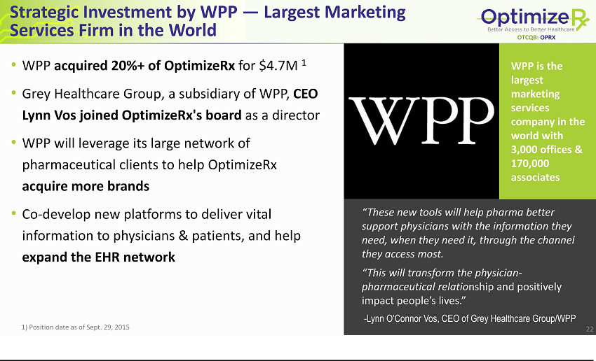

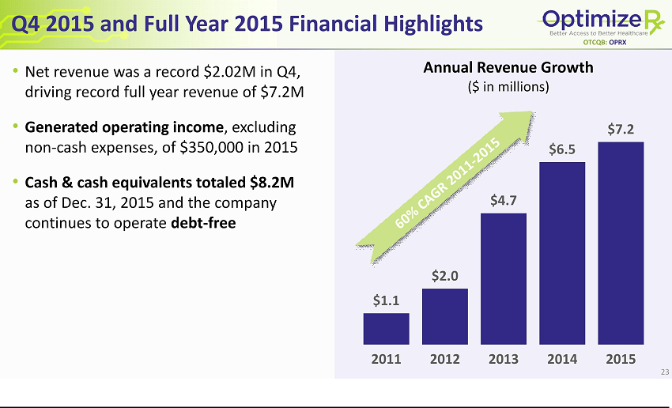

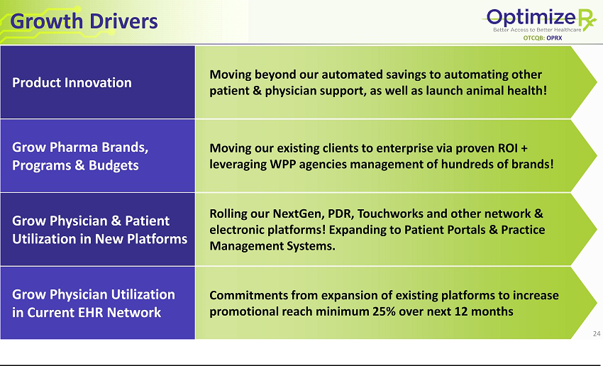

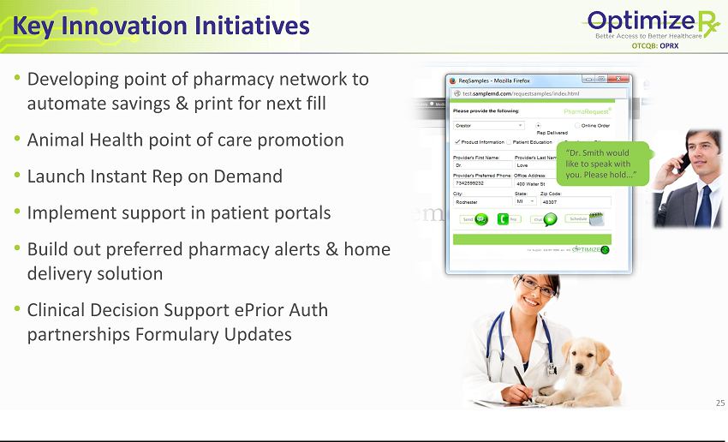

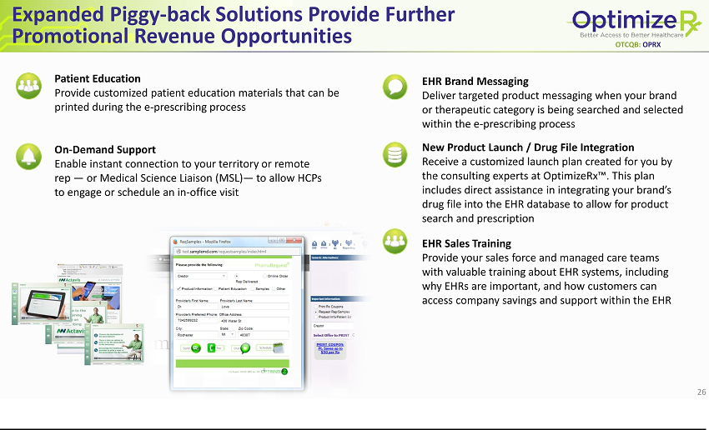

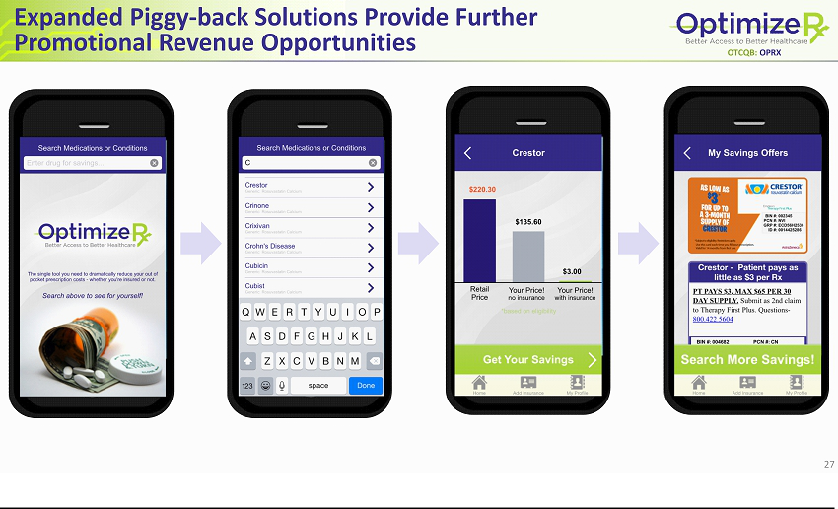

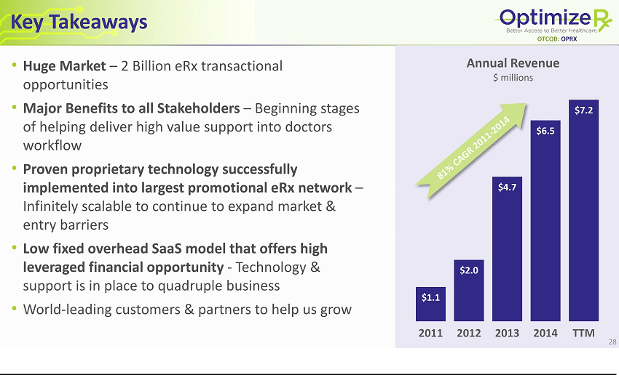

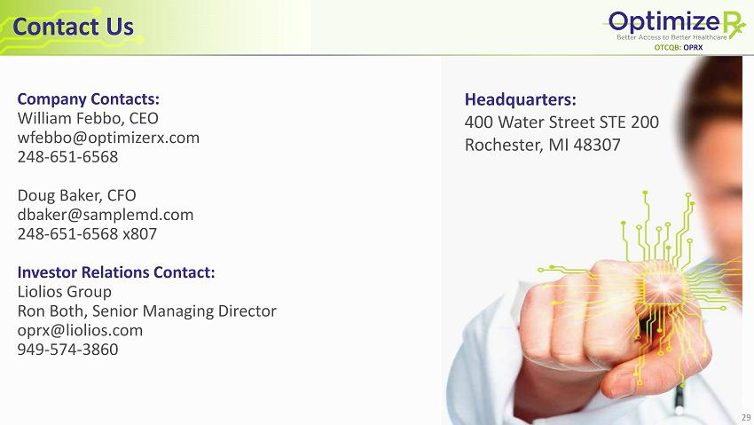

Exhibit 99.2
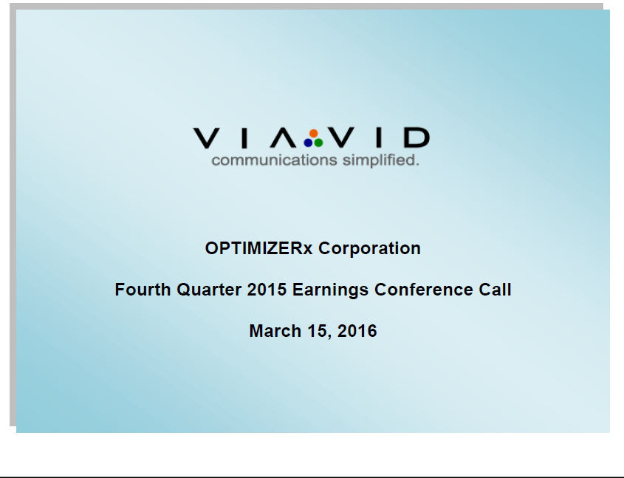

C O R P O R A T E P A R T I C I P A N T S

Doug Baker, Chief Financial Officer

David A. Harrell, Chairman & Founder

William J. Febbo, Chief Executive Officer

C O N F E R E N C E C A L L P A R T I C I P A N T S

Brian Murphy, Merriman Capital

Harvey Poppel, Poptech lp

Neal Feagans, Private Investor

Randy Rageth, Private Investor

Graham Jervis, Private Investor

P R E S E N T A T I O N

Operator:

Good afternoon and thank you for joining us today to discuss OPTIMIZERx’s fourth quarter and year-ended December 31, 2015. With us today are the Company’s Chairman, Dave Harrell; Chief Executive Officer, William Febbo; and its Chief Financial Officer, Doug Baker. Following their remarks, we will open the call to your questions.

Before we begin, I would like to read the Company’s safe harbor statements. Statements made by Management during today’s call may contain forward-looking statements within the definition of Section 27A of the Securities Act of 1933 as amended and Section 21E of the Securities Act of 1934 as amended. These forward-looking statements should not be used to make an investment decision. The words estimate, possible, and seeking, and similar expressions identify forward-looking statements and they speak only to the date the statement was made. The Company undertakes no obligation to publicly update or revise any forward-looking statements whether because of new information, future events, or otherwise. Forward-looking statements are inherently subject to risks and uncertainties, some of which cannot be predicted or quantified. Future events and actual results could differ materially from those set forth and contemplated by or underlying the forward-looking statements. The risks and uncertainties to which forward-looking statements are subject and could affect our business and financial results, are included in the Company’s Annual Report on Form 10-K for the fiscal year ended December 31, 2015. This form is available on the Company’s website and on the SEC website at sec.gov.

I would like to remind everyone that today’s call is being recorded and it will be available for replay through April 5th, starting later this evening. Please see today’s press release for replay instructions.

Now with that, I would like to turn the call over to the Chief Financial Officer of OPTIMIZERx, Mr. Doug Baker. Sir, please proceed.

ViaVid has made considerable efforts to provide an accurate transcription, there may be material errors, omissions, or inaccuracies in the reporting of the substance of the conference call. This transcript is being made available for information purposes only.

1-888-562-0262 1-604-929-1352 www.viavid.com

1

Doug Baker:

Thank you, Shannon and thank you everyone for joining us on today’s call to discuss our results for 2015. Before we get into the numbers, I’d like to begin by officially welcoming our new CEO, Will Febbo, who joined our team at the end of February. Will’s 18 years of experience and has proven leadership in technology and healthcare companies, made him the ideal candidate to lead us through our next stage of growth and development. Our Team in Michigan and our current Chairman and Former CEO, Dave Harrell, have worked to ensure a smooth transition for Will. In addition to his ongoing responsibilities as Chairman, Dave will continue to provide us management consulting on product innovation, business development, and market leadership over the next year. Following my financial review, Will is going to comment on our operational performance and provide our outlook for 2016.

Now, turning to our financial results for the quarter and year, our net revenue in the fourth quarter of 2015 increased to $2.02 million versus $1.97 million in the same year-ago quarter. Net revenue for the full-year was up 11% to a record $7.2 million. The increases in both periods were due to increased promotion of pharmaceutical brands and expanded distribution channels. I should note that we estimate revenue in 2015 would have been about $650,000 higher if it were not for one of our EHRs who focuses on urology turning off our program mid-year as a result of internal workflow issues at EHR. That would have resulted in an additional 10% growth. We are currently working with them to determine when they will be back online and anticipate the associated revenue will contribute significantly when they are back online in the second half of 2016.

Operating expenses in the fourth quarter of 2015 were $1.5 million as compared to $0.8 million in the year-ago quarter. The increase in expenses was primarily due to an exclusivity fee of $250,000 that we paid for development of the Allscripts Touchworks platform as well as exclusivity across all Allscripts platforms. The increase also reflects investments in our Executive and Sales Team. For full-year of 2015, our operating expenses decreased to $4.2 million from $4.3 million in 2014. For the full-year, our net loss totaled $0.6 million or $0.02 a share, an improvement from a net loss of $1.0 million or $0.04 a share in 2014. When removing the effective working capital fluctuations and cash flow from operations, we had income excluding non-cash expenses of approximately $350,000 in 2015.

Turning to the balance sheet, our cash and cash equivalents totaled $8.2 million at December 31, 2015, as compared to $3.4 million at December 31, 2014. The increase was primarily due to the strategic investment of $4.7 million by WPP as well as positive cash flow from operations of approximately $0.5 million. We also continue to operate debt free.

Now with that, I’d like to turn the call over to (inaudible) Dave.

David A. Harrell:

Thanks Doug and good afternoon everybody and welcome to our conference call. I also want to begin by welcoming and stating my excitement for Will coming on board as our new CEO. As Doug mentioned, Will has extensive (inaudible) both technology and healthcare and also has key roles that he’s led in the capital markets making him an ideal candidate to help us lead to the next stage of our (inaudible) at OPTIMIZERx. We have worked together again to ensure Will’s appointment as CEO, has maintained continued—continuing—continued operations at OPTIMIZERx and I will continue to directly support him moving forward. With his leadership and proven success, I have the utmost confidence that we will continue and accelerate OPTIMIZER’s delivery of best-in-class consumer and physicians’ platforms, as well as build shareholder value. I also look forward to being able to focus my passion to further innovate and connect OPTIMIZER to new partners and clients who seek a better way to deliver healthcare savings and support.

With that, I’m pleased to turn over the call to Will.

ViaVid has made considerable efforts to provide an accurate transcription, there may be material errors, omissions, or inaccuracies in the reporting of the substance of the conference call. This transcript is being made available for information purposes only.

1-888-562-0262 1-604-929-1352 www.viavid.com

2

William J. Febbo:

Thanks Dave and thanks everyone for joining us today, and actually Dave’s sitting here right next to me and once we get to questions you’ll hear more from him as well. But thanks for that intro, quite a buildup, I really appreciate the confidence.

Before I get into discussing our results, I’d first like to talk a little bit about what brought me to OPTIMIZERx. When I was first introduced to Dave and his Team, I couldn’t help but be impressed by their vision and especially their passion for helping pharmaceutical companies expand awareness and access to important medications and for helping doctors help patients better afford and comply with their prescriptions. In accomplishing this mission, I was amazed at how they had been able to deliver important product support and automate co-pay savings right within the physician’s electronic workflow while delivering a solid return on investment for their pharmaceutical clients.

Having worked with pharma clients for over 18 years, there has to be true value delivered to engage as many brands and companies as they have currently. As most of you know, I came over from Merriman Capital where as a COO I helped develop and lead discussions for WPP or Grey Healthcare Group Investment as a strategic investor. I saw Grey as a perfect strategic investor given their strong domain expertise, client reach, and especially their leadership team, which includes their CEO, Lynn Vos O’Connor who has recently joined our Board of Directors.

Following Lynn’s guidance, we plan to increase our activity within WPP’s group of companies which includes access to more than 300 brands. I’m glad to say we have already seen six new brands added to the mix and that will result in revenues of approximately $350,000 over the next six months. In joining our Board (inaudible) Lynn recognized as I did the market leadership OPTIMIZERx has established over a relatively short period of time and how the Company has accomplished this in partnership with some of the largest pharmaceutical companies in the world like Pfizer, Lilly, Novartis, Sanofi, and AstraZeneca, household names. These global market leaders have automated their co-pay savings and their trial voucher programs by using OPTIMIZERx proprietary on-demand content delivery platform. Through this platform they are able to reach more than 250,000 healthcare providers via our network of leading EHRs. Our platform allows these companies to address the fact that electronic prescriptions are likely to exceed 2 billion in 2016 as states move to e-prescription-only like New York you’ve seen in the paper recently, and that studies indicate that 80% of physicians are more likely to prescribe a drug that has a co-pay savings card versus one that doesn’t.

These market trends and growing demand by our big pharma partners was clearly evident in our most recent results for the year including more than 25% increase in promotional transactions which is our core product. These results also reflect the addition of more pharmaceutical manufacturers and brands for our SampleMD platform. In fact, we distributed e-coupons for 85 brands in 2015 which was up by more than 21%.

As many of you know though, our top line growth was not as high as previous years. This was due principally to two factors; longer sales cycles to close new brands and slower integration into the EHR partners. As a result, we plan to deploy our capital wisely and invest in expanding our sales team, leveraging our Partnerships like WPP and others, strengthening our marketing and continuing to innovate within the HER Partners by delivery technology solutions which reduce the integration time, a key factor in our growth.

ViaVid has made considerable efforts to provide an accurate transcription, there may be material errors, omissions, or inaccuracies in the reporting of the substance of the conference call. This transcript is being made available for information purposes only.

1-888-562-0262 1-604-929-1352 www.viavid.com

3

Also in 2015, we expanded our network of leading EHRs including the successful launch of our e-coupon solution by Practice Fusion which is the industry number one cloud-based EHR for doctors and patients. In the fourth quarter, we also became Allscripts’ exclusive provider of the e-coupons on all of its platforms including integrating our e-coupon solution with their Touchworks network. Touchworks is used by large health systems throughout the country. So, this represents a major expansion of our network. The integration of e-coupon functionality within Touchwork—Touchworks, sorry, is expected to launch on a test basis in late 2016 and then on a wider scale in early 2017.

In order to support our outreach to new age EHR providers and patient platforms, last quarter we appointed James Brooks in the new position of Senior Vice President of Business Development. James has executive sales and marketing experience and particularly with growing sales at Fortune 500 and electronic health record companies made him a great fit for OPTIMIZERx. He brings to us longstanding relationships with numerous EHRs which represent new opportunities for OPTIMIZERx integration and for us to reach more doctors and patients. James is now leading a new marketing effort designed to enhance our value proposition for both the EHR and pharma partners.

Aside from the WPP, one recent example of our increasing partnership reach is our new partnership with TrialCard which allows their pharmaceutical clients to incorporate our OPTIMIZERx service offering into their co-pay savings program. They are the second largest adjudicator in the market.

We had a great week last week in Vegas at the 2016 HIMSS conference which is where all the EHR partners gather, and it’s clear we have a seat at the table. As the market matures, we feel confident we can be best in class partner with the likes of Dr. Herst (phon), Allscripts, etc., so we all grow together. Tomorrow we will be presenting at the 28th Annual ROTH Conference being held at Dana Point, California. In fact, we are already here today to attend a number of one-on-one meetings with institutional investors and it’s been a busy day. For those of you unable to attend the event, you can watch our presentation via webcast at 11:30 Pacific Time. The webcast link is available in our ROTH Conference announcement.

In our ROTH presentation we will be talking about how in 2016 we’re planning to acquire, integrate, and expand into new promotional EHR and eRx platforms. We will also be talking about how we plan to expand our sales team and further leverage our strong channel partnerships. We continue to actively participate in industry and partner events. In fact we are sponsoring and assisting and leading the largest pharmaceutical EHR conference being held on March 21 and 22 in Philadelphia. In addition to sponsoring a conference, we’ll participate in key speaking, industry panel leadership and round table facilitation. This highly acclaimed forum serves as the only life science driven meeting tailored to this changing and expanding landscape.

As advances in health IT take healthcare provider engagement to the next level, this is a great opportunity to benchmark the position OPTIMIZERx as the trusted leader in EHR digital marketing solutions. Given our strong balance sheet, we are planning to make strategic investments designed to grow our pharmaceutical products and distribution network. We expect our distribution of e-coupons to grow significantly this year but we will also be focused on growing our clinical messaging and brand integration products and services.

While it is early for me to be giving specific growth forecast numbers, (inaudible) all the various activities between partnerships and investments and sales force, we expect (inaudible) top line growth well in excess of 2015’s modest growth.

ViaVid has made considerable efforts to provide an accurate transcription, there may be material errors, omissions, or inaccuracies in the reporting of the substance of the conference call. This transcript is being made available for information purposes only.

1-888-562-0262 1-604-929-1352 www.viavid.com

4

In summary, before we get to questions, we’re going to do four principle things. We are going to reinvigorate our revenue growth with a larger direct sales force, leveraging WPP relationships, and continuing to form partnerships that (inaudible) better access to brand managers. We will invest heavily in EHR partner space with leadership and technology and product extensions. The total projectable market is well over a billion (inaudible) front of us including e-coupon, messaging and brand launch services. There are 600 branded products of which we currently service 82. Given our lead and refreshed ownership and leadership, we feel very confident we can continue to be very relevant in this space. We want the market to think of OPTIMIZERx as the go-to-partner for communications between pharma, healthcare providers, pharmacies, and patients.

Now with that, I will open it up to questions.

Operator:

Thank you, sir. We will now begin the question-and-answer session. As a reminder, if you have a question, please press the star, followed by the one on your touchtone phone. If you’d like to withdraw your question please press the star, followed by the two. If you are using speaker equipment, you will need to lift the handset before making your corresponding selection. Once again that is star, one to ask a question at this time, and we’ll pause for just a moment while we assemble the queue.

We’ll take our first question from Brian Murphy with Merriman Capital.

Brian Murphy:

Thanks for taking my question. Hi Dave. Hi Doug and welcome (inaudible).

William J. Febbo:

Thank you, hey Brian.

Brian Murphy:

So, I guess at a high level, you guys are growing the top line double digits. You’re generating cash. But, you know, you’ve got $8 million on the balance sheet. I mean, you could easily double the expense base and yet still have in excess of two years’ of operating cash. I’m just wondering how you guys are thinking right now just big picture in terms of revenue growth versus profitability and cash flow, and maybe if you could just talk a little bit more about the kinds of levers you have to accelerate growth if you have the opportunity to.

David A. Harrell:

Sure. Will is taking a very strong look at what our projections are and seems to be very excited about that, but I can tell you that number one, we clearly see that we want to grow our revenue and really (inaudible) grab as much of this market in the next two years as we absolutely can, and so anything from a marketing, customer facing, account management, and promotional aspect, we will absolutely be gearing it up dramatically. We expect to certainly have profitable growth moving forward but the reality is, we want to grab this market, we want to leverage our leadership position and we certainly now with particularly WPP and some other key partnerships, are in a position to do that and we will invest appropriately.

Secondly, we think we have got some great technologies that are going to get actually reviewed fully through our partnership at WPP, and properly launched so that we can begin to expand some of those that Will mentioned. But clearly, you know, we do still want to run a tight ship but we don’t want to invest. The opportunity is too big to not fully invest and I think Will has seen and he brings a good perspective of it, and Will I will turn it over to you for any additional comments you have from that.

ViaVid has made considerable efforts to provide an accurate transcription, there may be material errors, omissions, or inaccuracies in the reporting of the substance of the conference call. This transcript is being made available for information purposes only.

1-888-562-0262 1-604-929-1352 www.viavid.com

5

William J. Febbo:

Yes. No, I think that’s a good summary, and investment is all about top line growth at this point, Brian. I think given our cash position, there’s less concern for profitability at this stage given how much of the market we still need to capture, and we will spend a lot of time in the next two months organizing our product set so that additional products can be sold to the same client base. Before I even joined, David already hired two Executives; one based in Michigan, one on the East Coast. James Brook was one of them on the East Coast and the other gentleman’s in Michigan to really help us streamline our account management and interaction with partners. They’re doing a great job and they are the newest of the team and very excited and we’re seeing results already.

We’ll plan to spend additional money over the next two months. Matter of fact we just had a sales person accept a position this week and we’re excited to get him going in the coming week, and I think having tried to build sales teams that sell to pharma, it’s—we really have a unique product that’s going to excite the best sales people, that have the best relationships, and then again this is why to be WPP was excited and Grey because we have a unique story, unique offering that offers a very clear value proposition to the clients. So yes, it’s all going to be sales and marketing focused and we’re excited to make the team bigger, and grow top line.

David A. Harrell:

Yes, and part of that too will be really putting in the right resource towards some of the key WPP agencies, some of the key partnerships like our recent announcement of TrialCard which is—just to give you a little color on TrialCard, TrialCard is one of the top-two largest backend processing companies that really manage programs for over 100 pharmaceutical brands. Certainly, we’ve worked with TrialCard and the other three big adjudicators like McKesson and PSKW and we’ll continue to, but they have basically looked at ways that they want to provide this as a general key offering that from their point of view every pharmaceutical client that they have should take advantage of. So again, we want to invest in these extremely powerful partnerships as well as invest to growing in our direct sales.

Brian Murphy:

Got it. That’s pretty helpful. And, just to follow up on WPP. I know that’s a very important strategic relationship for you guys. Can you maybe talk a little bit about how that arrangement is going so far, and maybe some color on what you think they can do for you?

William J. Febbo:

Sure. So—hold on, David wants to go first.

David A. Harrell:

Well, I want to go first because I—and I’ll turn it over to Will because I think this is a real advantage that Will brings in. I mean, I love the fact that he understands technology, I love the fact that he’s been in the healthcare pharmaceutical space, and I love the fact that WPP really likes him and was very supportive of him. So, the thing is Will has worked (inaudible) WPP and the organizations and I think that’s going to be a key focus for Will too, and I think before I turn it over to Will, up to this point we’ve had an outstanding engagement at the senior levels of each of the agencies and now the key component will be to pull that through at the account levels. So, we’ve had tremendous buy-in. We have seen some results already but I think Will’s focus and his team’s focus moving beyond here is to really pull that through so that we can get in front of these brands and really help prove our—help them understand our ROI that we’ve demonstrated and how they can leverage that as well.

So Will, I didn’t mean to interrupt you but I was really excited that you’ve had a great working relationships for over 15 years at WPP.

ViaVid has made considerable efforts to provide an accurate transcription, there may be material errors, omissions, or inaccuracies in the reporting of the substance of the conference call. This transcript is being made available for information purposes only.

1-888-562-0262 1-604-929-1352 www.viavid.com

6

William J. Febbo:

Yes and Brian just a little context. I know most of the investors who are in already know how that all happened, but the introduction of WPP into it is, they are a series—they are a holding company with lots of agencies and those agencies are critical to advising brand managers in healthcare and there’s several of them. So, from our perspective I’m going to treat each of those agencies within WPP as a client. As Dave said, we’ve already had top-level buy-in, we’ve had several meetings. We’re going to have another one coming up. We’ve seen results already. Some are ahead of the other groups and we’re going to work on getting them all equally producing, but the spirit is there and we’ll treat each one of them as individual clients and support it and hammer and close business together because it’s a win-win. They look good as an agency of record for any brand because they’re advising on a digital strategy, and our product is one of a kind. So it really—it’s a good value add to both sides.

Brian Murphy:

That’s great color. Thanks for that. Maybe just one more quick housekeeping question and then I’ll jump back in the queue. Can you tell me what the headcount is today and maybe where that could be at the end of the year?

William J. Febbo:

Yes, we’re around all in 14 and my guess is it we’ll be close to 20 by the yearend.

Brian Murphy:

Great. I’ll jump back in the queue. Thank you.

William J. Febbo:

Thank you.

Operator:

And as a reminder, that is star, one if you would like to queue for a question at this time. We’ll take our next question from Harvey Poppel with Poptech LP.

Harvey Poppel:

Yes, congratulations on coming on board Will.

William J. Febbo:

Thanks, Harvey. Good to hear you.

ViaVid has made considerable efforts to provide an accurate transcription, there may be material errors, omissions, or inaccuracies in the reporting of the substance of the conference call. This transcript is being made available for information purposes only.

1-888-562-0262 1-604-929-1352 www.viavid.com

7

Harvey Poppel:

Right. First question really is, it wasn’t clear from the public announcement of your arrival what Dave’s role might be going forward. Perhaps you could clarify that.

William J. Febbo:

Yes, so part of the early discussions in the winter when Dave and I were talking about this was he could not get far away. I wouldn’t take it if he did and that was a serious condition because, you know, from a perception standpoint and frankly just from a knowledge and leadership standpoint, I didn’t want that to happen and we agreed on that, and I think what we came down to is focusing on Dave’s strengths which is innovation, looking at strategic relationships that can really help grow revenue and also both on the pharma side and EHR side. So, moving to Chairman, I have full access to him at any point and I’ve seen nothing but since we started talking and I think we actually do very well together. We’ve had today with—one-on-ones with investors and it’s a good combination. I’m obviously new, so I’m still getting my arms around a lot but Dave is transferring everything. I have say the rest of the team is too. So, I expect to have full access to him for assessing things like animal health product development. Some of the other products in that we have a consumer app that we’ve done some early work on and really building out that business plan so that we can integrate it and grow it in a professional way.

David A. Harrell:

From my perspective too, I mean I think it’s a great role for me. You know classic, Founder both strengths and maybe some weaknesses to a point I think Will brings some refreshing viewpoints and I think it’s exactly perfect timing to come in. I think we’re well positioned from all aspects from not only our partnerships but our financial position to really look at some of these things from a new perspective and especially from somebody that has proven very strong operational performance. But again, my passion is to certainly get in front of as many pharmaceutical clients and EHR partners to not only look at the value that we’ve proven out on both sides of the fence, but looking at some of their other needs that can leverage our on-demand content delivery system. So again, I’m very excited about it. I think it’s something that’s going to make me actually potentially even a stronger ROI for the Company.

Harvey Poppel:

Great. I’m sure that’s very reassuring to investors who have known you and worked with you for a long time, Dave.

David A. Harrell:

Thank you.

Harvey Poppel:

A couple of specific questions, on the Touchworks deal, you indicated that’s really not going to start to cut in until late this year. Magnitude wise, just how big a deal is that relative to your existing base? Can you give us some sense of proportion?

ViaVid has made considerable efforts to provide an accurate transcription, there may be material errors, omissions, or inaccuracies in the reporting of the substance of the conference call. This transcript is being made available for information purposes only.

1-888-562-0262 1-604-929-1352 www.viavid.com

8

David A. Harrell:

Yes, I mean, it’s such an important new opportunity for us and it really distinguishes in the market. I can tell you that Touchworks is second only to epic in terms of these closed health systems that utilize their HER, and not every EHR is necessarily the same. Pharma companies love our reach, they have proven it across no matter what platform and they’re all in, but particularly those closed health systems, those are the real tough ones and Touchworks reaches an additional 50,000 doctors that their prescribing habits, they live in the HER. They don’t write handwritten as well as electronic prescriptions, and we looked at their utilization and it was between their other platforms, literally three times the size. So, that potential right there when launched could have a 25% increase on our business easy. The additional thing is once that’s ready to launch, there is going to be so many more brands that know that those closed health systems don’t take drugs samples, don’t see reps, and that’s going to be a huge driver for us not only in Touchworks but our network across the board too.

And, not to keep stammering too long though, again as Will mentioned too, we’re at the table with many of our other longer sales cycled EHRs who many of them invited us to meet with them at HIMSS Conference because they are starting to look at needs that they’re really not filling in. So, I think it’s a very exciting time and many of those groups are all involved in very large health systems.

William J. Febbo:

And Harvey, just—this is Will, just to add to it, I think part of the complexity of rapid growth versus steady growth is the integration process to EHRs, and it appears Allscripts we have tremendous relationship with them, we have generated a lot of revenue together, and them having it beta-tested in Q4 and then live in 2017 is no reflection of them not wanting us to get there sooner. It’s just in the queue—and this is true for integration work. So, one of the things and I mentioned it in my beginning comments is we’re going to work really hard at getting our technology to a point where the integration is simpler and we’re going to weight ROI decisions on how to get that up the queue on the list within our EMRs. It’s a big piece of the puzzle and the good news is as Dave said, I was blown away by everyone from Cerner to everybody. (Inaudible) and we have met with everybody and they all wanted to meet with us and sit down and it was very amicable and we talked about innovation together and these were people that are already generating revenues. So, it’s not just chit-chat, it’s actually real business, and I was blown away by the conference because it seemed like we actually were able to get some business done and not just spend three days walking around shaking hands. So, OPTIMIZERx has a seat at the table there it’s clear. It was good to feel.

Harvey Poppel:

Great. I had just a few more specific questions. It’s not clear to me when you refer to brand integration and clinical messaging I guess fell short of—from what you said in the press release in terms of revenue generation. But, it’s not clear to me or maybe other investors what that all means. What do those words mean in terms of what you do under the rubric of brand integration and clinical messaging?

David A. Harrell:

Yes, so first of all, that is a good question. I mean, last year for example we did approximately Doug and tell me if I’m wrong, about a million dollars in some of these programs that we’re talking about particularly in hoping drugs get integrated into the databases of these EHRs and doing some training programs to help them and managing any issues with drug brand launches. So, I mean, that’s a million dollars that frankly didn’t happen this year and one of the key growth opportunities that Will and certainly I have recognized, needs to happen.

The other opportunity though is more and more of our brands really want to not just do financial messaging, they want—which is our (inaudible) fund program, they want to do clinical messaging too, and we have great additional reach that beyond just their work with potentially an individual EHR that we can expand on where it might be talking about a new dose, a new indication, a new delivery system, etc., and that market currently is at least as big if not even bigger.

Harvey Poppel:

Okay.

ViaVid has made considerable efforts to provide an accurate transcription, there may be material errors, omissions, or inaccuracies in the reporting of the substance of the conference call. This transcript is being made available for information purposes only.

1-888-562-0262 1-604-929-1352 www.viavid.com

9

David A. Harrell:

So again, these are two areas that if we were to hit just the same numbers last year, these are key, and one last thing is, these are very complementary to our core financial messaging and that’s the key thing. It doesn’t distract us, it compliments us and it makes us a strong partner at the table.

David A. Harrell:

Yes. I would just add Harvey, you need to—for pharma to stay at the table, you need to be offering multiple services all around brand awareness. So, we will spend a lot of time in the next month or two with our friends we now know a lot of agencies, so our marketing is about to get a lot better, that will make the products more clear, distinguish the value proposition for each one but on the surface, the good news for the Company is they’re the same buyer, same client and it uses the same distribution and we have the technology. So, it’s really about getting organized around the value proposition for each, the pricing for some of the newer ones, and some branding.

Harvey Poppel:

Okay. Just continuing in that spirit then on TrialCard, those of us who are not familiar with that organization and what they do, it’s not clear to us exactly who’s going to do what for whom going forward and how that’s going to help the Company?

David A. Harrell:

Yes, TrialCard is—again as I mentioned, TrialCard is one of the top-three companies that manage the programs overall. They basically develop the co-pay programs, process the savings from the pharmacies and really are the overall managers of the programs. In turn, obviously we are one key channel, but in fact obviously a growing channel where they recognize that this is where the market’s going, and they approached us over the last four months and said listen we really want to partner with you. We want to make it easier for more of our brands that are currently not working with you because we have some brands that TrialCard happens to manage for them that the brands themselves directly went after and told them that we want to work with OPTIMIZERx. But instead they want to proactively go after these brands, and so I think again, these key partnerships like the WPP and TrialCard and some others that you’re going to be hearing, they really if they are properly managed, can really help us expand our marketing force out there because there’s no reason why any brand that has a co-pay savings shouldn’t be working with us. We just have to resonate the ROI, we have to make sure they know how to position us and ideally and I think your point Harvey in the past was get us in front of the clients and let us do it for them as their partners.

Harvey Poppel:

Okay. So, they’re basically in very, very simplistic terms an additional marketing channel, like a third party marketing channel?

David A. Harrell:

Absolutely.

Harvey Poppel:

Okay.

ViaVid has made considerable efforts to provide an accurate transcription, there may be material errors, omissions, or inaccuracies in the reporting of the substance of the conference call. This transcript is being made available for information purposes only.

1-888-562-0262 1-604-929-1352 www.viavid.com

10

David A. Harrell:

The best situation would be the WPP’s agency just talked about how great they are, OPTIMIZERx’s and the day after TrialCard manages our programs anyway, so yes, in fact you can work through us to integrate these same programs right through OPTIMIZERx to reach over 250,000 healthcare providers.

Harvey Poppel:

Okay, one final question then. Dave, you’ve been talking about products for the veterinary world for some time. I know you’ve had some out there in 2015. Do you see anything finally happening there that’s going to generate some substantial revenue going forward?

David A. Harrell:

Yes and again, thank you for bringing that up to and I will turn it over to Will on this but for a second too, but this market continues to just rear its head with huge-huge opportunity because it’s such—it leverages the exact technology that we do on the human health side. So, what I mean by that too it’s just a simpler market. There’s only four EHRs which really are called practice management systems that are key, maybe five. We’re talking to all of them, and there’s only about five key categories that matter for the high volume.

When we start looking at this, while we have got so much other opportunity but the reality is we built an initial team of key consultants that have guided us and opened us up to some very, very strategic discussions that I think will pan out beyond our pilot that just started live last month with the second largest health system. It’s a small pilot though, it’s about 20 clinics. So, I don’t want to overstate that. But, the reality is the—this has really got the attention of organizations like Patterson, Henry Schein, who are the largest distributors here who are saying, well we think we can help you, and so it’s a very exciting time not the steal Will’s point, I wanted to comment and he said that’s great but let’s develop a formal business plan, let’s look at exactly what kind of organization we need to build to support this. Let’s leverage Grey Healthcare and WPPs, client relationships are already on the (inaudible), and I think that’s exactly the types of things that we need Will to do.

William J. Febbo:

Yes. I think Dave covered it there, there is probably two or three things that we’re going to dive into deep and then come back to the market, but this one is, if you look it at a very simplistic level, it’s selling to pharma with our existing technology and it’s actually simpler because the buyer has both sides, both pharma relationship and practice management or EHR. So, definitely worth pursuing and the consultant team that’s been pulled together is excellent.

David A. Harrell:

I’d just like to piggyback when he says that, so if we could get a partner such as a Patterson and/or Henry Schein, I mean, they already have the pharma clients and they already have the veterinarians. So, the key is we want to work with them to leverage our technology almost like a licensing capability to bring better value to their veterinarians who are desperately looking for ways to protect their margin and keep their pharmacy in house.

Harvey Poppel:

Thank you very much. I will step away now. Thanks.

David A. Harrell:

Thanks, Harvey.

ViaVid has made considerable efforts to provide an accurate transcription, there may be material errors, omissions, or inaccuracies in the reporting of the substance of the conference call. This transcript is being made available for information purposes only.

1-888-562-0262 1-604-929-1352 www.viavid.com

11

Operator:

We’ll take a follow up from Brian Murphy with Merriman Capital.

Brian Murphy:

Thanks. How should we think about seasonality March to—December to March? Is it going to be similar to kind of what we saw last year?

David A. Harrell:

Yes, I mean, the seasonality aspect comes in is that some of these brands still are not finalizing their 2016 strategies. As crazy as that sounds, they’re late to get us assets. So, it’s always been a little bit less, you know what I mean, in terms of that. So, I don’t—and then they fully ramp up. They give us the insertion orders and you tend to lose in some brands some key times, and maybe that’s a point where we’re going have to start addressing it with as we get closer and closer to these agencies, and the fact that you can’t so don’t want to have that (inaudible) experience being interrupted. So, I would say that’s somewhat traditional.

Brian Murphy:

Okay great, and you know, you guys grew the number of brands, it looks like to 85 from 70 this year. It looks like your—the pharma customers that you did business with in 2015 was 25, it looks like it was the same as 2014, first are those all the same 25 customers?

David A. Harrell:

You know what, I’m not too sure about that. I think we have added some key ones, Teva’s coming on board now which is the largest generic company but they have key brands as well.

William J. Febbo:

No, it’s just churn. Some will drop off if they are acquired, you know that happens, but the number to watch is brand number because those are programs. You know you could—and as long as we’re not too heavy in one and we—part of the things that we’re reviewing now is end of patent life, where are we in that stage, we’re instituting a pretty heavy CRM, customer management platform so we can track everything very well and be ahead of it, and we’re also looking at as we’ve talked about, I’ve heard talked about before, I didn’t talk about it was a potential solution on the generics side. So, that as they go—as a drug goes through its phases of life, if you really want the longest tail for revenue, you need to be—you need the audit practice, the clinical and commercial messaging, and as it gets towards the end of its life, there is a whole another set of services that you need to deliver, and again this is where being part of an agency as you get baked into that process and while they may not have made their decisions win in pharma to say go, they have allocated the budgets and now they’re waiting for the agencies to propose how to actually spend it, and the good news is we’re getting integrated there.

David A. Harrell:

Yes, so I mean, the more brands we have, the less effect it will have. You’re always bringing in new brands that are blockbusters and you might lose some new ones. I can tell you too that kind of somewhat good news is that we ran out of some budget in December too, so were some key brands. So, we don’t want to act like could’ve, should’ve, would’ve but if we had some of our fall EHR channel working and didn’t already have the budgets filled and focus on some of the core additional businesses that we think we can easily can get back and leverage, I mean we certainly exceeded the numbers that we have.

ViaVid has made considerable efforts to provide an accurate transcription, there may be material errors, omissions, or inaccuracies in the reporting of the substance of the conference call. This transcript is being made available for information purposes only.

1-888-562-0262 1-604-929-1352 www.viavid.com

12

William J. Febbo:

Thanks, Brian. We got a couple of people in the queue, so we want to try to get a couple of more questions.

Brian Murphy:

Got it. Thank you.

William J. Febbo:

Thank you.

Operator:

We’ll take our next question from Neal Feagans, a Private Investor.

Neal Feagans:

Hey guys.

David A. Harrell:

Hey Neal.

William J. Febbo:

Hey Neal.

Neal Feagans:

Hey first of all, boy, what an informative call. This is great and a number of my questions have been mostly or partially answered. But, I was curious to understand a little bit about the revenue generation model for some of these other products and services. The coupons pretty cut and dry, on the veterinary opportunity and maybe specifically the test that you’re in now with some of these clinics, is it the same methodology? There’s a coupon and we do a revenue share with the EHR equivalent, and is that coupon being funded by the drug manufacturer or is it more or less identical to the human drug program?

David A. Harrell:

So, for the test what we did is we work with NVA who took funds out of their co-op money in most cases to get this up and it was kind of flat rate etc,. but the model will definitely be transactional based. Here is the beauty for the initial launch, we use what we call our desktop application. So, we don’t have to share any revenue and that’s going to be one key strategy (inaudible) as we look at even a human health side an opportunity too.

Neal Feagans:

Okay.

ViaVid has made considerable efforts to provide an accurate transcription, there may be material errors, omissions, or inaccuracies in the reporting of the substance of the conference call. This transcript is being made available for information purposes only.

1-888-562-0262 1-604-929-1352 www.viavid.com

13

David A. Harrell:

But looking forward, you’re absolutely right. When we look at integrating into the practice management, this is definitely a 50% revenue share. Now, what we asked our partners that were in discussions with is to help us assess what that is and that’s what the process how we’re looking at is. It’s not the same profitable market obviously from the client side. So—but it would be based on…

Neal Feagans:

Why is that Will, just because the drugs are way less expensive?

David A. Harrell:

Well this is Dave by the way. That’s okay. Yes, that’s exactly the key.

Neal Feagans:

Okay.

David A. Harrell:

The margins aren’t quite there but there is still a tremendous amount of sales and profits that we can generate from.

William J. Febbo:

Yes. Our cost of sales as a company is dramatically lower in that space just because as we described the partners we’ll end up working with most likely know both the veterinarian side and the pharma side. So, they have their own…

Neal Feagans:

So, the same driver though to the drug manufacturer that we have on the human drug?

David A. Harrell:

Absolutely. (Inaudible).

Neal Feagans:

The same rate of return argument prioritize your drug, keep the customer on your product, same basic premise as what we see with what you’re doing now with the human side.

David A. Harrell:

Maybe even more because of the price elasticity and sensitivity about the margin protection that the veterinarians are facing versus 1-800-Pet-Meds etc.

ViaVid has made considerable efforts to provide an accurate transcription, there may be material errors, omissions, or inaccuracies in the reporting of the substance of the conference call. This transcript is being made available for information purposes only.

1-888-562-0262 1-604-929-1352 www.viavid.com

14

Neal Feagans:

Okay. All right and then kind of a similar question. When you talk about—and you say that a priority in 2016, it’s a priority to get these brand integration products and clinical messaging products moving more aggressively. How do we get paid for example for clinical messaging, and if this is kind of a reciprocal benefit to the EHRs and the medical community for lack of a better word, is there not some incentive for them to help pay for and develop these technologies versus the coupon that I can see being in a different bucket. So, kind of a two part question, how do we get paid for a clinical message or a brand integration message, and is it us that’s going to fund developing and getting these technologies into the marketplace?

David A. Harrell:

So, first of all on the clinical messaging, that’s an add-on. We basically secure it for the EHRs that we have in our network and we help them implement it. So, it’s a similar type of message that pops up for them and that’s on…

Neal Feagans:

Do we get paid though if that message is delivered to a specific end user?

David A. Harrell:

Yes. So, it’s a cost per impression basis where ours is a cost per delivery basis. Interestingly enough it’s a little bit less than what we charge for financials but we deliver a better, confirmed value that the e-prescription was confirmed, sent with the coupon. So, that’s a little bit of a stronger value proposition. And, by the way when you’re selling both, it differentiates that value too by the way to the pharma companies even more. But, keep in mind most brands aren’t doing anything, but a lot of them are doing the clinical messaging even without the financial and the financial frankly is probably the most powerful message you can deliver. So, one of our strategies is go to the ones that are doing clinical messaging and say god bless you, but the reality is here is the ROI and financials so we’re all for the clinical, but you should be doing the financial. And, for the ones that are just doing the financials, we should say hey, you should do some testing here to see if there’s some clinical messaging that compliments it.

William J. Febbo:

And on the technology side to your question on the cost, so we have current capacity ourselves and with partners, but we will invest a little money this year in making it a broader and easily uploadable application. That’s not a heavy lift for us because it’s basically we know what to do and we know how to improve it, but it should accelerate revenue growth that’s why we’re doing it.

David A. Harrell:

We can deliver some of it right now.

Neal Feagans:

You’ve had a million messages delivered over our platform and you made x cents per message, that’s kind of the model?

David A. Harrell:

Yes it is.

Neal Feagans:

Okay.

ViaVid has made considerable efforts to provide an accurate transcription, there may be material errors, omissions, or inaccuracies in the reporting of the substance of the conference call. This transcript is being made available for information purposes only.

1-888-562-0262 1-604-929-1352 www.viavid.com

15

David A. Harrell:

It’s cost per impression just like any (inaudible) or anything.

Neal Feagans:

Right.

David A. Harrell:

Now, the drug file admission (phon) is a set fee where we offer anywhere from services where we’ll confirm which EHRs have UN (phon) versus not that might be like a $30,000 integration versus a full drug file management program not only will we help you get in there and leverage our relationships, we will manage any request that you have from reps, we will help train them to how the process can go. That can be anywhere up to $100,000.

Neal Feagans:

Okay.

David A. Harrell:

So, getting 10 of those would be nice stuff. I mean, if we would have 10 of those like we did, I think we had seven last year, we would have been—this call would have even been that much more pleasant you know what I mean. So…

Neal Feagans:

Well, let me ask you two more quick things that are unrelated. I think you said six new brands came from the WPP relationship and you were (inaudible) projecting—estimating $350,000 of additional revenue over the next 12 months is that correct?

David A. Harrell:

That’s over the next six months. So, they were smaller brands but we’re in the game and they are getting more and more used to dealing with us and that’s a great start and…

William J. Febbo:

It’s the tip of the iceberg.

David A. Harrell:

Most of them came from one agency, so we want to build on that and I think Will did a nice job of saying, hey, we’re working with your sister organizations and they see this as a huge strategic value to your client. Let’s share best practices and let’s invest in helping you be more successful with your clients.

Neal Feagans:

So, a blockbuster drug, if you were to land a new brand that had a $6 billion, $7 billion annual sales rate, I mean, you could be doing way more than $60,000 a year in coupon revenue.

ViaVid has made considerable efforts to provide an accurate transcription, there may be material errors, omissions, or inaccuracies in the reporting of the substance of the conference call. This transcript is being made available for information purposes only.

1-888-562-0262 1-604-929-1352 www.viavid.com

16

David A. Harrell:

We had a presentation last week for one drug that was over $1 million in revenue for us just on e-coupon, one drug.

Male Speaker:

Meeting went well…

Neal Feagans:

One more quick question and I don’t know right quite how to phrase it and I don’t have the correct name of the parties in front of me, but the lawsuit that we’ve been involved with where they’re not living up to their end of the agreement according to us yet we’re continuing to live up to our end of the agreement and pay them a substantial royalty. I’m not a patent expert but I know a lot of companies, if they feel they have a strong case, if they feel like it’s just patent trolling and part of this problem we have nationwide, is there any consideration being given to revisiting that, and any potential that we kind of do an about face and decide to stand down from writing them a check every month?

William J. Febbo:

So, this is Will, with his fresh perspective. Clearly he is looking to look at the—fully understand this but the reality of it is is that there is an opportunity for synergistic value and opportunity for both companies that were intended to be exceedingly stronger together, and we fully intend to make sure that we get the positive benefits out of that relationship that we saw, and there’s not a lot of things we can do to comment on it but that is absolutely one of the key focuses is to work with our legal department as well as the potential discussions that we can have and with the group to look at ways—the market is still so big that— why we entered in the agreement still makes complete sense. Yet we want to make sure we enforce what was intended so that both parties win.

Neal Feagans:

Okay. All right, well listen guys, I appreciate you taking my call. Good luck, it sounds like a really exciting almost kind of a pivotal year for the Company and you know my little request, keep us apprised of progress regularly during the quarter, don’t make us wait three months at a time to hear it all during one hour long call. So, thanks again.

David A. Harrell:

Okay. Thanks for your help and support.

Operator:

We’ll take our next question from Randy Rageth, a Private Investor.

Randy Rageth:

Yes, hello gentlemen.

William J. Febbo:

Hi, Randy.

ViaVid has made considerable efforts to provide an accurate transcription, there may be material errors, omissions, or inaccuracies in the reporting of the substance of the conference call. This transcript is being made available for information purposes only.

1-888-562-0262 1-604-929-1352 www.viavid.com

17

David A. Harrell:

Hey, Randy.

Randy Rageth:

So, quick question, so fourth quarter revenue ‘15 was essentially flat from fourth quarter ’14, yet we had about 10 new drugs. So, was the fourth quarter just kind of weak would you say, or what would you say to the…

David A. Harrell:

Well, I mean as we mentioned to you, we first of all had some—we had fulfilled some budgets so we’re always looking to get as we grow which we did on our EHR side, we need to make sure we have the correlating budgets which we are acquiring, and then the second thing is some of the programs still take upwards of a month or two to get fully up and ramped up so to speak, so I wouldn’t get too focused in that area. But again, our retainment of brands is very strong, as those brands get pushed in, we are not losing a lot of brands for any other reasons in most cases but patents, loss of patent—so, does that give you a little bit of color in there?

William J. Febbo:

You know, there will be some programs that are $300,000 in a month and some that are $50,000. So, it’s not a direct correlation to the numbers as to revenue growth, and as the new person I’ll get my head around that to see how I can do a better job communicating to the investors what it means when we bring on a new HR of 50,000 prescribers, what does it mean when we have a brand, how big is that brand. So I’ll—I’m going to work pretty hard with Dave and the Team over next couple of months to be able to communicate in a way that’s just easier for people to understand the impact of some of these amazing partnerships that we’re forming.

David A. Harrell:

I mean, at the end of the day, I would say we need to continue to fully ramp up our marketing efforts on both sides of the business. The EHRs, we’ve got somebody that’s leading that now. The pharma which Will is investing and just hired a new sales person, and we’re going to continue to do that, but again the size of this market is there’s over 700 brands that have a coupon program that we absolutely need to do the proper marketing that we have proven out to say guys, this doesn’t make any sense why you’re not leveraging us, and make sure we have the account teams to support the implementation of those quicker, and again take them into—after we get them in their e-coupon, move them over to clinical messaging and other value points that are very complimentary.

So, the market is, if you look at there’s over 2 billion electronic prescriptions in the market. So, if you took out generics which still represent a play, that’s 400 million transactions that potentially if we had all the brands or at least the top brands that have a lot of volume, I mean we’re at a very still early stage, but I think from your perspective Will when you look at the two sides, and I am probably steering him a little bit, but you’re engagement already with the pharma clients that we brought you out and EHRs, I don’t—I think Will, and I am putting words in his mouth not intentionally, but the scale of this will happen, it’s just when and that’s the challenge that’s difficult. Will, for that, what’s your thoughts?

ViaVid has made considerable efforts to provide an accurate transcription, there may be material errors, omissions, or inaccuracies in the reporting of the substance of the conference call. This transcript is being made available for information purposes only.

1-888-562-0262 1-604-929-1352 www.viavid.com

18

William J. Febbo:

Yes. Just before I go on to that, does that answer your question on (inaudible)…? Yes, I think that the—it’s really—we were asked today multiple what’s the tipping mark and that is obviously the question when you’re investing in companies. I think the things that I can say for sure are OPTIMIZERx is in the market, we’re focused on reinvigorating our sales growth with as we said WPP, direct sales, and partnerships. We’re investing in the EHR space to get access to more healthcare professionals, and it’s a big enough market. It’s a gigantic market. As a matter of fact the shift is happening, starting to happen fast. So, it doesn’t entirely surprise me that over the last three years, the growth is in hockey stick. I mean, as we all know as investors, entrepreneurs, and business people, you know that hockey stick takes a while. If you look at any of the companies in and out of San Francisco, it does take a while. So, I think we’re at that point though where all the blocks are in place. You’ve got leaders in pharma that have taken some risk and gotten return on investment, which means the others will follow. You’ve got major EHRs that are very happy working together, what we bring to them is a very profitable revenue and we want to do more of it, and then we get organized on the products and services and we stack growth on new products and services on top of our core. I think you start to see hockey stick. When does that happen? That’s premature for me to say but I’m deadly focused on it, I can tell you that.

Randy Rageth:

So, with two weeks left in this quarter, the first quarter, how is the year starting off?

David A. Harrell:

It’s starting off pretty well. We’ve got a strong pipeline. I’ve been in for three or four weeks, obviously Q1 from a financial operational standpoint is because we’re public, it’s decay (phon) and hiring people so we’re focused on closing deals, getting the team in place, but in general my…

William J. Febbo:

No surprises or anything, I mean it’s… No surprises, I think you see seasonality building from Q1 up to Q4, and just from my background in pharma, that’s how spending happens. It goes Q1, Q2 goes up, Q3 slows down and Q4 gets bigger. So, that’s what I would anticipate this year as well.

David A. Harrell:

Yes and I will leave you with, you know we want to play to win. I mean, the reason why we’re bringing in certain people like somebody to run the full HER, somebody to help us with the operationalizing the account teams in WPP, and certainly turning over the day to day operations to someone like Will Febbo is not to do the same things but to leverage what we’ve been able to accomplish yet do things differently that we haven’t done yet to fully go after what we have in this market on both sides of the fence because it is waiting here and I think and I think we’re—the last four months have taken some key steps to do that. I think Will’s new focus and infusion to make sure that’s going to continue to happen is really refreshing, and I think we’re all very, very committed. We’re very appreciative too of all of the investors, and again I’ve been more confident (inaudible) that what we have is extremely unique, suddenly disruptive to $380 billion marketplace that’s desperately trying to find in ways like we provide to get in front of the doctor and patient.

So, we don’t want to do the same things that we have always done. We want to take what we have done right and we want to fully scale that up, but we want to be openly humble to potentially some of the things that we might have missed and bring some new ideas, and certainly not only from Will and from some of the new team but from our partners too. So, with that I…

Randy Rageth:

I’ve been a shareholder for five years, so I’m in it for the long haul, there is no doubt.

David A. Harrell:

Thank you. We appreciate that and it’s a pleasure talking to you.

Randy Rageth:

Yes, you bet.

ViaVid has made considerable efforts to provide an accurate transcription, there may be material errors, omissions, or inaccuracies in the reporting of the substance of the conference call. This transcript is being made available for information purposes only.

1-888-562-0262 1-604-929-1352 www.viavid.com

19

David A. Harrell:

Thank you. We’ll talk to you soon.

Operator:

We’ll take our next question from Graham Jervis, Private Investor.

Graham Jervis:

Hello?

William J. Febbo:

Hi.

David A. Harrell:

Hi There.

Graham Jervis:

I’m just curious if we will be uplisting this year or we’ll continue to grow our revenues and hopefully more institution investor buy-in to the Company and increase the share price before obviously or come with this (inaudible)…

William J. Febbo:

Yes, so one of the—I have spent the last couple of years in capital markets company, so fairly familiar with the strategy of uplisting and such, and I think right now what we need to prove to our investor base is steady growth, smart investment and get the team in place for that, and then that will take care of itself.

Graham Jervis:

Okay.

William J. Febbo:

It’s about growing the top line, investing our capital wisely and there are lots of people who know a lot more about it than we do and we’ll get good advice on it, but our focus is revenue growth this year.

ViaVid has made considerable efforts to provide an accurate transcription, there may be material errors, omissions, or inaccuracies in the reporting of the substance of the conference call. This transcript is being made available for information purposes only.

1-888-562-0262 1-604-929-1352 www.viavid.com

20

David A. Harrell:

Yes, I mean we’ve looked at it but you know there’s some—the size of the flow and if you had to—we fully want to operationalize our Company, ramp up our revenues so that we can meet the shareholder price that’s certainly the minimum, and then from there I think it’s a logical thought at that point to uplist.

Operator:

At this time, this concludes our question-and-answer session. I would like to turn the call back over to Mr. Febbo. Sir, please proceed.

William J. Febbo:

Thanks everyone and I appreciate the questions, follow up and for those of you’ve been in many years, the patience. We ask you to have some more. But just in summary, we’re going to reinvigorate our revenue growth with a larger direct sales force, leverage our partnerships, we’re going to invest in EHR partner space with technology and product extensions, and we think the market is big enough. With 600 branded products, we service 82 and we plan on growing that this year. I’m glad to be here. We will communicate more often through the quarter, and I am always available and my information is always available. So, thanks for the time and look forward to many more conversations.

Operator:

I would like to remind everyone that this call will be available for replay starting later today. Please refer to today’s press release for dial-in replay instructions. A webcast replay will also be available via the Company’s website at www.optimizerxcorp.com.

Thank you for joining us today. You may now disconnect.

ViaVid has made considerable efforts to provide an accurate transcription, there may be material errors, omissions, or inaccuracies in the reporting of the substance of the conference call. This transcript is being made available for information purposes only.

1-888-562-0262 1-604-929-1352 www.viavid.com

21

