SECURITIES AND EXCHANGE COMMISSION

WASHINGTON, D.C. 20549

____________________

FORM 8-K

CURRENT REPORT

PURSUANT TO SECTION 13 OR 15(d) OF

THE SECURITIES EXCHANGE ACT OF 1934

Date of Report (Date of earliest event reported): February 21, 2012

OptimizeRx Corporation

(Exact name of registrant as specified in its charter)

 | Nevada |  |  | 000-53605 |  |  | 26-1265381
(State or other jurisdiction of incorporation) |  |  |  | (Commission File Number) |  |  | (I.R.S. Employer Identification No.)
 |  |  | 407 Sixth Street, Rochester, MI |  |  |  |  |  | 48307
 |  | (Address of principal executive offices) |  |  |  |  | (Zip Code)

Registrant’s telephone number, including area code: 248.651.6568

___________________________________________________

(Former name or former address, if changed since last report)

Check the appropriate box below if the Form 8-K filing is intended to simultaneously satisfy the filing obligation of the registrant under any of the following provisions:

- ] Written communications pursuant to Rule 425 under the Securities Act (17CFR 230.425)

- ] Soliciting material pursuant to Rule 14a-12 under the Exchange Act (17 CFR 240.14a-12)

- ] Pre-commencement communications pursuant to Rule 14d-2(b) under the Exchange Act (17 CFR 240.14d-2(b))

- ] Pre-commencement communications pursuant to Rule 13e-4(c) under the Exchange Act (17 CFR 240.13e-4(c))

SECTION 7 – Regulation FD Disclosure

Item 7.01 Regulation FD Disclosure

On February 21, 2012, OptimizeRx Corporation (the “Company”) will make investor presentations that will include the slides furnished as Exhibit 99.1 to this Current Report on Form 8-K. The slides contained in Exhibit 99.1 are also posted on the Company’s website at www.optimizerxcorp.com.

The information in Item 7.01 of this Current Report on Form 8-K (including Exhibit 99.1) shall not be deemed “filed” for purposes of Section 18 of the Securities Exchange Act of 1934 (the “Exchange Act”) or otherwise subject to the liabilities of that section, nor shall it be deemed incorporated by reference in any filing under the Securities Act of 1933 or the Exchange Act, except as expressly set forth by specific reference in such a filing.

SECTION 9 – Financial Statements and Exhibits

Item 9.01 Financial Statements and Exhibits

99.1 Investor Relations Presentation, dated February 21, 2012

SIGNATURES

Pursuant to the requirements of the Securities Exchange Act of 1934, the registrant has duly caused this report to be signed on its behalf by the undersigned hereunto duly authorized.

OptimizeRx Corporation

/s/ David Lester

David Lester

Chief Executive Officer

Date: February 21, 2012

2

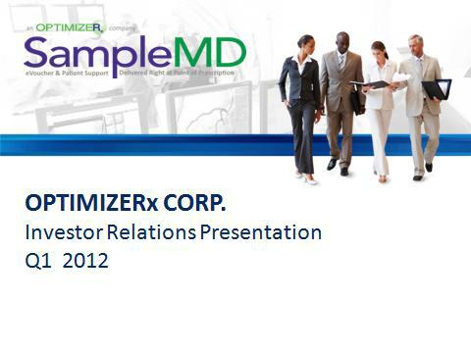

OPTIMIZERx CORP.Investor Relations Presentation Q1 2012

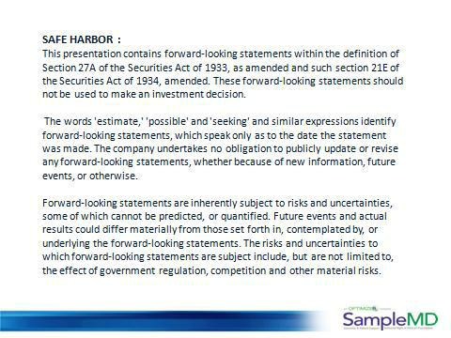

SAFE HARBOR : This presentation contains forward-looking statements within the definition of Section 27A of the Securities Act of 1933, as amended and such section 21E of the Securities Act of 1934, amended. These forward-looking statements should not be used to make an investment decision.The words 'estimate,' 'possible' and 'seeking' and similar expressions identify forward-looking statements, which speak only as to the date the statement was made. The company undertakes no obligation to publicly update or revise any forward-looking statements, whether because of new information, future events, or otherwise.Forward-looking statements are inherently subject to risks and uncertainties, some of which cannot be predicted, or quantified. Future events and actual results could differ materially from those set forth in, contemplated by, or underlying the forward-looking statements. The risks and uncertainties to which forward-looking statements are subject include, but are not limited to, the effect of government regulation, competition and other material risks.

2

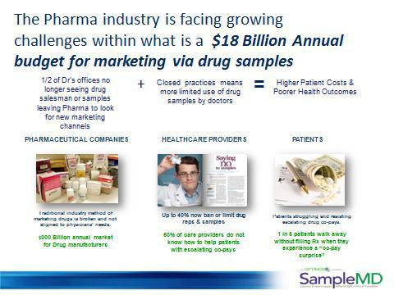

The Pharma industry is facing growing challenges within what is a $18 Billion Annual budget for marketing via drug samples

1/2 of Dr’s offices no longer seeing drug salesman or samples leaving Pharma to look for new marketing channels Closed practices means more limited use of drug samples by doctors Higher Patient Costs & Poorer Health Outcomes Pharmaceutical Companies Healthcare Providers Patients Traditional industry method of marketing drugs is broken and not aligned to physicians’ needs.$300 Billion annual market for Drug manufacturers Up to 40% now ban or limit drug reps & samples50% of care providers do not know how to help patients with escalating co-pays Patients struggling and resisting escalating drug co-pays.1 in 5 patients walk away without filling Rx when they experience a “co-pay surprise”

3

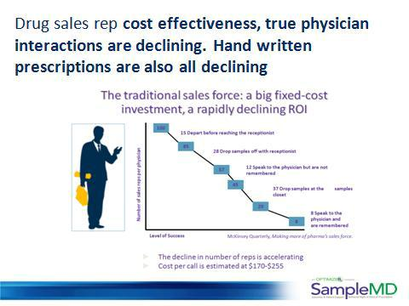

Drug sales rep cost effectiveness, true physician interactions are declining. Hand written prescriptions are also all declining

4

ays to leverage growing technology The Facts at the end of 2010, approximately one in four prescriptions were delivered electronically, up from one in 18 prescriptions at the end of 2008.

5

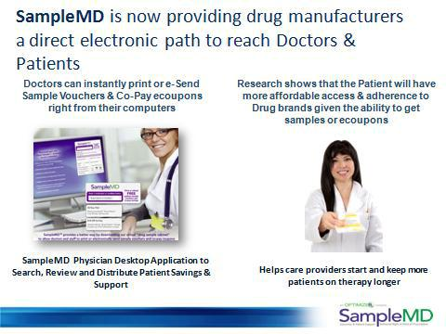

SampleMD is now providing drug manufacturers a direct electronic path to reach Doctors & Patients Doctors can instantly print or e-Send Sample Vouchers & Co-Pay ecoupons right from their computers Research shows that the Patient will have more affordable access & adherence to Drug brands given the ability to get samples or ecoupons SampleMD Physician Desktop Application to Search, Review and Distribute Patient Savings & Support Helps care providers start and keep more patients on therapy longer

6

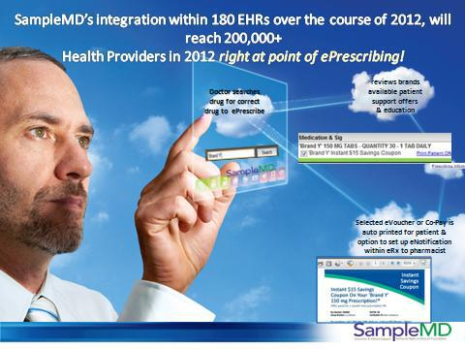

SampleMD’s integration within 180 EHRs over the course of 2012, will reach 200,000+ Health Providers in 2012 right at point of ePrescribing! reviews brands available patient support offers & education Doctor searches drug for correct drug to ePrescribe Selected eVoucher or Co-Pay is auto printed for patient & option to set up eNotification within eRx to pharmacist

7

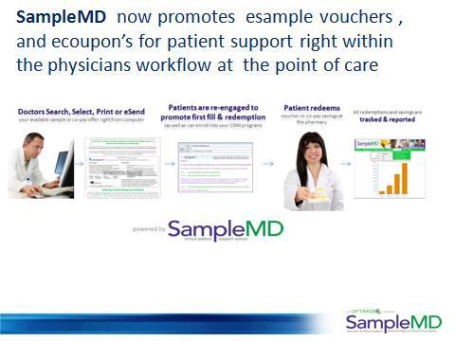

SampleMD now promotes esample vouchers , and ecoupon’s for patient support right within the physicians workflow at the point of care Doctors Search, Select, Print or eSend your available sample or co-pay offer right from your computer. Patients are re-engaged to promote first fill & redemption (as well as can entoll into your CRM program) Patient redeems voucher or co-pay savings at the pharmacy All redemptions and savings are tracked and reported

8

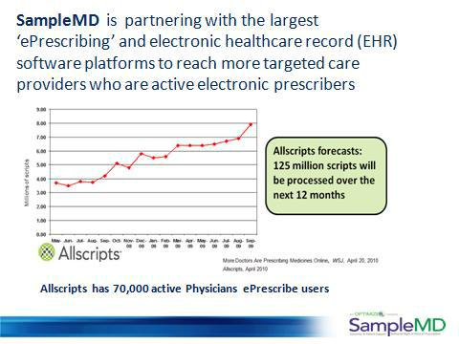

SampleMD is partnering with the largest ‘ePrescribing’ and electronic healthcare record (EHR) software platforms to reach more targeted care providers who are active electronic prescribers Allscripts has 70,000 active Physicians ePrescribe users More Doctors are prescribing medicines online, wsj, april 20, 2010 allscripts, april 2010 Allscripts forecast: 125 million scripts will be processed over the next 12 months.

9

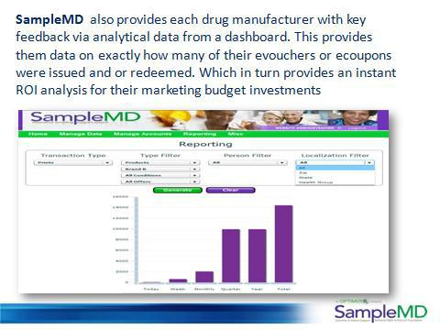

SampleMD also provides each drug manufacturer with key feedback via analytical data from a dashboard. This provides them data on exactly how many of their evouchers or ecoupons were issued and or redeemed. Which in turn provides an instant ROI analysis for their marketing budget investments

10

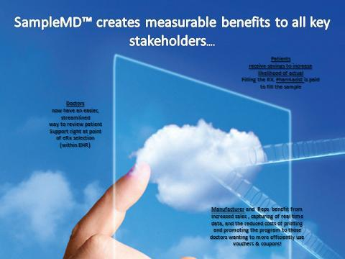

SampleMD™ creates measurable benefits to all key stakeholders….Doctors now have an easier, streamlined way to review patient

Support right at point of eRx selection (within EHR) Patients receive savings to increase likelihood of actual Filling the RX. Pharmacist is paid to fill the sample Manufacturer and Reps benefit from increased sales , capturing of real time data, and the reduced costs of printing and promoting the program to those doctors wanting to more efficiently use vouchers & coupons!

11

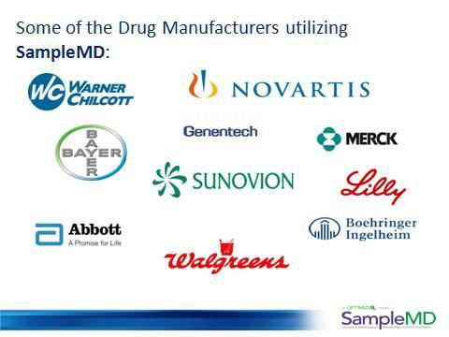

Some of the Drug Manufacturers utilizing SampleMD:

12

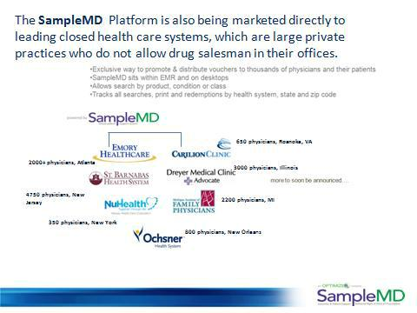

The SampleMD Platform is also being marketed directly to leading closed health care systems, which are large private practices who do not allow drug salesman in their offices. Exclusive way to promoate & distribute vouchers to thousands of physicians and their patients SampleMD sits within EMR and on desktops Allows search by product, condition or class Tracks all searches, print and redemptions by health system, state and zip code 2000+ physicians, Atlanta 4750 physicians, New Jersey 350 physicians, New York 650 physicians, Roanoke, VA 3000 physicians, Illinois 2200 physicians, MI 800 physicians, New Orleans

13

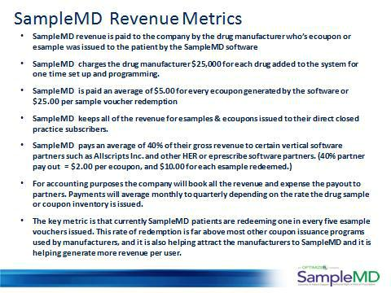

SampleMD Revenue Metrics SampleMD revenue is paid to the company by the drug manufacturer who’s ecoupon or esample was issued to the patient by the SampleMD software SampleMD charges the drug manufacturer $25,000 for each drug added to the system for one time set up and programming. SampleMD is paid an average of $5.00 for every ecoupon generated by the software or $25.00 per sample voucher redemption SampleMD keeps all of the revenue for esamples & ecoupons issued to their direct closed practice subscribers. SampleMD pays an average of 40% of their gross revenue to certain vertical software partners such as Allscripts Inc. and other HER or eprescribe software partners. (40% partner pay out = $2.00 per ecoupon, and $10.00 for each esample redeemed.) For accounting purposes the company will book all the revenue and expense the payout to partners. Payments will average monthly to quarterly depending on the rate the drug sample or coupon inventory is issued. The key metric is that currently SampleMD patients are redeeming one in every five esample vouchers issued. This rate of redemption is far above most other coupon issuance programs used by manufacturers, and it is also helping attract the manufacturers to SampleMD and it is helping generate more revenue per user.

14

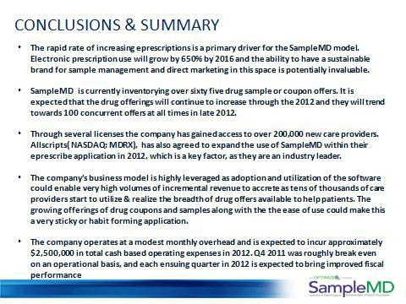

CONCLUSIONS & SUMMARY The rapid rate of increasing eprescriptions is a primary driver for the SampleMD model. Electronic prescription use will grow by 650% by 2016 and the ability to have a sustainable brand for sample management and direct marketing in this space is potentially invaluable.SampleMD is currently inventorying over sixty five drug sample or coupon offers. It is expected that the drug offerings will continue to increase through the 2012 and they will trend towards 100 concurrent offers at all times in late 2012.Through several licenses the company has gained access to over 200,000 new care providers. Allscripts( NASDAQ: MDRX), has also agreed to expand the use of SampleMD within their eprescribe application in 2012, which is a key factor, as they are an industry leader.The company’s business model is highly leveraged as adoption and utilization of the software could enable very high volumes of incremental revenue to accrete as tens of thousands of care providers start to utilize & realize the breadth of drug offers available to help patients. The growing offerings of drug coupons and samples along with the the ease of use could make this a very sticky or habit forming application.The company operates at a modest monthly overhead and is expected to incur approximately $2,500,000 in total cash based operating expenses in 2012. Q4 2011 was roughly break even on an operational basis, and each ensuing quarter in 2012 is expected to bring improved fiscal performance

15

