SEC Form 3
FORM 3 | UNITED STATES SECURITIES AND EXCHANGE COMMISSION
 | Washington, D.C. 20549
 | Washington, D.C. 20549 |  | OMB APPROVAL
 | INITIAL STATEMENT OF BENEFICIAL OWNERSHIP OF SECURITIES
 | INITIAL STATEMENT OF BENEFICIAL OWNERSHIP OF SECURITIES |  | OMB Number: | 3235-0104
 |  |  | Estimated average burden
 | Filed pursuant to Section 16(a) of the Securities Exchange Act of 1934 |  | hours per response: | 0.5
or Section 30(h) of the Investment Company Act of 1940
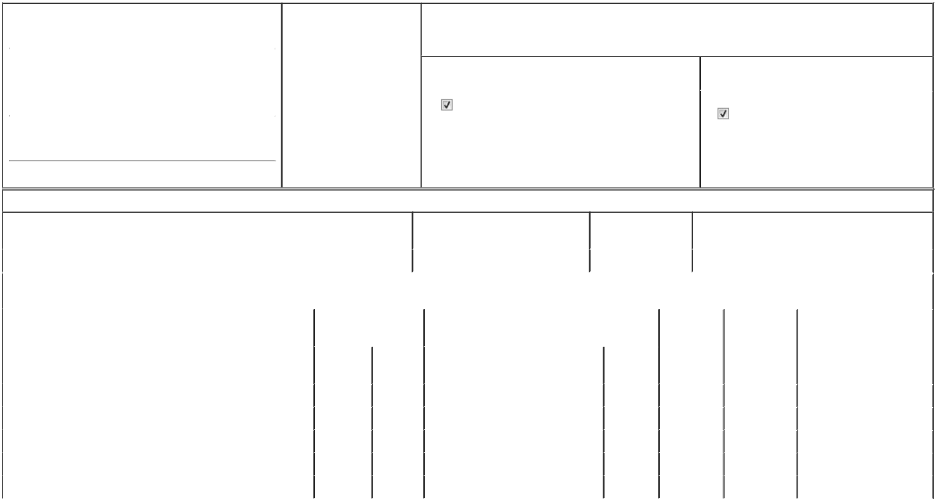

1. Name and Address of Reporting Person* |  |  |  |  |  | 2. Date of Event Requiring
 |  | D'Silva Andrew J. |  |  |  | Statement (Month/Day/Year)
 |  |  |  |  | 08/21/2025
 |  | (Last) | (First) |  | (Middle)
 |  | C/O OPTIMIZERX CORPORATION
 |  | 260 CHARLES STREET, SUITE 302
(Street)
 |  | WALTHAM | MA |  | 02453

3. Issuer Name and Ticker or Trading Symbol

OptimizeRx Corp [ OPRX ]

4. Relationship of Reporting Person(s) to Issuer |  | 5. | If Amendment, Date of Original Filed (Month/Day/Year)
(Check all applicable)
Director | 10% Owner
Officer (give title | Other (specify below) | 6. | Individual or Joint/Group Filing (Check Applicable Line)
below) | Other (specify below) |  | Form filed by One Reporting Person
Chief Business Officer |  |  | Form filed by One Reporting Person
 |  |  | Form filed by More than One Reporting Person

(City) (State) (Zip)

Table I - Non-Derivative Securities Beneficially Owned

1. Title of Security (Instr. 4) | 2. Amount of Securities Beneficially | 3. Ownership Form: | 4. Nature of Indirect Beneficial Ownership (Instr. 5)
 | Owned (Instr. 4) | Direct (D) or Indirect
 |  | (I) (Instr. 5)

 | Common Stock |  |  |  | 37,097⁽¹⁾ | D
 |  |  | Table II - Derivative Securities Beneficially Owned
 |  | (e.g., puts, calls, warrants, options, convertible securities)
 | 1. Title of Derivative Security (Instr. 4) |  | 2. Date Exercisable and |  | 3. Title and Amount of Securities Underlying |  | 4. | 5. Ownership | 6. Nature of Indirect Beneficial
 |  |  | Expiration Date |  | Derivative Security (Instr. 4) |  | Conversion | Form: Direct | Ownership (Instr. 5)
 |  |  | (Month/Day/Year) |  |  |  | or Exercise | (D) or Indirect
 |  |  |  |  |  |  | Price of | (I) (Instr. 5)
 |  |  |  |  |  | Amount or | Price of | (I) (Instr. 5)
 |  |  |  |  |  | Amount or | Derivative
 |  |  | Date | Expiration | Title | Number of | Security
 |  |  | Exercisable | Date | Title | Shares
 | Stock Option | (2) |  | 10/01/2029 | Common Stock | 6,993 | 7.2 | D
 | Stock Option | (3) |  | 08/31/2026 | Common Stock | 40,000 | 67.31 | D
 | Stock Option | (4) |  | 10/02/2027 | Common Stock | 13,018 | 15.04 | D
 | Stock Option | (5) |  | 12/19/2028 | Common Stock | 5,892 | 12.73 | D
 | Stock Option | (6) |  | 12/11/2029 | Common Stock | 13,723 | 4.95 | D
 | Explanation of Responses:

- Includes 24,890 shares of common stock underlying unvested restricted stock units ("RSUs") granted under OPRX's equity incentive plans. Each RSU represents the contingent right to receive, upon vesting of the RSU, one share of OPRX common stock. The RSUs vest as follows: (i) 8,000 RSUs which represent the 4th and 5th installments of Mr. D'Silva's 9/1/2021 grant, these installments vest ratably on 9/1/2025 and 9/1/2026; (ii) 2,217 RSUs which represent the final installment of Mr. D'Silva's 10/3/2022 grant, which installment vests on 10/3/2025; (iii) 3,928 RSUs which represent the 3rd and 4th installments of Mr. D'Silva's 12/19/2023 grant, which installments vest ratably on 12/19/2025 and 12/19/2026; (iv) 3,472 RSUs which will vest in 3 equal annual installments beginning on 10/1/2025, which is the 1st anniversary of the grant date; and (v) 7,273 RSUs which will vest in three equal annual installments beginning on 12/11/2025, which is the 1st anniversary of the grant date.

- The stock option vests in three equal annual installments beginning October 1, 2025, which was the first anniversary of the grant date.

- The stock option vests in three equal annual installments beginning September 1, 2022, which was the first anniversary of the grant date.

- The stock option vests in three equal annual installments beginning October 3, 2023, which was the first anniversary of the grant date.

- The stock option vests in three equal annual installments beginning December 19, 2023, which was the first anniversary of the grant date.

- The stock option vests in three equal annual installments beginning December 11, 2024, which was the first anniversary of the grant date.

Remarks:

The filing of this Statement shall not be construed as an admission (a) that the person filing this Statement is, for the purposes of Section 16 of the Securities Exchange Act of 1934, as amended, the beneficial owner of any equity securities covered by this Statement, or (b) that this Statement is legally required to be filed by such person

/s/ Marion Odence-Ford, by Power of

Attorney

** Signature of Reporting Person

Reminder: Report on a separate line for each class of securities beneficially owned directly or indirectly.

* If the form is filed by more than one reporting person, see Instruction 5 (b)(v).

- Intentional misstatements or omissions of facts constitute Federal Criminal Violations See 18 U.S.C. 1001 and 15 U.S.C. 78ff(a). Note: File three copies of this Form, one of which must be manually signed. If space is insufficient, see Instruction 6 for procedure.
Persons who respond to the collection of information contained in this form are not required to respond unless the form displays a currently valid OMB Number.

10/06/2025

Date



