SECURITIES AND EXCHANGE COMMISSION

WASHINGTON, D.C. 20549

____________________

FORM 8-K

CURRENT REPORT

PURSUANT TO SECTION 13 OR 15(d) OF

THE SECURITIES EXCHANGE ACT OF 1934

 |  |  | Date of Report (Date of earliest event reported): April 5, 2013
 |  |  |  |  | OptimizeRx Corporation
 |  |  |  | (Exact name of registrant as specified in its charter)
 | Nevada |  |  | 000-53605 |  |  |  |  |  | 26-1265381
(State or other jurisdiction of incorporation) |  |  |  | (Commission File Number) |  |  |  |  |  | (I.R.S. Employer Identification No.)
 |  |  | 400 Water Street, Suite 200, Rochester, MI |  |  |  |  |  |  | 48307
 |  |  | (Address of principal executive offices) |  |  |  |  |  |  |  | (Zip Code)

Registrant’s telephone number, including area code: 248-651-6568

___________________________________________________

(Former name or former address, if changed since last report)

Check the appropriate box below if the Form 8-K filing is intended to simultaneously satisfy the filing obligation of the registrant under any of the following provisions:

- ] Written communications pursuant to Rule 425 under the Securities Act (17CFR 230.425)

- ] Soliciting material pursuant to Rule 14a-12 under the Exchange Act (17 CFR 240.14a-12)

- ] Pre-commencement communications pursuant to Rule 14d-2(b) under the Exchange Act (17 CFR 240.14d-2(b))

- ] Pre-commencement communications pursuant to Rule 13e-4(c) under the Exchange Act (17 CFR 240.13e-4(c))

1

SECTION 7 – Regulation FD Disclosure

Item 7.01 Regulation FD Disclosure

On April 5, 2013, OptimizeRx Corporation (the “Company”) made an investor presentation that included the slides furnished as Exhibit 99.1 to this Current Report on Form 8-K. The slides contained in Exhibit 99.1 are also posted on the Company’s website at www.optimizerxcorp.com.

The information in Item 7.01 of this Current Report on Form 8-K (including Exhibit 99.1) shall not be deemed “filed” for purposes of Section 18 of the Securities Exchange Act of 1934 (the “Exchange Act”) or otherwise subject to the liabilities of that section, nor shall it be deemed incorporated by reference in any filing under the Securities Act of 1933 or the Exchange Act, except as expressly set forth by specific reference in such a filing.

SECTION 9 – Financial Statements and Exhibits

Item 9.01 Financial Statements and Exhibits

Exhibits |  | Description
Number
99.1 |  | Investor Relations Presentation, dated April 5, 2013

2

SIGNATURES

Pursuant to the requirements of the Securities Exchange Act of 1934, the registrant has duly caused this report to be signed on its behalf by the undersigned hereunto duly authorized.

OptimizeRx Corporation

/s/ David Lester

David Lester

Chief Operating Officer

Date: April 8, 2013

3



1

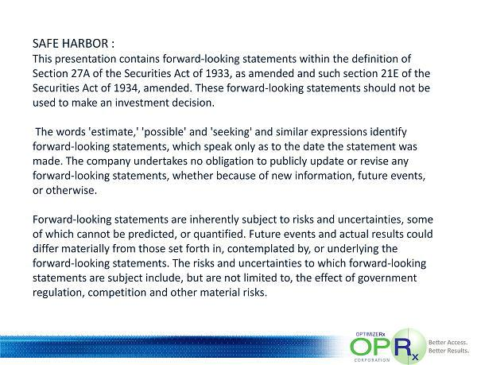

2



3

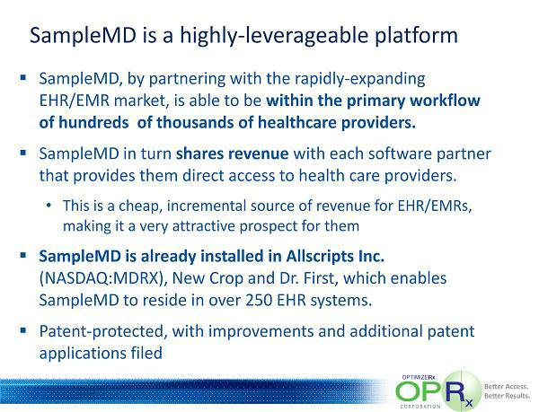

4

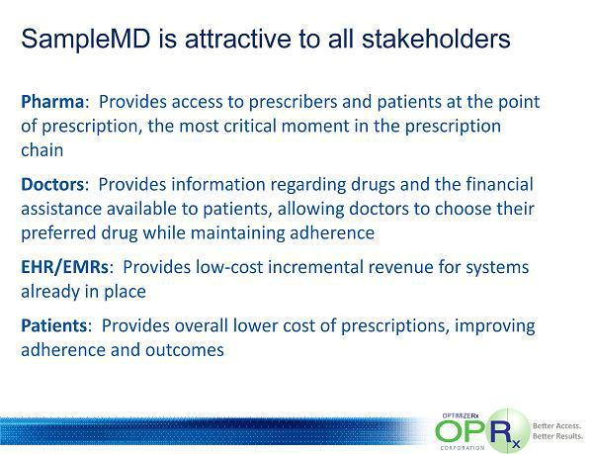

5

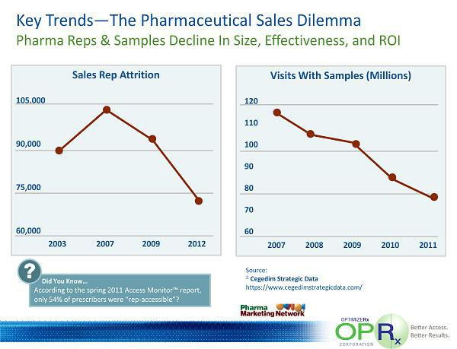

6

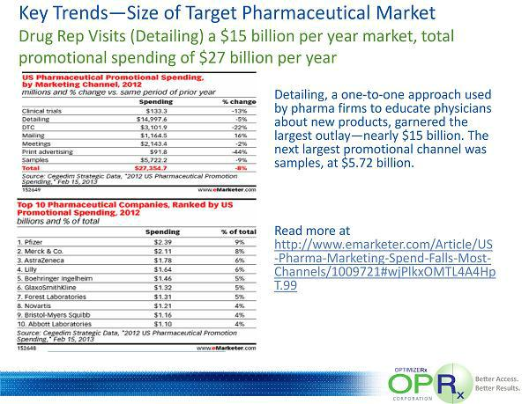

7

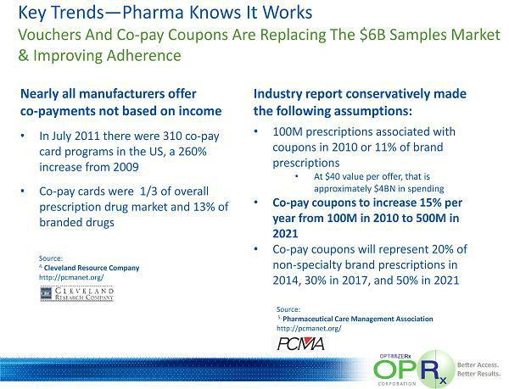

8

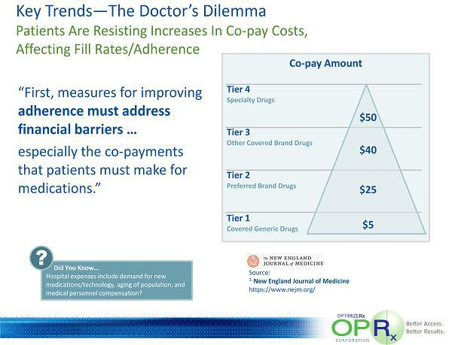

9

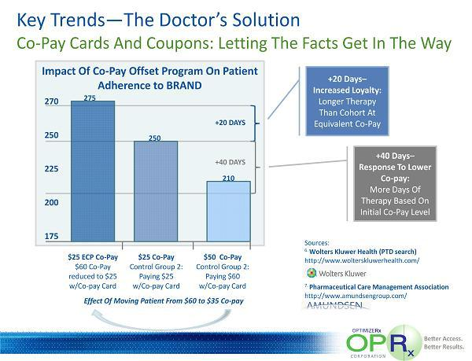

10

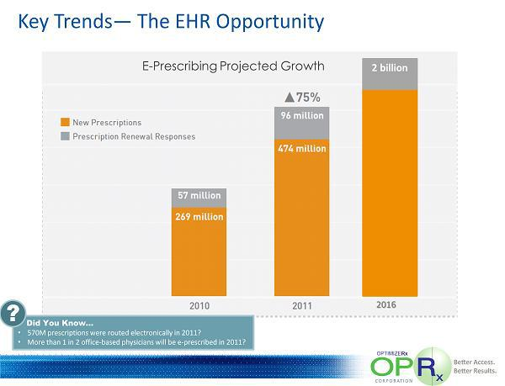

11

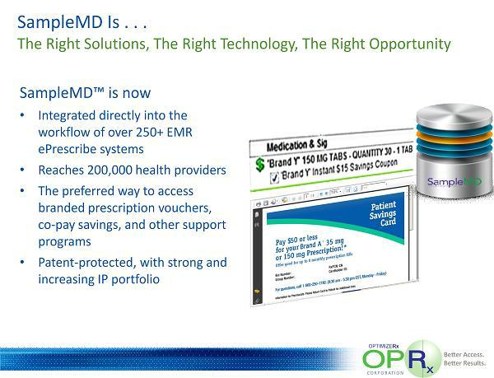

12



13

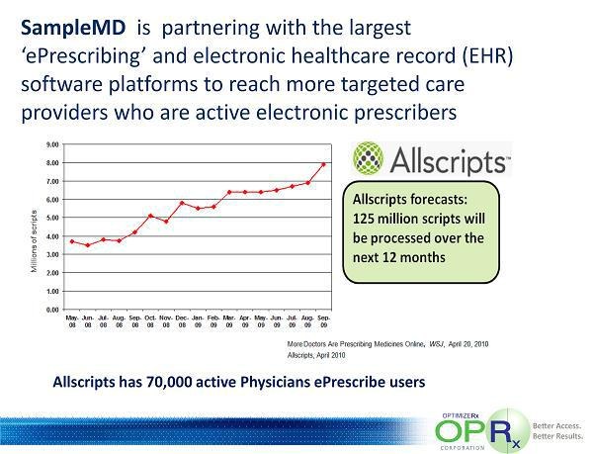

14

15

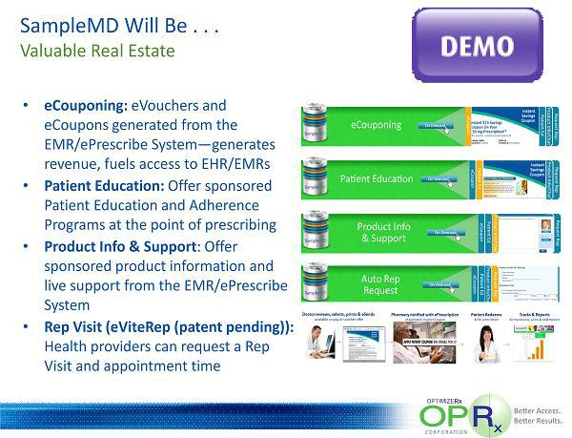

16

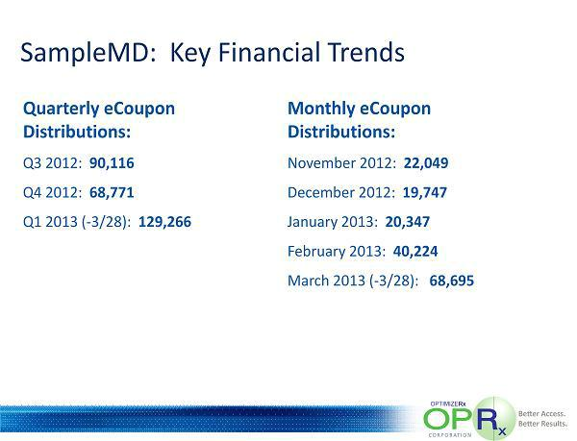

17

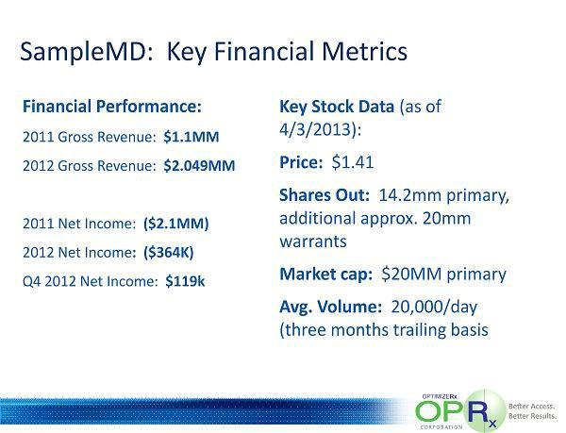

18

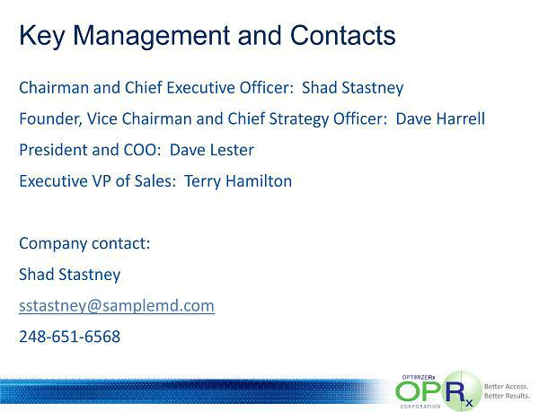

19

